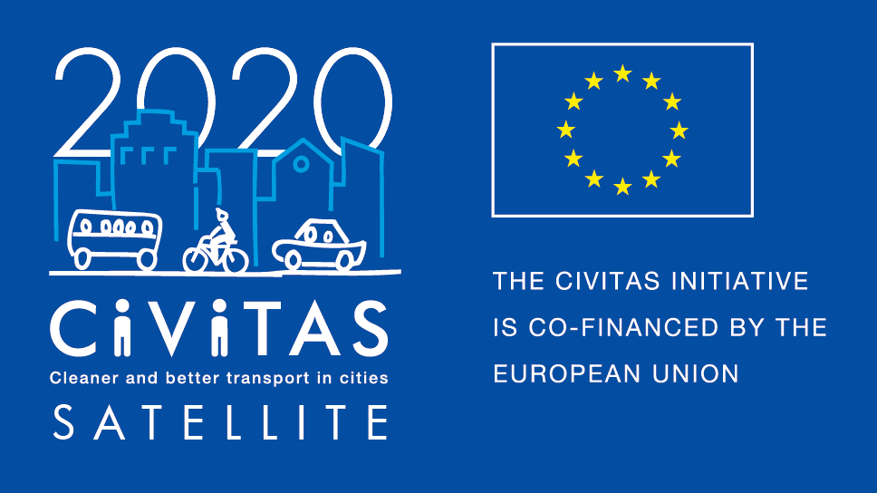
w

SATELLITE application form for visiting cities
Study Visit in Bratislava

Project Acronym: | CIVITAS SATELLITE
Full Title: Support Action Towards Evaluation, Learning, Local Innovation, Transfer and Excellence
Grant Agreement No.: | 713813
Deadline for application: 31 August 2020
Contact person: arianna.americo@eurocities.eu

CIVITAS SATELLITE peer-to-peer activities in a nutshell

CIVITAS SATELLITE is an initiative designed to support cities in gaining better access to innovative solutions and to address transport challenges by applying exchange mechanisms for transfer and take-up.
Between 2017 and 2020, SATELLITE will organise at least 20 visits, in the form of work placements and study visits, for city representatives willing to learn from each other and to exchange extensively with each other.
Participants for these peer-to-peer visits will be selected each year through calls for expression of interest.

This form is for cities willing to take part as a visiting city in a study visit in Bratislava on 5 - 7 October 2020.

If you are selected as visiting city, you:
- Will receive support for the preparation and the follow-up of the visit you will attend.
- Might be selected to receive financial support up to €600 to cover for travel and accommodation for a study visit, after providing us with invoices.

Apply!
Do you want take part to CIVITAS SATELLITE peer-to-peer exchanges? Please fill in the application form by 28 February 2020 and send it back to arianna.americo@eurocities.eu
- Contact person:
If you have any questions, please contact Arianna Americo: arianna.americo@eurocities.eu
(+32 2 552 08 72)

ADDITIONAL INFORMATION TO READ BEFORE APPLYING

- Study Visit in Bratislava

The city is a space where different kinds of transport meet. Pedestrians and bicycles present, ecologically and financially, the most effective means of transportation. They both are sustainable in the long term and they do not have a negative impact on the environment. Moreover, the price of building infrastructure for cyclists and pedestrians in comparison to infrastructure for cars is negligible.
Despite this, Bratislava nowadays remains mainly the city of cars, sometimes also called Autoslava. Although the number of bikes in Bratislava is comparable to the number of cars, only low percentage of Bratislava inhabitants rides a bike regularly.
According to the Plan Bratislava, our key strategic document, the vision of sustainable mobility is built on four basic pillars – (1) pedestrians in the first place, (2) healthy city with cyclists, (3) high quality of urban city transport and (4) smart car using (e.g. car sharing).
Hereby, one of our key priorities is to find innovative solutions for different kinds of non-motorized transport and to support and promote car-independent lifestyles to citizens, which might lead to safer and healthier public space and living environment. Within this context, the study visit will showcase several of ongoing city projects aimed at transforming public spaces, previously used by cars, to free car zones for pedestrians and cyclo-transportation.
Moreover, to ensure sustainability in mobility issues, it is necessary to build partnerships – those between the different levels of public administration on the one hand, and opening up to partners from the private and civil sectors on the other hand.
Bratislava study visit will, therefore, present the partnership between our city and relevant civil initiatives, promoting achievements of this cooperation in the field of sustainable mobility, especially in the field of cyclo-transportation.

- What is a study visit?
CIVITAS SATELLITE study visits offer the opportunity for up to 10 city representatives from 10 different cities to travel to another European city facing similar challenges in sustainable urban mobility to learn about possible solutions and best practices. These 2,5-3 day study visit will be tailored to the needs of the participating cities and take an interactive approach, to facilitate in-depth exchange, and strengthen cooperation. City representatives will benefit from financial support covering travel and accommodation costs.
- Why join CIVITAS SATELLITE peer-to-peer programme?
If you are a visiting city, you will:
- Have hands-on experience in another city,
- Have the opportunity to exchange on a one-to-one basis with leading peers,
- Be promoted on the CIVITAS website and European-wide media outlets as a city committed to sustainable urban mobility,
- Be offered speaker slots at European level events,
- Be able to apply for the CIVITAS award in the Take-up category

- What will be the tasks of cities involved?
If you are a visiting city, you will:
- Define a detailed request for learning
- Identify a local challenge faced by your city
- Liaise with the SATELLITE team to agree on the objectives of the visit
- Write a short impact report describing new skills acquired
- Send all documents required for the reimbursement of costs (if selected for financial support)

CIVITAS SATELLITE Call for visiting cities (Study Visit in Bratislava)

- Fundamental information
Name of the city & Country
Structure & size | ☐ City  ☐ Metropolitan area  Population:
Are you member of the CIVITAS Community? | ☐ CIVITAS demonstration city  ☐ CIVITAS Forum network city  ☐ CIVINET member city  ☐ IA or RIA project partner city  ☐ None
Has your city been awarded an award for its work on sustainable mobility?  If yes, which one? | ☐ CIVITAS award  ☐ EUROPEANMOBILITYWEEK award  ☐ SUMPs award  ☐ Other (please specify)  ☐ My city has applied or has been short listed but not selected  ☐ None
Do you have recent experience of peer-to-peer exchange?  If yes please specify | ☐ Yes (Please specify below)  ☐ No

- Preparing the visit
What are the main reason(s) why you want to take part to a CIVITAS peer-to-peer visit?
Which challenge from your city do you plan to present to your host city?
How do you plan to do this?
Which key local/regional decision makers, project managers and/or stakeholders would you like to meet during your visit? Why?
Will you communicate about this visit? If yes how?

- Practicalities and joining instructions
Contact person(s) for the organisation of the visit | Name:  Position:  Telephone:  Email:  Address: | Name:  Position:  Telephone:  Email:  Address:
Can you confirm and make sure that your colleagues have a sufficient level of English to present their experience? | ☐ Yes  ☐ No
How did you find out about the CIVITAS SATELLITE study visit?
Other questions

Final declaration
I have the pleasure to inform you that the city of name of the city/region supports the participation of its staff in the CIVITAS SATELLITE initiative in [2020].
Place
Click here to enter a date.
Name
Position
City/region
NB: this form should be signed by the Mayor, the Vice-Mayor or the Director of the Transport department in your municipality

