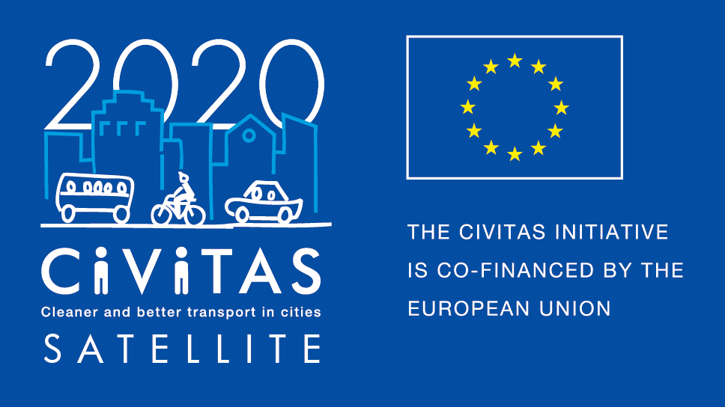
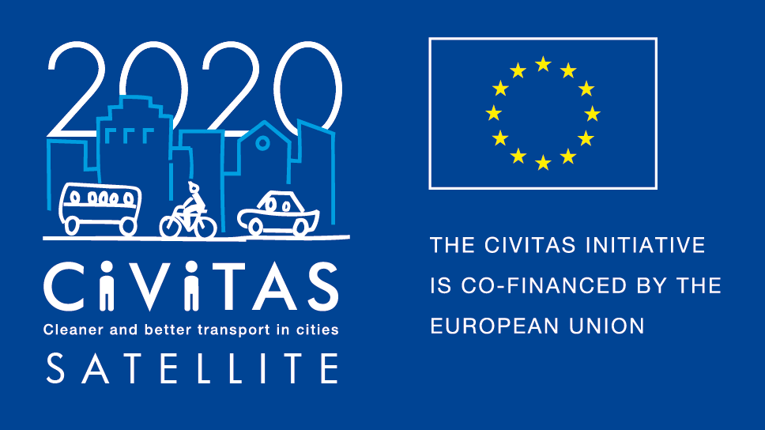
w
Agenda Study visit

Madrid, 25-27 March 2020

- Contact person
- Location
- Agenda
- Hotels
- Map and directions to venues and hotels
- Useful information
Contact person
Name Francisco J. López Carmona
Mobile: +34 686 300 285
E-mail: lopezcfjo@madrid.es

Location
All activities will take place at International lab centre. This venue is located in Madrid city centre.
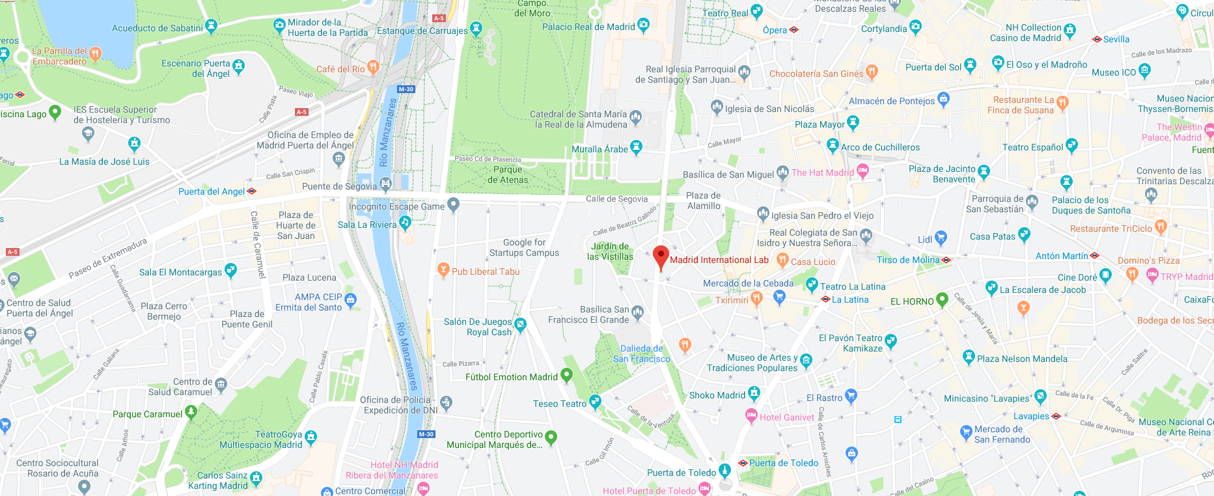

VENUE – International lab
Calle de Bailén, 41
28005 Madrid
You can find deeper information about the venue here: https://www.esmadrid.com/en/tourist-information/madrid-international-lab

Agenda

Day 1 (Venue: Madrid International Lab)
Time | Subject | Notes / Objectives
09.00–09:15 | Welcome, agenda and practical issues  Person, role
09:15–10:00 | General overview of the city  Person, role | General overview of the city and specific approach to parking and mobility management
10:00–10:30 | Round table and expectations from the visit  All | Feedback from the attendants
10:30–11:00 | Coffee break
11:00–12:00 | Advanced parking management discussion  Person, role | Discussion with expert about parking management
12.00–13.00 | Lunch
13:00–15:00 | Visit to parking management facilities  All | Visits related to parking management
15:00–15:30 | Coffee break
15:30–16:30 | Surveillance and mobility management discussion  Person, role | Discussion with expert about surveillance and mobility management
16.30–18.00 | Visit to surveillance and mobility management centre  All | Visits related to surveillance and mobility management
18.00 | Break for participants
19.30 | Networking dinner

Day 2 (Venue: Madrid International Lab)
Time | Subject | Notes / Objectives
09.00–09:30 | General overview of the city  Person, role | General overview focused on cycling, pedestrian and public transport
09.30–10:30 | Public transport network discussion  Person, role | Discussion with expert about public transport network
10:30–11:00 | Coffee break
11:00–12:00 | Visit to Operational Centre of EMT  All | Visit related to public transport
12.00–13.00 | Lunch
13.00–14:30 | Cycling & pedestrian infrastructure discussion  Person, role | Discussion with expert about cycling and pedestrian infrastructure
14:30–16:15 | Visit to cycling infrastructure  All | Visit related to cycling infrastructure
16:15–18:00 | Visit to pedestrian infrastructure  All | Visit related to pedestrian infrastructure
18:00 | End of the day

Day 3 (Venue: Madrid International Lab)
Time | Subject | Notes / Objectives
09.00–09:30 | General overview of the city  Person, role | General overview focused on electromobility and new mobility modes
09.30–10:30 | Electromobility and new mobility modes discussion  Person, role | Discussion with expert about electromobility and new mobility modes
10:30–11:00 | Coffee break
11:00–12:00 | Visit to electromobility facilities  All | Visit related to electromobility and new mobility modes
12.00–13.00 | Lunch
13.00–15.00 | Evaluation and transferability session  All | Discussion on the output of the visit and drafting of the evaluation report
15.00 | End of the visit

Map and directions to venues

TRAVEL INFORMATION – How to get & to leave from the airport
We encourage city partners to take public transportation when travelling to and from the airport in Madrid, as this is mostly faster, cheaper and more environmentally friendly. Attendants are responsible for arranging their own transfers to and from the airport to the hotel. There are several transportation options to get to and from the airport into the city:
- Metro:
Madrid's Barajas Airport has Metro stations in Terminal T2 and the newer Terminal T4. / Journey time: ca. 35min / Price: 4,50 - 5 €
  - Follow the Underground signs at the airport T1 T2 T3 exit Aeropuerto T1 T2 T3 & T4
  - Take Línea 8 (pink line), to Nuevos Ministerios
  - Transfer at Nuevos Ministerios to Línea 10 (dark blue line), direction Puerta del Sur
  - Transfer at Alonso Martínez with Línea 5 (light green line), direction Casa de Campo
  - EXIT at Underground station ‘La Latina’
  - Walk 8 min to the venue

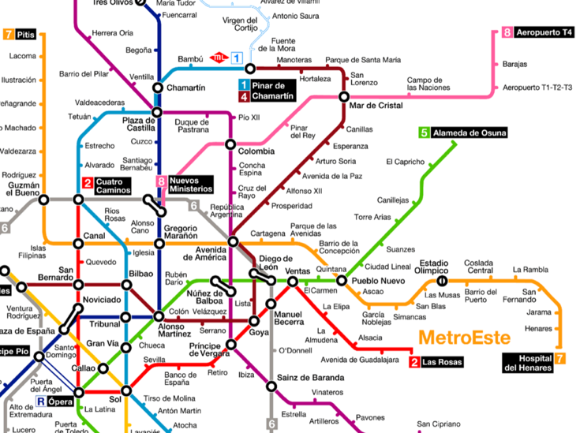

For your trips you could either purchase:
- Single tickets: 1.5-2 € depending on the number of stops. Airport supplement: 3 €
- 10 trips ticket “Metrobus” (€12.20). It allows the use of both Metro and Urban buses. Airport Metro supplement (3 €) and Airport Express bus not included. There is no combined ticket with Commuter trains “Cercanías”.
https://www.metromadrid.es/en/travel-in-the-metro/card-types

- Train
"Cercanías- Commuter Train" C1 line connects the airport with the city centre in about 22 minutes. The train station is on the terminal T4 floor -1, and is called Aeropuerto T4 (please note that this service is only available from Terminal 4. To move to the other terminals there is a shuttle service).
  - Single ticket tariff is 2,60 €, valid for one journey in within two hours.
  - Running times are: From the airport: 5.58 a.m. until 22.27 p.m. (last one).
  - The train takes you to some of the main public transports hubs of the city and allows to connect with Metro in Nuevos Ministerios, Recoletos (close walking to Banco de España metro Station), Atocha and Principe Pio.

- Bus
The Exprés Aeropuerto (Airport Express shuttle) from Madrid-Barajas to Madrid city centre is approximately 30 minutes. The bus runs every 15 minutes during the day and every 35 minutes at night. Get off the bus at ‘Plaza de Cibeles’ and take the metro line 2 (from ‘Banco de España’) to the station ‘Ópera’. Tickets cost 5€ and can be purchased on the bus.
The airport is also connected with Madrid city centre via other urban buses of the Municipal Transport Company (EMT) such as lines 200, N27 EXPRÉS, and 101.

- Taxi
Madrid airport disposes of several public taxi ranks, distributed over all airport terminals. The final price for your ride should be indicated by the taximeter. It is possible to request your invoice once you arrive at your destination. The price for a taxi ride from the Madrid-Barajas airport to the centre of Madrid* is a flat rate € 30 one way. Taxi time for Friday afternoon can be around 40-45’.

- Connection between terminals (Shuttle bus)
In order to get from one terminal to another (T1 T2 T3 T4), passengers and visitors can use the shuttle bus, a freebus transport service between the airport terminals, 24 hours a day.
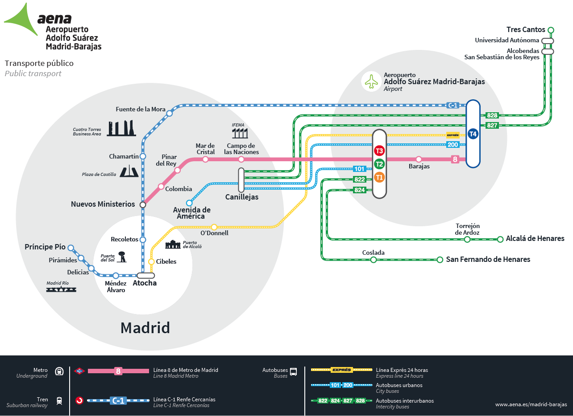

Useful information
What to do if an Emergency in Madrid:
Emergency numbers: 112 (for ambulance, police and fire brigade)
Chemists nerby the venue: Calle de Bailén, 16, 28005 Madrid

International dialling code: Spain is +34

