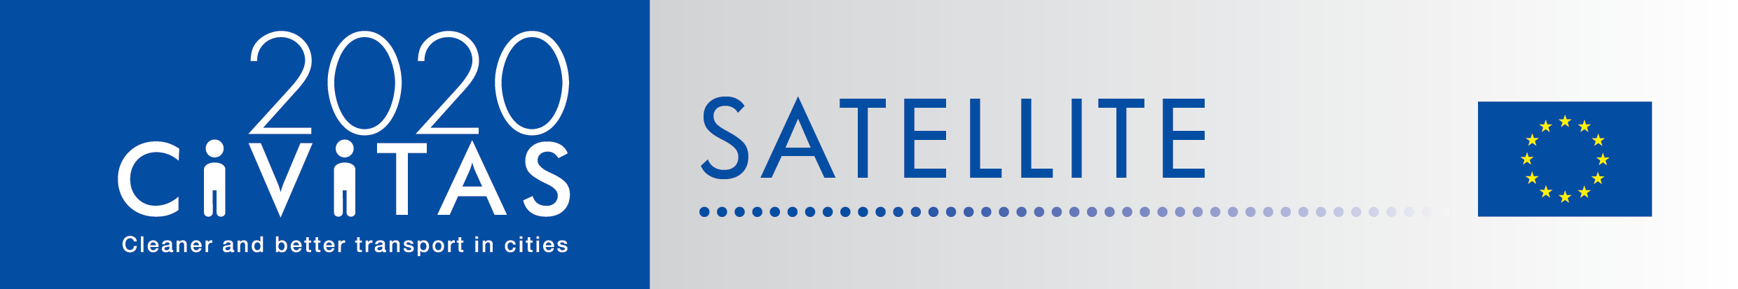
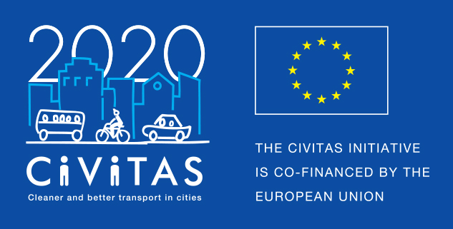
w
CIVITAS call for e-publication contribution - 3 best practices template
CIVITAS peer-exchange
Programme - Alternative activity
Call for e-publication contribution - three best practices

Project Acronym: | CIVITAS SATELLITE
Full Title: Support Action Towards Evaluation, Learning, Local Innovation, Transfer and Excellence
Grant Agreement No.: | 713813
Deadline for applications: 11 September 2020
Contact person: Arianna Americo, EUROCITIES
arianna.americo@eurocities.eu

As alternative to the cancelled CIVITAS study visits due to the COVID19 crisis, CIVITAS will produce an e-publication as "an interactive best-practice sharing experience". If selected, your city will be included in the e-publication and a maximum of 2.500 EUR will be allocated to your city to produce a short (2-3 min) video. The video should focus on one of the three best practices described in the text and/or on how you think the future of mobility will look like in your city after the crisis. An online event will be organised to launch the e-publication and to interact with virtual visiting cities in an online exchange.
To apply, fill in the form below, describing three best practices you would like to showcase. Please focus on best practices that could be relevant to other peer cities and show a potential for replicability. These three best practices should cover different themes, see below:

Select three themes from the list | ☐ Public transport  ☐ Shared mobility  ☐ Active mobility  ☐ Clean fuels and vehicles  ☐ Car-independent lifestyles  ☐ Demand management strategies  ☐ Public involvement  ☐ Safety and security  ☐ Transport Telematics  ☐ Urban freight logistics  ☐ Other/optional: you can also choose to focus on a relevant measure implemented as response to the COVID-crisis (i.e. extended bike lanes, car-free zones, reduced speed areas etc…)
What will your video showcase? | Please specify which one of the three best practices would be showcased in the video if you are selected

Deadline
Please describe the three best practices in the form below by the 11 September 2020 and send it back to arianna.americo@eurocities.eu and annecharlotte.trapp@eurocities.eu.
The selected cities will be informed by 16 September.

Best practice 1
(max 300 words)

Best practice 2
(max 300 words)

Best practice 3
(max 300 words)

