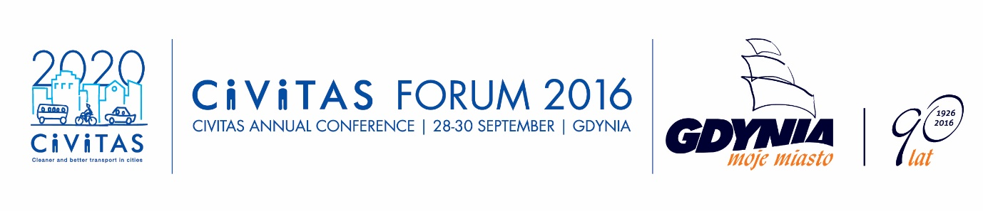

CIVITAS Brokerage Event: Present project ideas and look for partners!
A CIVITAS Brokerage Event focusing on the EU funding opportunities for urban mobility and transport projects will take place during the CIVITAS Forum 2016 on September 29th 2016 at 14.00. The Brokerage event will be an opportunity to clarify questions about the next transport calls, present your project idea or find a needed partner.
The Brokerage Event on will be structure as follows:
- The ELENA Facility (EIB) – Henriette Van Eijel, EC Representative
- Horizon2020 Calls – Marcel Rommerts, INEA
- Questions & Answers
- Pitches for Project ideas and Partners searches (3 minutes / each)
If you are interested in presenting a project idea or announcing a partner search, please submit your request for a three-minute pitch by filling out the application form (see next page). Send the form to Chiara Frencia (chiara.frencia@inovamais.eu) as soon as possible, however at the very latest by September 10th 2016.
Please note that due to limited time available, only a limited number of pitches will be accepted. First come, first serve principle will apply.
The Brokerage Event ends at 15.30, after which the participants can continue networking until 16.30.

PITCH REQUEST _ PROPOSAL FORM
Name:
Organisation:
Email:
CIVITAS project (if appropriate):
Representative of a City (if appropriate):
Type of pitch: 󠄨 Project idea Partner search
Call identification (if appropriate):
Short description of the pitch:

