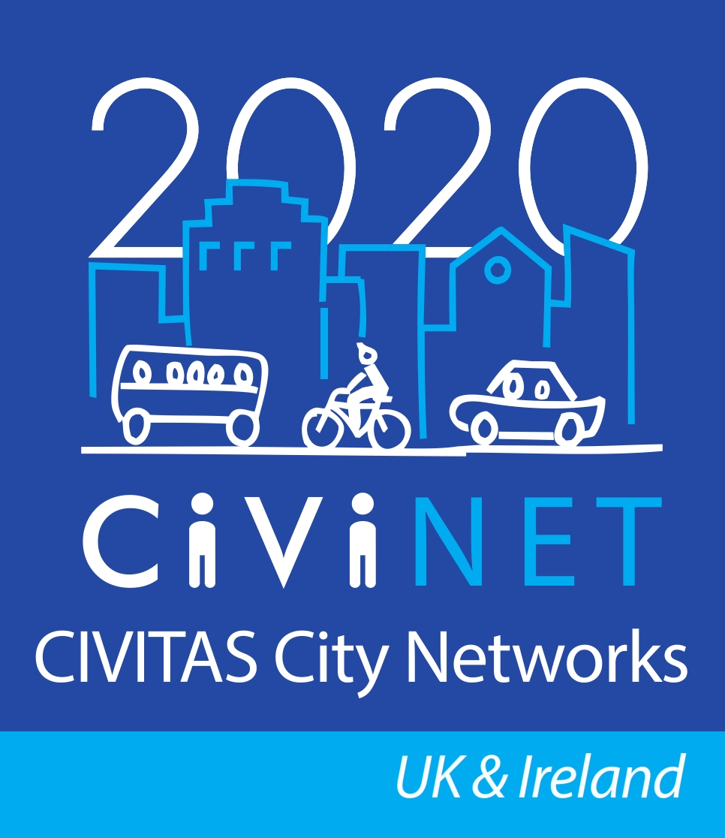

Personal mobility & the mobile phone - Using smart technology to deliver Sustainable Mobility

Hosted by CIVINET UK & Ireland, MobiWallet and Centro

10am – Tuesday 24 November 2015

Centro House, Summer Lane, Birmingham

Programme
10.00-10.25 | Registration, networking and coffee/tea
10.25-10.30 | Welcome | Chris Hadfield, Chair  National Network Manager, CIVINET UK & Ireland
10.30-10.50 | Using mobile apps to encourage active travel | Greg Smart, 500more.com
10.50-11.10 | Converting mobility events into media assets | Mebs Loghdey, GoMoMo
11.10-11.30 | The success of the itravel smart app | Lynne McKie,  Team Leader, Information, Concessions & Travelcard  Cheshire West & Chester Council
11.30-11.50 | Coffee/tea break
11.50 -12.10 | MyAccessibleEU and Wheelmap - A European perspective to delivering sustainable mobility | Louise Francis,  Co-founder & Chief Executive, Mapping for Change
12.10 -12.30 | Discussion and Q&A on morning session | With all speakers.
12.30-13.30 | Lunch & Demonstration of selected apps
13.30 13.50 | Intelligent Mobility - Centro’s perspective | Andy Page,  Smart Mobility Manager, Centro
13.50 -14.10 | Gamification and modal shift | Scott Davidson,  Technical Manager – Smarter Travel Transport & Travel Research
14.10-14.25 | Discussion and Q&A on afternoon session | With all speakers.
14.25 -14.30 | Conclusion | Chris Hadfield  National Network Manager, CIVINET UK & Ireland

