CIVITAS Webinar
Sustainable Urban Mobility Plans

date
14.30 – 16.00 CET

CIVITAS VANGUARD, and will hold their WEBINAR: Sustainable Urban Mobilityplans
During this webinar an overview of SUMPS in the Netherlands will presented, followed by case studies and the effect of EU regulation on SUMPs and sustainable urban mobility plans.
In the programme below you will find a short description of all presentations and speakers. At the end of the webinar there is an opportunity for questions and discussions.

Information & registration
More information: training@civitas.eu

Registration from the 15th of February 2013 onwards at http://www.civitas.eu/index.php?id=12&event_id=526&more=

Please register before march 4th.
Programme
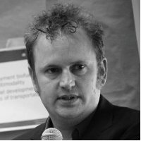 | INTRODUCTION  Rick Lindeman  Rijkswaterstaat  SUMPS and Welcome
SUMPs in the netherlands
Marcel van Lieshout, Move Mobility
Goudappel Coffeng and Move Mobility did a scan of the SUMP-readyness of Dutch muncipal traffic plans
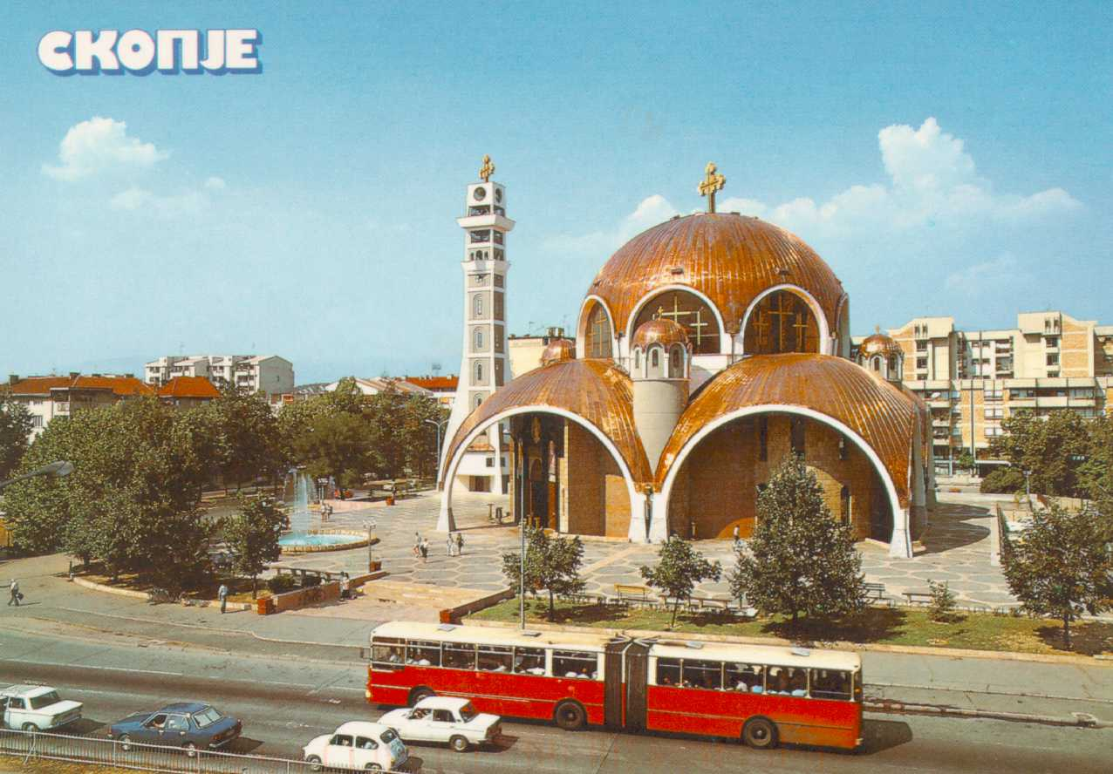 | SUMP in Skopje  Ana Gruevska, JSP Skopje, Macedonia  With Civitas, Skopje is one of the Pioneers in the field of SUMPs, Ms. Gruevska will discuss this.
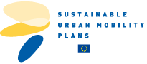 | ABERDEEN, an Award Winning SUMP example  Alan Simpson, Aberdeen City Council  Aberdeen has been a finalist in the SUMP Award 2012. The objective of this campaign “Do the Right Mix” is to promote the advantages of combining different modes of transportation.
EU funding and sumps
Cezar Grozavu, Ministry of Regional Development and Public Administration (MDRT)
Romania is one of the first countries which had to deal with the new preconditions on EU financing regarding SUMPs. Mr. Grozavu will discuss his experiences.

