CIVITAS Webinar

Cities’ experiences with Biodiesel

Thursday 14 February 2013
14.00 – 15.30

CIVITAS VANGUARD and the CIVITAS thematic group ‘Clean fuels and vehicles’ will hold a WEBINAR on biodiesel.
During this webinar experiences from cities having introduced biodiesel vehicles in their fleet will be presented.
In the programme below you will find a short description of all presentations and speakers. At the end of the webinar there is an opportunity for questions and discussions.

Information & registration
More information: training@civitas.eu

Registration from the 4th February onward at
https://attendee.gotowebinar.com/register/423302428803922176
Please register before the 12 February 2013, 12.00.

Programme
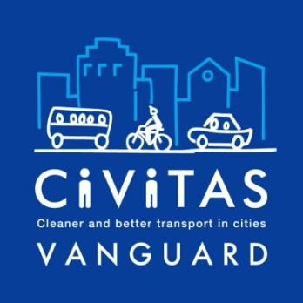 | INTRODUCTION  Melanie Leroy, EUROCITIES (Belgium), CIVITAS VANGUARD Manager of the Thematic group Clean Fuels and Vehicles
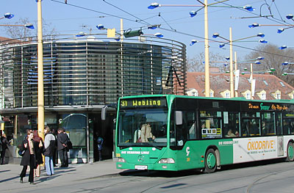  Picture: ELTIS | Cooking oil as resource for mobility  Gerhard Ablasser, Graz (Austria)  For 10 years, Graz buses are running on biodiesel and the whole municipal bus fleet has been converted to biodiesel. 41 new climate-controlled, wheelchair-accessible biodiesel buses have been introduced.  Graz has introduced a very successful used cooking oil collection scheme collecting from restaurants and households. The collected used cooking oil is converted into biodiesel and provides most of the fuel for the busfleet. The collection marketing campaign has been combined with mobility consulting.  Graz has the only municipal public transport fleet running for 100% on 100% biodiesel
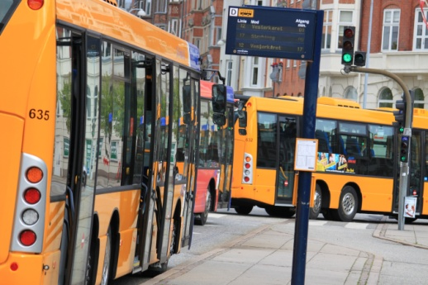  Picture: Finn Vestergaard Madsen | Aalborg and Biodiesel buses  Gustav Friis, Aalborg (Denmark)  Fossil oil is a scarce resource and the use of it leads to environmental changes with large impacts to the world’s population. Using bio-diesel is a measure that can help to prevent these impacts. Not only are the CO2-emission reduced, but also (rather logical) the consumption of fossil fuels.  In the City of Aalborg, two projects have been dealing with bio-diesel. In total fifty buses and almost fifty postal vehicles have been operating on bio-diesel blends between 10% and 20% percent. The bio-diesel is made from animal fat waste which is not usable for other purposes. Due to other properties of the bio-diesel products, the risks of implementing this have been researched throughout the project and strategies on how to avoid any problems and break downs in fleets that depends on full operation have been developed. This has resulted in a smooth operation of the vehicles, yet fulfilling innovative objectives.
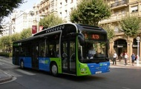  Picture: CIVITAS | Dbus Fleet Running on Biodiesel  Eduardo González Lopez, Donastia-San Sebastian, Chief of Manteinance department in Dbus (Spain)  Within the CIVITAS ARCHIMEDES project, CTSS-DBUS goals included reducing dependency on fossil fuels, as well as to bring down emission levels and increase energy efficiency.  In 2009, when the ARCHIMEDES project started, CTSS-DBUS installed a biodiesel mixing station at its own premises. This allowed the company to experiment with different biodiesel blends to operate its fleet (currently 120 vehicles). After four years, the experience gained has helped reach an optimum biodiesel mix compatible with the technical needs of its fleet (currently 95 buses are running on a 30% blend, 15 buses on a 50% blend and six buses on 100% biodiesel). This allowed for a significant reduction in terms of greenhouse gas and pollutant emissions.
Picture | TITLE  EBB European Biodiesel Board, (Belgium) tbc

