

**City-level Evaluation Guidance**

**December 2019**

**UNIABDN**

# **City-level Evaluation Guidance**

*The city-level evaluation report keeps track of the city level indicators in line with the high level overall objectives in the PORTIS project and the strategic objectives of the city.*

*The purpose of the city level report is to explore the extent to which the different PORTIS measures contribute to these strategic objectives and indicators.*

*There are five components to the city-level evaluation.*

1. *Understanding the city context*
2. *Collection of ‘before’ and ‘after’ data corresponding to the city level indicators. This provides the change in indicator values.*
3. *Qualitative judgement and assessment of the trends, external factors and PORTIS measures which contribute to the change in indicator values.*
4. *Where appropriate, apply the strategic level evaluation tool to better understand the relative contribution of each PORTIS measure to the change in indicator value.*
5. *Conclusions and critical interpretation/validity of the results*

# Understanding the city context

*Background description of the city and the position of the port within the city. Size of city, number of employees in city, transport characteristics of city, size of port, number of employees, scale of road freight movements in and out of port, geographic location of port in relation to city.*

* *This information can be extracted from evaluation plan.*

*What strategic planning/policy documents does the city adhere to?*

* *List the main or important strategic planning documents for the city relating to transport/urban mobility/urban form.*
* *List any planning documents specific to the PORT or PORT /CITY interaction?*

*What are the main strategic objectives of the city.*

* *Describe the main strategic objectives relating to transport/urban mobility for the city and/or port*

# Data corresponding to the city level indicators

*List the PORTIS project indicators and target impacts at the city level for your city (see page 18/19 of the DoA)*

**Table 1: PORTIS project indicators and target impacts at the city level**

|  |  |
| --- | --- |
| PORTIS project indicator | Target Impact (city level) |
| Number of port employees |  |
| Number of total employment in city |  |
| Unemployment rate in city |  |
| Number of new jobs created thanks to docks redevelopment |  |
| Number of new businesses attracted thanks to port redevelopment |  |
| Number of city-port commuters by car |  |
| Commuting travel time (all modes, in minutes) |  |
| Modal share of PT in the city |  |
| Modal share of cycling in the city |  |
| Modal share of walking in the city |  |

*List any additional important city level indicators associated with strategic city objectives for your city.*

**Table 2: Additional city level indicators associated with strategic city objectives**

|  |  |  |
| --- | --- | --- |
| Strategic City Objective | Additional city level indicator | Target Impact (city level) |
|  |  |  |
|  |  |  |
|  |  |  |
|  |  |  |
|  |  |  |
|  |  |  |
|  |  |  |
|  |  |  |
|  |  |  |
|  |  |  |

*For each city level indicator describe the data collected ‘before’ PORTIS and ‘after’ PORTIS in Table 3.*

*In Table 4, for each indicator indicate the date and method of data collection and provide a comment on the quality/completeness of the data: e.g. is it sufficient in terms of sample size (number of suitable respondents for surveys, number of days of counts/readings for sensor or observed data) or coverage (locations of sensors/observation points); for sensor/count data does the collection period reflect typical conditions and avoid holidays; is the data collected specific to the target group or time of day where this is specified in the indicator and is it geographically appropriate.*

* *Page 18/19 from Part B of the DoA contains the ‘before’ data (from 2015) for most of the PORTIS project indicators*
* *‘After’ data should be data collected by March/April 2020.*

|  |  |  |  |  |  |  |
| --- | --- | --- | --- | --- | --- | --- |
| Name of city level indicator | ‘Before’ data | | | ‘After’ data | | |
| ‘Before’ data value | Date/ period of data collection | Method of data collection | ‘After’ data value | Date/ period of data collection | Method of data collection |
|  |  |  |  |  |  |  |
|  |  |  |  |  |  |  |
|  |  |  |  |  |  |  |
|  |  |  |  |  |  |  |
|  |  |  |  |  |  |  |
|  |  |  |  |  |  |  |
|  |  |  |  |  |  |  |
|  |  |  |  |  |  |  |
|  |  |  |  |  |  |  |

**Table 3: Summary of ‘Before’ and ‘After’ data relating to city-level indicators**

**Table 4: Summary of quality of data relating to city-level indicators**

|  |  |
| --- | --- |
| Name of city level indicator | comment on the quality/completeness of the data |
|  |  |
|  |  |
|  |  |
|  |  |
|  |  |
|  |  |
|  |  |
|  |  |

# Explaining the change in city level indicator values

*Changes in indicator values between the ‘before’ and ‘after’ points in time can be due to a number of reasons. The three key reasons are:*

1. *There may be underlying trends which are affecting the data values (for instance CO2 emissions may show a reducing trend as a result in the improvement in vehicle engine standards between 2015 and 2020 which may be either amplified by an accompanying reduction on car use or dampened by increases in car use). Other significant trends may relate to a change in societal attitudes towards cycling. These types of trends, those which are likely to have some impact on changes in the indicator values, need to be identified and their level of impact between the ‘before’ and ‘after’ dates assessed.*
2. *Other factors which may contribute towards the change in indicator values are major projects or initiatives, external to PORTIS, that are happening concurrently and that contribute to changes in the indicator values between the ‘before’ and ‘after’ dates.*
3. *PORTIS measures which contribute to the change in indicator values between the ‘before’ and ‘after’ dates. In many instances several PORTIS measures may be contributing to a change in the measured indicator value between the ‘before’ and ‘after’ periods.*

*The first 2 of these define the Business as Usual scenario. See Figure 1.*

***Figure 1: Illustration of the factors that contribute to changes in indicator value (KPI) between the ‘before’ and ‘after’ points in time***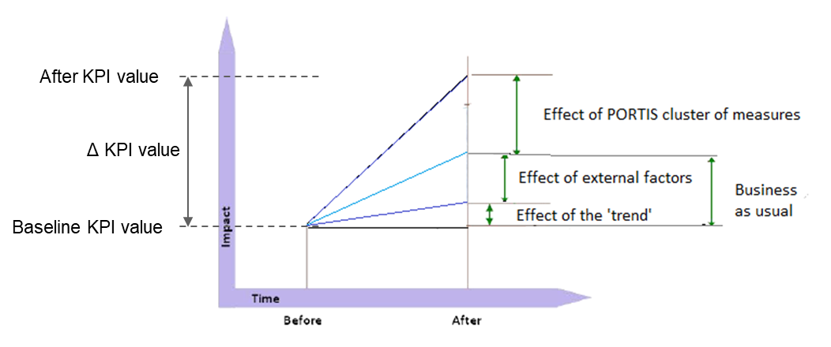

*While the change in indicator (KPI) value between the ‘before’ and ‘after’ periods can be measured, it is impossible to accurately quantify the impact that each of these reasons (i.e. trends, external factors, PORTIS measures) contributes to the measured change in indicator value. It is therefore necessary to rely on expert opinion from stakeholders involved in strategic planning and implementing both external projects/initiatives as well as PORTIS measures.*

***It is suggested that an ‘trends and external factors’ workshop be held by the LEMs with the local stakeholders / PORTIS measure leaders with the purpose of assessing the key trends relating to the city level indicators.***

*This has been conducted by Antwerp in Feb 2018 and the summary of this process is provided in Annex A: This considers the direction of the trends and what is causing the trends including major projects and initiatives not related to PORTIS. The assessment is qualitative but provides a means of understanding the external influences which are impacting on the changes in indicator values.*

*A useful exercise to identify the relevant external factors is to undertake a ‘visioning mindmap’. This approach has been conducted by Aberdeen to help establish the most relevant external factors that may influence changes in indicator values. This can be conducted as the first task within the workshop.*

***Figure 2: Example showing direction of trends relating to car, PT, bicycle and freight in Antwerp (see also Annex A for full description)***

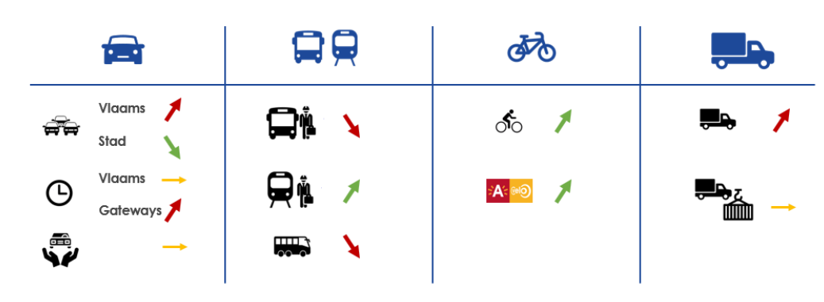

***A second workshop (PORTIS measure influence workshop) with local stakeholders / PORTIS measure leaders should be repeated towards the end of the PORTIS project (in Spring 2020) once the PORTIS measures have been implemented and operational for a sufficient length of time to get an indication of their effectiveness.***

*The ‘PORTIS measure influence’ workshop should revisit the assessment of trends and major projects and initiatives not related to PORTIS, while also considering the impact that PORTIS measures have had on the changes in indicator value. Again, this assessment is mainly qualitative in nature providing explanations and reasoning for the changes observed. However, coarse judgements on the magnitude (e.g. low, medium, high, very high) of the contribution from external projects/initiatives and from PORTIS measures to changes in the indicator value should be made.*

*While this does not give clear conclusions on the impact of PORTIS measures on city level indicators, it does provide expert judgements on the relative contribution of PORTIS measures/clusters of PORTIS measures on the strategic objectives for the city.*

*For the city level indicators related to transport system performance there may be a complex array of many PORTIS measures which simultaneously contribute to changes in indicator values in addition to external factors. In such circumstances it becomes very difficult for stakeholders/measure leaders to conceptualise the relative contribution of each element. For these cases it may be advisable to use the Strategic Level Assessment Tool with the local stakeholders / PORTIS measure leaders as an aid to unravel the complex interactions of multiple measures. See Section 4 for more details.*

*The strategic level tool is most useful for assessment of transport related city level indicators in the following circumstances:*

* *Where multiple PORTIS measures are acting simultaneously on the strategic objective / KPI value along with external factors, and hence straightforward judgements on their relative contributions become difficult.*
* *Where a more tailored assessment is sensible; e.g. considering specific variations to the strategic objectives/KPI’s due to availability of data and/or to better reflect the scope of the measures introduced.*
* *If only one PORTIS measure contributes to a strategic objective, then there is no need to apply the strategic level tool*

*Workshop 1 (Trends and External Factors)*

*Date:*

*List of Attendees:*

*Trends/external factors explored (related to strategic objectives/city level indicators):*

*Outcomes for each assessment:*

*Overall conclusions:*

*(see Annex A for an example of the outcomes from such a workshop)*

*Workshop 2 (PORTIS measure influence)*

*Date:*

*List of Attendees:*

*City level indicators explored (related to strategic objectives):*

*Outcomes for each assessment (including coarse judgement on PORTIS measure contributions to changes in city level indicator values):*

*Overall conclusions:*

# Applying strategic level evaluation tool

*The qualitative assessment described in Section 3 is adequate and indeed the most suitable approach to evaluating the contribution of PORTIS to several of the strategic objectives and city level indicators; in particular those relating to employment/economy and governance.*

*For the city level indicators related to transport system performance there may be a complex array of many PORTIS measures which simultaneously contribute to changes in indicator values in addition to external factors. In such circumstances it becomes very difficult for stakeholders/measure leaders to conceptualise the relative contribution of each element.*

*To address this complexity the strategic assessment tool has been developed by the project. This tool utilises the Analytic Hierarchy Process (AHP) approach to enable local stakeholders/experts to make informed judgements on complex multidimensional problems by simplifying them to a series of two dimensional pairwise comparisons. The two dimensional pairwise comparisons are made by considering only two elements (e.g. comparing one PORTIS measure with another or comparing a PORTIS measure with external factors) at a time and making judgements on how much influence they have in terms of their contribution to the change in indicator value (the basis for the judgements is provided in Table 5). Every element is considered against every other element in turn and internal consistency checking is applied to reveal any judgements which are contradictory.*

**Table 5: Valuations for pairwise comparison judgements**

**

*While these pairwise comparisons between PORTIS measures and/or external factors still rely on subjective judgements from the experts, any knowledge gained from the individual measure evaluation (e.g. quantified impacts or process information) can be used to inform those judgements.*

*The result is a systematic method for translation of qualitative judgements comparing two factors at a time into an overall indication of the relative contributions of each PORTIS measure to the impact achieved.*

*The strategic level tool allows flexibility in what are defined as your strategic objectives and key performance indicators. This means it can be shaped by the data that you have access to.  So, for instance, if the strategic objective is “increase levels of active travel” then this can be split into two objectives for the assessment: “increased levels of active travel (walking)” and “increased levels of active travel (cycling)”. This allows collection of data on cycling separate to data on walking (which is more common) and conducting the AHP assessment for the cycling and walking independent of each other is more logical and provides more informative results.*

*Often data that is available varies by journey type, and again this can be accommodated by the strategic level tool by being more specific in the objective. Instead of “reduction in number of car journeys”, this could be defined as “reduction in number of car journeys for commuter trips”. If some of your measures address other types of trips, you could add another objective and KPI to reflect this e.g. “reduction in number of car journeys for leisure trips”.*

*If there are areas of the city where the impacts may be contradictory (e.g. 20% reduction in car trips in city centre but 5% reduction in car trips around port) then again it may be best to split the objective when conducting the assessment by adding area specific criteria. So the objective “reduction in number of car journeys” may become two objectives: “reduction in number of car journeys in city centre” and “reduction in number of car journeys around port”. As described above these can potentially be further split by adding the specific trip purposes as well.*

*So, in summary the strategic level tool is useful for assessment of transport related city level indicators in the following circumstances:*

* *Where multiple PORTIS measures are acting simultaneously on the strategic objective / KPI value along with external factors, and hence straightforward judgements on their relative contributions become difficult.*
* *It is also useful to provide more tailored assessment where specific variations to the strategic objectives/KPI’s make sense due to availability of data and/or to better reflect the scope of the measures introduced.*

*If only one PORTIS measure contributes to a strategic objective, then there is no need to apply the strategic level tool as its effectiveness will be evaluated adequately by the individual measure evaluation along with the straightforward city level judgements following the approach described for Workshop 2 in Section 3.*

***Procedure for applying the Strategic Level Tool***

*The use of the strategic level tool should be firstly undertaken by the LEMs at each site for the strategic objectives / city level KPIs that are appropriate. During this initial assessment LEMs, in consultation with the LIMs, will identify the indicators to be subject to the assessment and will specify the PORTIS measures and external factors that have influence on those indicators. The LEMs/LIMs should then follow the AHP approach undertaking the pairwise comparisons for each of the indicators to get an initial set of outputs. Detailed guidance on each step is given in the Strategic Level Tool. This initial assessment should be undertaken prior to Workshop 2 (PORTIS measure influence) detailed in Section 3.*

*Table 6 provides an example of a completed pairwise comparison table based on applying judgements as detailed in Table 5. The final output is a table containing indications of the proportion of change in KPI value attributed to each PORTIS measure as well as to external trends/factors (the Business as Usual scenario) as illustrated in Table 7.*

*While the data in Table 7 are presented as quantified percentages they should not be viewed as accurate and robust at this stage. For this reason, it may be preferable to present the % results in Table 7 as gradings (low, medium, high, very high) describing the relative contribution to changes in indicator value. An approach for grading the % results has been developed, based on standardised scores which accounts for the number of measures/factors included in the analysis. Table 8 shows the graded descriptions for the Table 3 % results.*

*These graded descriptions of relative contribution to changes in indicator value serve as a useful prompt for further discussions with measure leaders and local stakeholders during the final workshops at the end of the PORTIS project evaluation (i.e. Workshop 2 described in Section 3). During this final workshop the local stakeholders and measure leaders should review and reassess the pairwise comparison valuations (i.e. see example in Table 6) in light of the more complete information and knowledge available to them at this time. This will include results from individual measure impact and process evaluation documentation giving some improved understanding of the effectiveness and scale/extent of the impacts from each measure as well as better knowledge on the background environment into which the measures have been implemented. With this additional information, the measure leaders and local experts are in a position to re-assess the initial pairwise comparison valuations. This could be done in a group exercise, or each expert could undertake the assessment individually, providing a number of independent results from which differences can be highlighted and discussed amongst the group to seek explanation.*

*While the above will not provide certainty on the accuracy of the results, it will offer a higher level of confidence in the judgements made and offers a more robust evaluation. It will still be important to acknowledge the results from this approach are estimates and to report the level of confidence placed on any conclusions that are drawn. When presenting final results, it is advisable to acknowledge the subjectivity inherent in the process and to use the gradings to describe the relative contribution to changes in KPI value from each measure (low, medium, high or very high) rather than a precise % value (see Table 8).*

**Table 6: Example of completed table containing pairwise comparison valuations**

|  |  |  |  |  |  |  |  |
| --- | --- | --- | --- | --- | --- | --- | --- |
| ***KPI*** | ***reduction in city centre traffic*** | | | | | | |
| *Column (j)* | | *1* | *2* | *3* | *4* | *5* | *6* |
| *Row (i)* | *Measure Name* | *Redesigning Collective Travel* | *Developing Travel Plans* | *Supporting Sound Planning and Decisionmaking* | *Developing Dynamic Traffic Management* | *Enhancing Demand Management* | *External Trends/Factors* |
| *1* | *Redesigning Collective Travel* | *1.00* | *0.33* | *1.00* | *1.00* | *0.20* | *0.20* |
| *2* | *Developing Travel Plans* | *3.00* | *1.00* | *3.00* | *3.00* | *1.00* | *0.33* |
| *3* | *Supporting Sound Planning and Decision making* | *1.00* | *0.33* | *1.00* | *0.20* | *0.20* | *0.33* |
| *4* | *Developing Dynamic Traffic Management* | *1.00* | *0.33* | *5.00* | *1.00* | *0.20* | *0.33* |
| *5* | *Enhancing Demand Management* | *5.00* | *1.00* | *5.00* | *5.00* | *1.00* | *1.00* |
| *6* | *External Trends/Factors* | *5.00* | *3.00* | *3.00* | *3.00* | *1.00* | *1.00* |

**Table 7: Example of quantified indications for the proportion of change in KPI value attributed to each PORTIS measure**

|  |  |  |
| --- | --- | --- |
| ***KPI*** | ***reduction in city centre traffic*** | |
| *Row* | *Measure Name* | *Proportion of change in KPI value attributed to measure* |
| *1* | *Redesigning Collective Travel* | ***6%*** |
| *2* | *Developing Travel Plans* | ***19%*** |
| *3* | *Supporting Sound Planning and Decision making* | ***6%*** |
| *4* | *Developing Dynamic Traffic Management* | ***11%*** |
| *5* | *Enhancing Demand Management* | ***29%*** |
| *6* | *External Trends/Factors* | ***30%*** |

**Table 8: Example of gradings for the relative contribution to of change in KPI value attributed to each PORTIS measure**

|  |  |  |  |  |
| --- | --- | --- | --- | --- |
| ***KPI*** | ***reduction in city centre traffic*** | | | |
| *Row* | *Measure Name* | *Proportion of change in KPI value attributed to measure* | *Standardised score[1]* | *Relative grading[2]* |
| *1* | *Redesigning Collective Travel* | ***6%*** | -0.99 | **LOW** |
| *2* | *Developing Travel Plans* | ***19%*** | 0.20 | **MEDIUM** |
| *3* | *Supporting Sound Planning and Decision making* | ***6%*** | -0.99 | **LOW** |
| *4* | *Developing Dynamic Traffic Management* | ***11%*** | -0.53 | **LOW** |
| *5* | *Enhancing Demand Management* | ***29%*** | 1.12 | **HIGH** |
| *6* | *External Trends/Factors* | ***30%*** | 1.21 | **HIGH** |

*Please copy the initial pairwise comparison tables (example in Table 6) and quantified indications tables (example in Table 7) from your Strategic Assessment Tool for the strategic objectives/KPIs you have chosen to assess.*

*After workshop 2 (PORTIS measure influence workshop) has been held please confirm who has undertaken the re-assessment using the strategic level assessment tool and copy the final pairwise comparison tables (example in Table 6) and quantified indications/relative grading tables (example in Table 8) from your Strategic Assessment Tool.*

*Please also report on the outcome of discussions around suitability of results and differences in results between different experts.*

# Critical assessment and conclusions

*This section incorporates the crucial elements and outcomes from the process evaluation undertaken for each of the individual measures to assess the impact that different aspects of the design, implementation and delivery of the measures have had on the results obtained for the city level evaluation.*

*In addition, major external elements, such as policy decisions, events, projects, economic circumstances should also be considered in terms of their impact on the city level evaluation results obtained.*

*Table 9 lists some key factors which are important when putting the city-level results into context. For each city level indicator identified in Tables 1 and 2, please provide as much detail as possible to answer the questions (information to be primarily collated from the measure level process evaluation and workshop activities undertaken in Section 3).*

**Table 9: Critical assessment of factors influencing city level results**

|  |  |
| --- | --- |
| ***Table to be copied and completed for each city level indicator identified in Section 2*** | |
| *Name of city-level indicator* |  |
| *For the PORTIS measures identified as impacting on the city level indicator:*  *Did delays in launching measures have an impact on the success of the measures?* |  |
| *Did lack of support from stakeholders/actors limit the effectiveness of the measures?* |  |
| *Did major external disruptions affect the measured impacts?* |  |
| *Did marketing reach the desired target market* |  |
| *Were there technical problems with the measures once launched?* |  |
| *Were there any problems related to the data collection for the city level indicators? How did this affect the results?* |  |
| *Was the data collected reliable? Sufficient samples? Weather conditions when collecting? Time period over which data was collected?* |  |
| *Did the scale (in terms of geography or targeted users) of the PORTIS measures limit the influence of the measures on achieving impacts at the city level? Highlight where it is not sensible or feasible to consider upscaling the measure to the city level.* |  |
| *Please describe the influence of any other factors which significantly impacted on this city level indicator?* |  |

**ANNEX A: Output from Antwerp Workshop 1 (Trends / External Factors)**

# Local Evaluation Meeting CIVITAS PORTIS

Antwerp

Meeting 14 February 2019

## Attendees

|  |  |
| --- | --- |
| **Name** | **Organisation** |
| **Marijke De Roeck** | Stad Antwerpen |
| **Marjolein Salens** | Stad Antwerpen |
| **Emilie Couwenberg** | Stad Antwerpen |
| **Herlinde Smet** | Stad Antwerpen |
| **Chris Van Maroey** | Stad Antwerpen |
| **Nathalie Neirynck** | Stad Antwerpen |
| **Steven Windey** | Stad Antwerpen |
| **Laura Tavernier** | Stad Antwerpen |
| **Stijn Vernaillen** | Stad Antwerpen |
| **Dominique Jacobs** | Stad Antwerpen |
| **Katia Kishchenko** | Stad Antwerpen |
| **Koen Christiaen** | NMBS |
| **Nathalie Duerinck** | De Lijn |
| **Karen De Cleyn** | De Lijn |
| **Erwin Fierens** | De Lijn |
| **Jeroen Van Houtte** | BAM |
| **Ingrid Cattrel** | BAM |
| **Jan Buytaert** | Haven van Antwerpen |
| **Candide De Bruyn** | Haven van Antwerpen |
| **Annelien Peeraer** | Provincie Antwerpen |
| **Dirk Engels** | TML (Satellite) |
| **Freya De Muynck** | Traject |
| **Kirsi Suutarinen** | Traject |
| **Helena De Bruycker** | Traject |
| **Bram Bruggeman** | Traject |

Purpose of the meeting

On a trimestral basis a meeting with all local stakeholders / measure leaders is organized in Antwerp. During the meeting, all measure leaders report on the state of the art of the measure. In the meeting of 14th of February, the scope of the meeting had been changed: a set of trends was presented to the stakeholders. In small groups, measure leaders were invited to brainstorm about what could explain those trends. The input from the participants will mainly be used as input for the City level MER but also taken into account when writing the measure-related MER and PER documents in the CIVITAS PORTIS project. As a follow-up to this workshop, one on one calls or meetings are scheduled with all measure leaders.

## Trends

For more details on trends, please see the PowerPoint presentation.

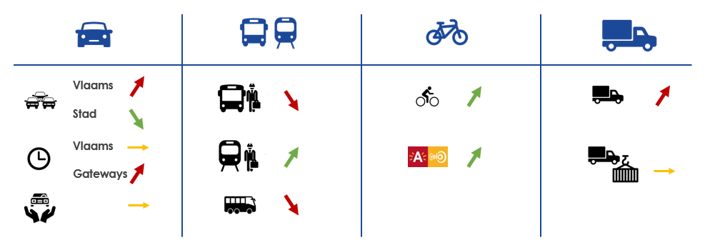

## Summary of results

### Car

The trends in car use were defined in 4 categories: Spatial ‘shift’ in intensities:

* Road works and buffering of cars towards the city on the Charles De Costerlaan
* Rerouting of traffic around Antwerp

Traffic towards and out of the city centre has dropped:

* Low Emission Zone in combination with free parking outside the ring road
* An increase in favour of train use towards the city. On top of that, more working spaces are located on easily accessible locations.

The modal share of cars in the city remains on the same level:

* Participants believe that people will not renounce their car quickly because of the comfort of having one and the invisible costs involved. On top of that, car sharing is perceived very expensive.
* In addition, our special planning and housing permits enhance car ownership (minimal parking spaces per house or office space).
* Modal shift is mainly for non-recurrent trips and not for everyday trips such as commuting.
* The modal share of cars is expected to decrease but participants think this is happening slower than initially was thought. Deeply rooted behaviour is often hard to change.

Car use in the port:

* Car use in the port can be expected to drop because of the increasing popularity of cycling and other initiatives such as the bike bus and the water bus.
* ‘Threats’ or ‘weaknesses’ are the shift hours in which a large part of the employee population has to work, and the long home to work distances.
* The left bank of the port is more attractive to cycle than the right bank largely due to better infrastructure. Since the introduction of the cycle bus, the situation has improved on the right bank as well (a detour of 15 km is no longer necessary) but the left bank still remains better accessible.

### Public transport

With regard to public transport, participants explained the drop in bus/tram/metro use resulting from several factors:

* Modal shift towards train and bike use: trains offer a higher frequency and more quality and are faster, while bikes have become increasingly more comfortable and more easily accessible; financially (via bike lease) and physically (everywhere in Antwerp there are bike sharing stations or bikes).
* Secondly, the bus has a negative perception: it is old fashioned, and on top of that people feel like it has a considerable financial cost.
* Context factors in Antwerp: the large road works in and around the city, and the creation of a bus hub where people had to transfer (and felt unsafe) do not encourage people to use public transport.

De Lijn wanted to emphasize that they do not have an insight into the tickets which are being sold via SMS and via the app. 2018 was a transition year, and they hope to have the numbers in 2019.

In terms of possible solutions, participants concluded the following:

* There should be more transparency on real-time info: public transport often arrives too late or not all, which causes frustration among users.
* Policy makers should invest more in public transport
  + Higher frequency, shorter travel times
  + Better material, increased comfort

With regard to public transport facilities in the port, participants concluded the following:

* Participants are curious to know the effects of innovative solutions such as the water bus or bike bus. Collective transport (i.e. shuttles) use is expected to drop in favour of the bike.
* Innovative solutions such as waterbus and bike bus should be combinable with car use to reach the north of the port.

### Bicycle

Cycling is becoming increasingly popular in Antwerp and in Flanders as a whole, both in the city and among the port employees. According to the participants, there are different factors playing a role:

* Road works and increased congestion: commuting by bike saves more time than travelling by car or using other transport modes
* Employers are promoting sustainable mobility among employees via different services (e.g. cycle lease)
* Cycling infrastructure has been augmented: not only in terms of qualitative cycle paths but also in terms of access to bikes (e.g. bike share systems).
* Bicycle revolution: thanks to electric bikes and speed bikes larger commuting distances can be covered.
* Cycling has become hip and trendy. More and more accessories are being sold and bikes can be bought in all types and colours.
* Parking policy of the city has been changed → this creates an extra barrier to come to Antwerp by car
* Housing permit policy of local government: the City of Antwerp requires in its housing permits for both houses and office spaces that sufficient space for bicycles needs to be available.

At the same time, the participants also signalled some ‘threats’ or ‘weaknesses’:

* Cannibalization of bike share by new transport modes such as steps, monowheels, hover boards and scooters: at the moment some sharing systems for new transport modes are already active in Antwerp. Participants expect a rise in use of these systems and a drop in public transport use and cycling.
* Not all public spaces are adequately adapted to the increased number of cyclists: the existing cycling paths are too crowded. On top of that, more and more people are in favour of introducing a cycling etiquette.
* With the increase in cycling the issue of cycle safety also comes in play, especially in companies which are located in the port area. Some companies report a serious rise in cycle accidents since the start of their cycle lease programme.
* Is there also a rise in cycling visible among the immigrant population? The feeling among participants is that there is, but this needs to be further investigated.

### Logistics

With regard to city logistics, there is a clear lack of data, because of the following:

* The research in city logistics is not yet very elaborate
* The issue of privacy prevents the city from collecting detailed information from the ANPR cameras (in contrast with the port ANPR cameras where they are enable to retrieve detailed info of vehicles)
* The different logistics suppliers are hesitant to supply data to the city and to cooperate with each other in order to exchange data and expertise

However, participants see multiple trends in the city logistics sector towards more sustainability:

* Retail sector is taking the lead both in first mile logistics (to their shops) as in last mile logistics (from the retail shop to customer’s home): e.g. Carrefour located at the metro hub at Groenplaats and the Colruyt pilot project using collective transport to enable elderly customers to shop in their supermarkets
* The logistics projects of Smart Ways to Antwerp are successful: one of the partners, DHL, reduced their trips made by van with 1,500

Threats according to participants in terms of city logistics:

* Existing legislation: in places where vehicles above 3, 5 tonnes are prohibited to enter the city, logistics operators shift goods towards smaller ‘white vans’. This causes more trips and thus more greenhouse gas emissions in the city centre.
* Rise in e-commerce and just-in-time delivery Possible solutions for city logistics according to participants:
* More hubs in city centres
* A more restrictive parking policy: reduce the amount of resident parking permits
* Allow night delivery

The numbers of port logistics show that a lot remains to be done in order to reach the ambition of 2030. There are several factors playing a role:

* The port has no authority with regard to the railway infrastructure: if cargo needs to be unloaded, a railway track has to be requested two years in advance. The port authority has now created Railport in order to organize the planning on a part of the existing railway structure themselves. For more information on Railport, please see: [https://www.portofantwerp.com/en/news/port-seeks-double-rail-volume-railport- antwerpen](https://www.portofantwerp.com/en/news/port-seeks-double-rail-volume-railport-antwerpen)
* Smaller ships with fewer containers are last in line to unload their cargo in the terminals: they have no direct contract with the terminals. The port authority has created several hubs where smaller ships can unload their containers, which are then being bundled and then dropped off at terminals.
* The perception of logistics by containerships or railway infrastructure is still low in comparison with trucks. Operators believe trucks to be more reliable, in terms of delivery on time

## Overall conclusion

In short, we can draw the following conclusions for different modes: Car

* According to the participants, traffic entering the city centre has dropped because of the road works, the new low emission zone as well as free parking outside the ring road.

However, when looking at travel behaviour and mode choice, people hold on to their own private cars. In the port, cycling is taking an increasing share from car traffic among commuters resulting from new initiatives encouraging cycling: cycle bus, communication campaigns (Slim naar Antwerpen/Smart Ways to Antwerp), and so forth.

Public transport

* Public transport is losing ground to bicycle and train: trains are faster, more frequent and of higher quality than buses or trams; bicycles offer freedom, comfort, easy access and value for money. The collective transport schemes in the port are also expected to lose more

share to bicycles with the introduction of the new bike sharing schemes. This has already been seen with the existing cycle-lease programmes.

Bicycle

* Cycling is gaining popularity in Antwerp and the whole of Flanders both in the city and the port for many reasons: commuting by bicycle saves time compared to travelling by car or public transport, there are new employer schemes promoting sustainable mobility, cycling infrastructure is improved, cycling is considered hip and trendy, and so on. However, new transport modes such as steps, monowheels, hover boards and scooters form a possible threat for bicycles, and, increased cycling also means crowded cycling paths.
* The port takes traffic safety seriously by organising workshops on traffic safety. There is a common misperception that there are more accidents due to commuting by sustainable transport modes but there is not necessarily a link with an increased risk of accidents.

Logistics

* The research in city logistics is not yet very comprehensive and privacy issues prevent the city from collecting detailed information from the ANPR cameras. However, retail sector is taking the lead in both first and last mile logistics. More hubs in city centres, a more restrictive parking policy and the authorisation of night delivery could help the situation of city logistics.
* As for the port, operators still believe trucks to be more reliable than trains or inland cargo ships with regard to delivery on time. To increase delivery by train, the port authority has created Railport in order to organize the planning on a part of the existing railway structure themselves.

1. The grading is based on standardised scores rather than grading based on absolute % due to the variation in number of measures/factors in the assessment for different indicators.
2. The grading ranges applied to the standardised scores are [LOW < -0.5 < MEDIUM < 0.5 < HIGH < 1.4 < VERY HIGH]