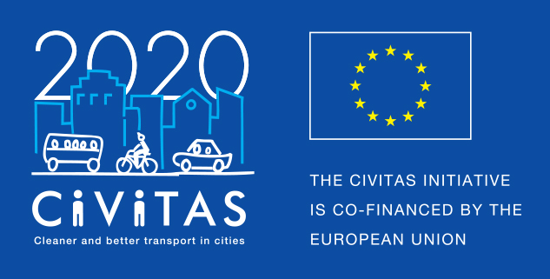
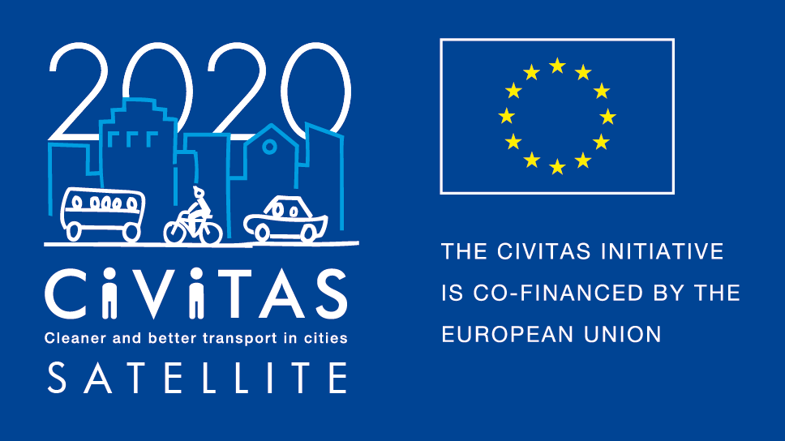
w
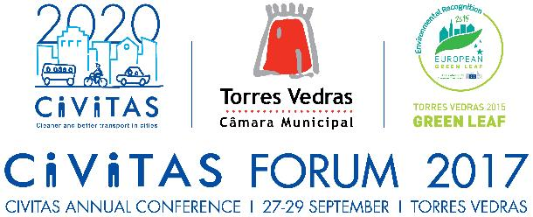
DEMONSTRATION
OPPORTUNITIES

CIVITAS Forum Conference
27- 29 September 2017
Torres Vedras
- Deployment Day: share your tools, products and services!
- Regular exhibition stands

About the Forum Conference
The CIVITAS Initiative, established 15 years ago by the European Commission, supports cities with developing and implementing sustainable urban mobility measures. Its flagship event is the annual CIVITAS Forum conference, with over 400 participants, technical solutions, innovations, and challenges to sustainable urban mobility and how these can be applied in their local contexts.
Regular exhibitor stand – 27-29 September
Associations, cities, businesses, universities, European Commission funded projects and other stakeholders as well as participants in current CIVITAS projects have the opportunity to apply for an exhibitor stand. More details below. For the exhibitor stand only, please fill out application form A.
Deployment Day – 28 September
Deployment Day is a new feature of the CIVITAS Forum Conference 2017 where tools and methods supporting cities in implementing sustainable mobility solutions will be presented. This is open to associations, cities, businesses, universities, European Commission funded projects and other stakeholders as well as participants in the current CIVITAS projects.
Exhibiting your tool/method and showcasing it through the deployment day programme will help to facilitate building relationships and potential partnerships with cities. In addition, your tool/ method will be featured in the CIVITAS online marketplace on tools and methods that will be launched at the CIVITAS Forum Conference 2017.
As part of deployment day, participants can undertake the following activities:

- Exhibitor stand
You can set up your stand for the entire CIVITAS Forum conference or for Deployment Day only.
Conference venue
Centro Social Paroquial Torres Vedras, Rua António Leal D'ascenção 2, 2560-295 Torres Vedras, PT
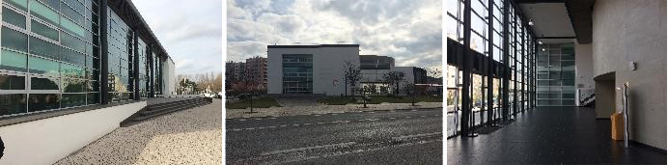

Exhibitor area
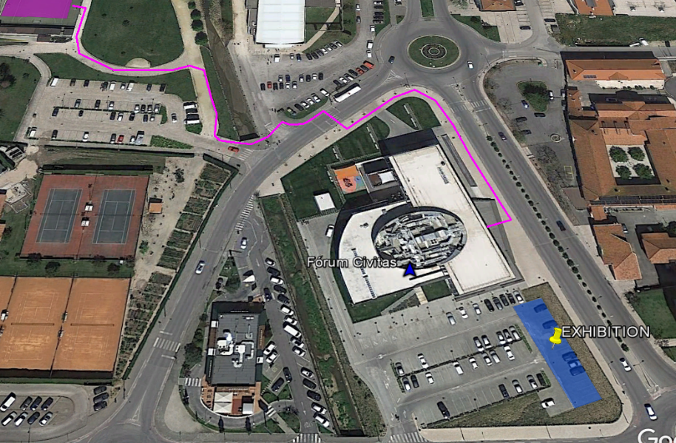
Exhibition stand pricing
- Exhibition space is free of charge for non-profit organisations and EC projects; equipment/furniture can be rented
- Exhibition space for commercial organisations is € 600 for the entire duration of the Forum Conference, and € 300 for Deployment Day only; equipment/furniture can be rented.

Further information regarding payment details, rental options and local logistics will be communicated to the applicants directly.
Timeline
18 May 2017 | Deadline to submit an application
5 June 2017 | Applicants informed of selection
27-29 September 2017 | CIVITAS Forum Conference

Shipment of material to the conference venue
All materials will have to be shipped to Torres Vedras in advance. The following steps will need to be followed:
- All materials will be shipped to the logistic centre of the municipality (address to be given to the applicants directly later)
- All packages will be transported to the conference venue on 25th September 2017
- All materials shipped to the conference venue need to be correctly identified with a CIVITAS Forum Conference label
- Information regarding the return shipping of materials will be discussed with the applicants at a later stage

- Deployment day programme
Exhibitors who would like the opportunity to have a two-way exchange with potential users of their tool or method can, as part of the CIVITAS Deployment Day, choose to showcase your tool/method through one of the listed below.
During the Deployment Day, conference participants will be able to sign up for your activity right at your exhibition stand which would act as “home base”. Next to the accompanying activity that will take place for a limited period of time during the Deployment Day, tool/ method owners can – via the “sign-in sheet” at their stand – offer time slots to present the respective tool/ method in more detail to interested participants.
As you will need a stand for these events, please fill out application form A and B.

Format | Description
Presentation at exhibition stand | In this format you would give a short – usually PowerPoint-based – presentation on your tool/ method at your stand. Presentations would be given repeatedly or “on-demand” for individual people or for a group of people. A “sign-in sheet” at the stand can be used to schedule presentations or to display a predefined schedule of presentations.
PechaKucha presentation at exhibition stand | In contrast to giving a traditional presentation at your stand you may present your tool/ method with a PechaKucha presentation consisting of 20 slides which are shown for 20 seconds each (6 minutes and 40 seconds in total). The slides typically consist of pictures only (or very limited text added) and the slides change automatically. Such a presentation can also be given repeatedly or “on-demand” for individual people or for a group of people. A “sign-in sheet” at the stand can be used to schedule presentations or to display a predefined schedule of presentations.
Speed-networking | This meeting format should encourage the take-up of the tool and method presented at your exhibition stand by accelerating contacts with potential customers through quick exchange of information. Generally, participants greet each other in a series of brief exchanges during a set period of time. During an interaction, attendees share their professional backgrounds and interests and the tool/ method presented at the exhibition stand could be explained via a short tutorial. This format should on the one hand help cities to find tools and methods to push forward sustainable urban mobility policies and measures, and on the other hand it should help tool and method owners to market their products. During the Deployment Day itself this would be managed by SATELLITE involving several tool/ method owners.
Study tour | In this format you would take out a group of people to walk around the city of Torres Vedras and visit points of interest on a predetermined route in order to demonstrate the application of the tool/ method presented at your exhibition stand. The study tour format can kick-off and/ or end with a short session of (PechaKucha) presentations.  The length of the study tour should be determined by the programme you are suggesting (typically it is longer than a walkshop). For this format you are encouraged to contact representatives from Torres Vedras in advance (via the CIVITAS Secretariat) to discuss the possibilities on what can be shown on site during the study tour. The aim should be to address and jointly discuss local urban mobility challenges in a constructive way.
Walkshop | In this format you would take out a group of people to walk around the city of Torres Vedras and visit points of interest on a predetermined route in order to demonstrate the application of the tool/ method presented at your exhibition stand. A walkshop should be more interactive than a study tour. Participants may be asked to observe and document what they see, e.g. by taking pictures and/ or videos or using other means of documentation such as social media tools. The walking component may be followed by a workshop component. During this workshop, participants’ observations could by pooled and discussed. Such an analysis of the results of the walkshop could consist of short stimulus presentations and open discussions which could take place in a meeting room.  The length of the walkshop should be determined by the programme you are suggesting (typically it is shorter than a study tour). For this format you are encouraged to contact representatives from Torres Vedras in advance (via the CIVITAS Secretariat) to discuss the possibilities on what can be shown on site during the walkshop. The aim should be to address and jointly discuss local urban mobility challenges in a constructive way.

Timeline
18 May 2017 | Deadline to submit an application
5 June 2017 | Applicants informed of selection
1st week of September 2017 | Telephone conferences to brief those organising and those involved in an activity (required, will be organised by SATELLITE); at the end everyone confirms their contributions to the Forum programme
27-29 September 2017 | CIVITAS Forum conference

APPLICATION FORM A – Exhibition stand

- Contact person
Name
Organisation
E-mail address
Phone
Project

- Company and product information
Company profile
(max. 300 words):
Product description
(max. 400 words):

- Type of space needed
Indoor or outdoor stand | Exhibition stand (during Deployment Day only)  Exhibition stand (during entire CIVITAS Forum conference)
Need for equipment | We will need a table at our stand  We will need chair(s) at our stand. Please indicate number: ____  We will need electricity at our stand
Additional space needed | If you require further space than just your exhibition stand, e.g. to present vehicles, please include information how much space you would need.

Notes:

Signature: Date:

APPLICATION FORM B – Deployment Day activity

Contact person
Name
Organisation
E-mail address
Phone
Project

Company and product information
Company profile
(max. 300 words):
Product description
(max. 400 words):

Your contribution
Type of contribution | Presentation at exhibition stand  PechaKucha presentation at exhibition stand  Speed-networking  Study tour  Walkshop  Other (Innovative approaches are encouraged! Please also explain concept in abstract below.)
Type of space needed | The exhibition stand will be the starting point of your activities suggested for the Deployment Day. Therefore, please indicate whether you would prefer an indoor or outdoor stand and the equipment you need at your stand. Additionally, please indicate whether you also need a meeting room, a starting point for an outdoor tour, or anything else.  Exhibition stand (during Deployment Day only)  Exhibition stand (during entire CIVITAS Forum conference)  We will need a table at our stand  We will need chair(s) at our stand. Please indicate number: ____  We will need electricity at our stand  Meeting room (small, 12-15 people)  Meeting room (large, up to 60 people)  Outdoor tour starting point  Other (e.g. if you need more space than just your exhibition stand – please include further information in your abstract below)
Abstract (max. 800 words):
Notes:

Signature: Date:

Please send your application by email to the CIVITAS Secretariat: forum.contributions@civitas.eu.

If you have any questions, please contact the CIVITAS Secretariat.

Contact:
CIVITAS Secretariat
c/o Regional Environmental Center (REC)
Ady Endre ut 9-11
2000 Szentendre, Hungary
Phone: +36 26 504046
Email: secretariat@civitas.eu

* Please note that CIVITAS SATELLITE will not cover any travel costs to the CIVITAS Forum conference.
** We would like to remind you that everyone who will attend the Forum conference 2017 (also those having an exhibition stand, etc.) should also register for the conference on the CIVITAS website. Registration is available here:
http://civitas.eu/civitas-forum-conference-2017

The outdoor area will be in a tent (i.e. protected from rain). A security service will ensure that the exhibition stands in the outdoor area will be guarded (also at night).
If you wish to only have a stand and not organise an accompanying activity please fill in the Application Form A.
The exhibition area will be in a tent (i.e. protected from rain). A security service will ensure that the exhibition stands in the outdoor area will be guarded (also at night).

