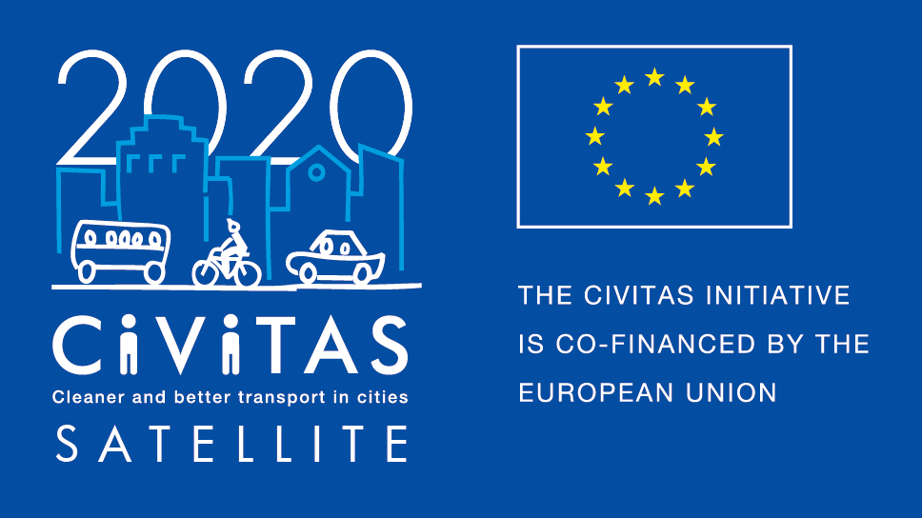
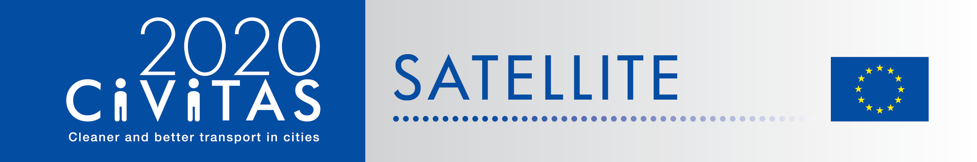
w

SATELLITE application form for visiting cities
Work Placement in Rethymno

Project Acronym: | CIVITAS SATELLITE
Full Title: Support Action Towards Evaluation, Learning, Local Innovation, Transfer and Excellence
Grant Agreement No.: | 713813
Deadline for application: 21 January 2019
Contact person: Melanie.Leroy@eurocities.eu

CIVITAS SATELLITE peer-to-peer activities in a nutshell

CIVITAS SATELLITE is an initiative designed to support cities in gaining better access to innovative solutions and to address transport challenges by applying exchange mechanisms for transfer and take-up.
Between 2017 and 2020, SATELLITE will organise at least 20 visits, in the form of work placements and study visits, for city representatives willing to learn from each other and to exchange extensively with each other.
Participants for these peer-to-peer visits will be selected each year through calls for expression of interest.

This form is for cities willing to take part as a visiting city to a work placement in Rethymno in September-October 2019.

If you are selected as visiting city, you :
- Will receive support for the preparation and the follow-up of the visit you will attend.
- Might be selected to receive financial support up to €700 to cover for travel and accommodation for a work placement or a study visit, after providing us with invoices.

Apply!
Do you want take part to CIVITAS SATELLITE peer-to-peer exchanges? Please fill in the application form by 21 January 2019 and send it back to Melanie.Leroy@eurocities.eu
- Contact person:
If you have any questions, please contact Melanie Leroy: Melanie.Leroy@eurocities.eu
(+32 2 552 08 81)

ADDITIONAL INFORMATION TO READ BEFORE APPLYING
- Work Placement in Rethymno
Rethymno is partner of the project CIVITAS DESTINATIONS. The city has adopted the principles of Sustainable Development since 2007, joined the Covenant of Mayors (2011), Mayors Adapt (2016) and Covenant of Mayors for Climate & Energy (2017); and included sustainable mobility as a priority pillar the Municipal Sustainable Energy and Climate Action Plan (SECAP). The work placement will be characterised by the following content: innovative dock (electromobility, sharing system, University’s communities, mobility plan for schools). During the visit different local/regional partners and stakeholders will be involved: Rethymno Municipality (DESTINATIONS partner), Technical University of Crete (DESTINATIONS partner), Public transport operators, Regional government, CIVINET CY – EL, Region of Crete, Ministry of Transport, Hoteliers Association, Chamber of Commerce, University of Crete, Technical Chamber of Greece.
- What is a work placement?
CIVITAS SATELLITE work placements offer transport professionals hands-on learning experience in another European city that leads in a specific area of sustainable urban mobility. These 3 day placements will focus on a concrete topic and respond to a local challenge faced by the applicant/visiting city. The main objective is to transfer practical knowledge and expertise from the host city to help achieve a specific objective. Financial support is available to cover travel and accommodation costs.
- Why join CIVITAS SATELLITE peer-to-peer programme?
If you are a visiting city, you will:
- Have hands-on experience in another city,
- Have the opportunity to exchange on a one-to-one basis with leading peers,
- Be promoted on the CIVITAS website and European-wide media outlets as a city committed to sustainable urban mobility,
- Be offered speaker slots at European level events,
- Be able to apply for the CIVITAS award in the Take-up category

- What will be the tasks of cities involved?
If you are a visiting city, you will:
- Define a detailed request for learning
- Identify a local challenge faced by your city
- Liaise with the SATELLITE team to agree on the objectives of the visit
- Write a short impact report describing new skills acquired
- Send all documents required for the reimbursement of costs (if selected for financial support)

CIVITAS SATELLITE Call for visiting cities (Work Placement in Rethymno)

- Fundamental information
Name of the city & Country
Structure & size | ☐ City  ☐ Metropolitan area  Population:
Are you member of the CIVITAS Community? | ☐ CIVITAS demonstration city  ☐ CIVITAS Forum network city  ☐ CIVINET member city  ☐ IA or RIA project partner city  ☐ None
Has your city been awarded an award for its work on sustainable mobility?  If yes, which one? | ☐ CIVITAS award  ☐ EUROPEANMOBILITYWEEK award  ☐ SUMPs award  ☐ Other (please specify)  ☐ My city has applied or has been short listed but not selected  ☐ None
Do you have recent experience of peer-to-peer exchange?  If yes please specify | ☐ Yes (Please specify below)  ☐ No

- Preparing the visit
Which period do you prefer for the activity? | ☐ September  ☐ October
What are the main reason(s) why you want to take part to a CIVITAS peer-to-peer visit?
Which challenge from your city do you plan to present to your host city?
How do you plan to do this?
Which key local/regional decision makers, project managers and/or stakeholders would you like to meet during your visit? Why?
Will you communicate about this visit? If yes how?

- Practicalities and joining instructions
Contact person(s) for the organisation of the visit | Name:  Position:  Telephone:  Email:  Address: | Name:  Position:  Telephone:  Email:  Address:
Can you confirm and make sure that your colleagues have a sufficient level of English to present their experience? | ☐ Yes  ☐ No
How did you find out about the CIVITAS SATELLITE work placement?
Other questions

Final declaration
I have the pleasure to inform you that the city of name of the city/region supports the participation of its staff in the CIVITAS SATELLITE initiative in [2018].
Place
Click here to enter a date.
Name
Position
City/region
NB: this form should be signed by the Mayor, the Vice-Mayor or the Director of the Transport department in your municipality

