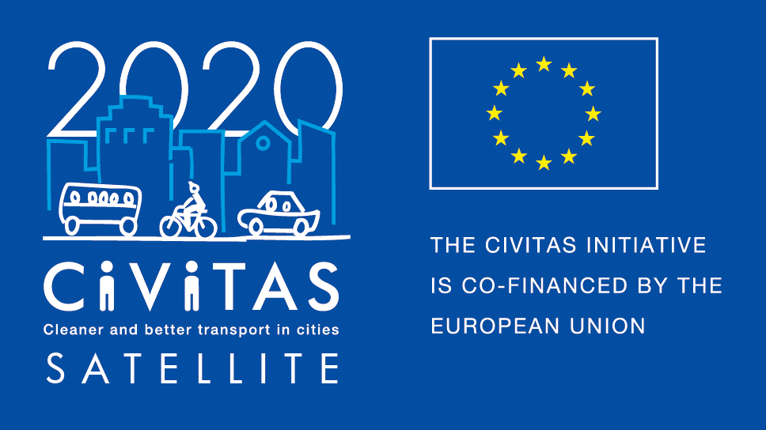
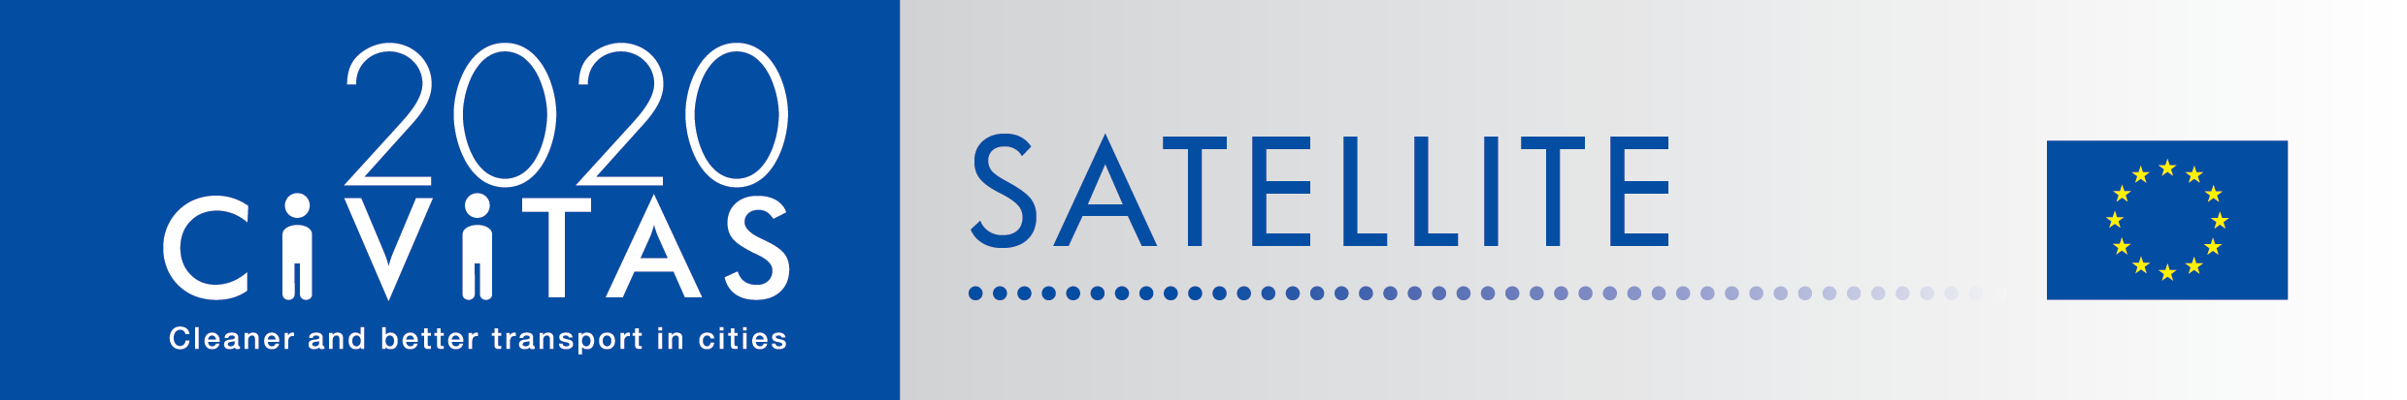
w

SATELLITE application form for visiting cities
Study Visit in Budapest

Project Acronym: | CIVITAS SATELLITE
Full Title: Support Action Towards Evaluation, Learning, Local Innovation, Transfer and Excellence
Grant Agreement No.: | 713813
Deadline for application: 21 January 2019
Contact person: Melanie.Leroy@eurocities.eu

CIVITAS SATELLITE peer-to-peer activities in a nutshell

CIVITAS SATELLITE is an initiative designed to support cities in gaining better access to innovative solutions and to address transport challenges by applying exchange mechanisms for transfer and take-up.
Between 2017 and 2020, SATELLITE will organise at least 20 visits, in the form of work placements and study visits, for city representatives willing to learn from each other and to exchange extensively with each other.
Participants for these peer-to-peer visits will be selected each year through calls for expression of interest.

This form is for cities willing to take part as a visiting city to the study visit in Budapest in June or September 2019.

If you are selected as visiting city, you :
- Will receive support for the preparation and the follow-up of the visit you attend.
- Might be selected to receive financial support up to €700 to cover for travel and accommodation for the study visit, after providing us with invoices of expenses.

Apply!
Do you want take part to CIVITAS SATELLITE peer-to-peer exchanges? Please fill in the application form by 21 January 2019 and send it back to Melanie.Leroy@eurocities.eu

- Contact person:
If you have any questions, please contact Melanie Leroy: Melanie.Leroy@eurocities.eu
(+32 2 552 08 81)

ADDITIONAL INFORMATION TO READ BEFORE APPLYING

- Study Visit in Budapest
Budapest: in the last years the city has played an important role inside international association, forum group and projects linked with urban mobility, furthermore it was awarded by different contests (European Mobility Week Award, Euro-China Green and Smart City Award) for its work on sustainable mobility. The study visit organised by Budapest will focus on: Urban Freight, Public/Citizen involvement, Community planning, Shared mobility and MaaS. During the visit BKK Centre for Budapest Trasport and all project managers, working in the R&D projects in which BKK is participating, will be involved as partners and stakeholders.

- What is a study visit?
CIVITAS SATELLITE study visits offer the opportunity for up to 10 city representatives from 10 different cities to travel to another European city facing similar challenges in sustainable urban mobility to learn about possible solutions and best practices. These 2,5-3 day study visit will be tailored to the needs of the participating cities and take an interactive approach, to facilitate in-depth exchange, and strengthen cooperation. City representatives will benefit from financial support covering travel and accommodation costs.

- Why join CIVITAS SATELLITE peer-to-peer programme?
If you are a visiting city, you will:
- Have hands-on experience in another city,
- Have the opportunity to exchange on a one-to-one basis with leading peers,
- Be promoted on the CIVITAS website and European-wide media outlets as a city committed to sustainable urban mobility,
- Be offered speaker slots at European level events,
- Be able to apply for the CIVITAS award in the Take-up category

- What will be the tasks of cities involved?
If you are a visiting city, you will:
- Define a detailed request for learning
- Identify (a) local challenge(s) faced by your city to present it/them
- Liaise with the SATELLITE team to agree on the objectives of the visit
- Write a short impact report describing new skills acquired
- Send all documents required for the reimbursement of costs (if selected to get some financial support)

CIVITAS SATELLITE Call for visiting cities (Study visit in Budapest)

- Fundamental information
Name of the city & Country
Structure & size | ☐ City  ☐ Metropolitan area  Population:
Are you member of the CIVITAS Community? | ☐ CIVITAS demonstration city  ☐ CIVITAS Forum network city  ☐ CIVINET member city  ☐ IA or RIA project partner city  ☐ None
Has your city been awarded an award for its work on sustainable mobility?  If yes, which one? | ☐ CIVITAS award  ☐ EUROPEANMOBILITYWEEK award  ☐ SUMPs award  ☐ Other (please specify)  ☐ My city has applied or has been short listed but not selected  ☐ None
Do you have recent experience of peer-to-peer exchange?  If yes please specify | ☐ Yes (Please specify below)  ☐ No

- Preparing the visit
Which period do you prefer for the visit? | ☐ 3-6 June  ☐ 17-21 June  ☐ 9-13 September
What are the main reason(s) why you want to take part to that CIVITAS peer-to-peer visit?
Which challenge from your city do you plan to present to your host city?
How will you do this?
Which key local/regional decision makers, project managers and/or stakeholders would you like to meet during your visit? Why?
Will you communicate about this visit? If yes how?

- Practicalities and joining instructions
Contact person(s) for the organisation of the visit | Name:  Position:  Telephone:  Email:  Address: | Name:  Position:  Telephone:  Email:  Address:
Can you confirm and make sure that your colleagues have a sufficient level of English to present their experience? | ☐ Yes  ☐ No
How did you find out about the CIVITAS SATELLITE visit?
Other questions

Final declaration
I have the pleasure to inform you that the city of name of the city/region supports the participation of its staff in the CIVITAS SATELLITE initiative in [2018].
Place
Click here to enter a date.
Name
Position
City/region
NB: this form should be signed by the Mayor, the Vice-Mayor or the Director of the Transport department in your municipality

