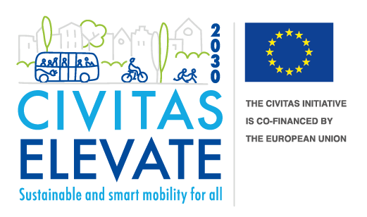
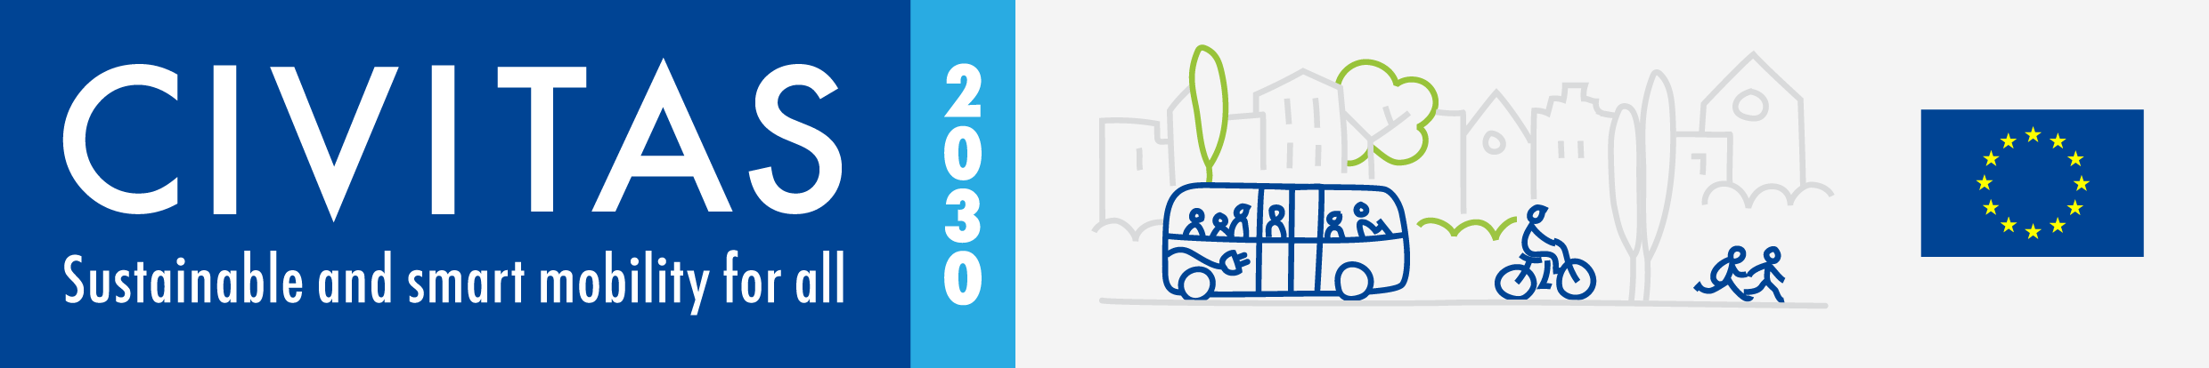

CIVITAS ELEVATE has received funding from the European Union’s Horizon 2020 research and innovation programme under grant agreement no. 824228.

Visual Story Competition Moving from the year of youth to the year of skills

Submission Form
Youth ages 18-27 are invited to share visual stories about sustainable mobility. Please fill in the following form to accompany your submission.
Please note that only the submitters’ name will be shared publicly. Other personal information requested in this form is collected only in order to communicate with submitters, and to issue prizes to the winners (i.e. Interrail tickets). Personal information other than submitters’ full names will not be shared, and will be deleted upon completion of the competition.

About you
First name: Click or tap here to enter text. Last name: Click or tap here to enter text.
Date of birth: Click or tap here to enter text.
Email address: Click or tap here to enter text.
The submitter must be a currently enrolled Bachelor, Master or PhD student at an EU institution. Name of the institution at which you are currently enrolled: Click or tap here to enter text.

Your submission
Please indicate to which question your submission responds (check all that apply):
☐ What would you like to see in the future of mobility?
☐ What would you definitely not like to see in the future of mobility?
☐ What skills do you need to achieve your dream mobility future?

Which CIVITAS Thematic Areas do you believe your story addresses? (check all that apply)
☐ Active mobility
☐ Behavioural change & mobility management
☐ Clean & energy-efficient vehicles
☐ Collective passenger transport & shared mobility
☐ Demand & urban space management
☐ Integrated & inclusive planning
☐ Public participation & co-creation
☐ Road safety & security
☐ Smart, sustainable, connected & shared mobility
☐ Urban logistics

Please indicate the following:
- How many visuals have you submitted (photos and/or illustrations), at least minimum 1 MB each? Click or tap here to enter text.
- Have you submitted the required written story line in English (250-500 words), which either connects or complements the visuals, and which answers at least one of the above-mentioned questions? Click or tap here to enter text.
- Does your submission include photos of people’s faces? Click or tap here to enter text.
  - If yes, have you submitted the required consent form signed by all individuals whose faces are recognisable? Click or tap here to enter text.

Please use the space below to indicate, in approximately 100 words, how the prize (a 1-month Interrail ticket) would help you advance your mobility career:
Click or tap here to enter text.

Please submit all visual materials, your written story line, signed consent forms, and this submission form via email to: communications@civitas.eu by the deadline of 27 February 2023, 17:00 CET.

Thank you!

