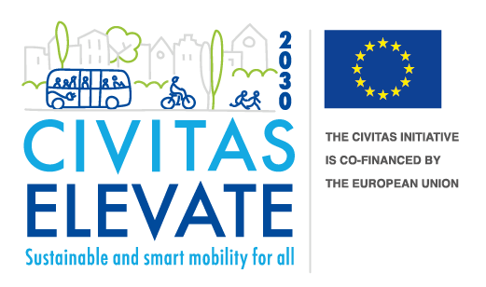
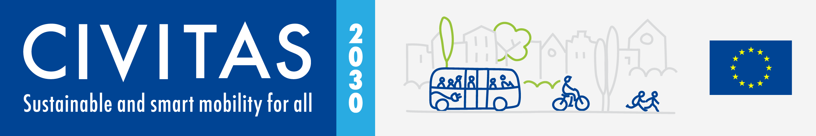

CIVITAS ELEVATE has received funding from the European Union’s Horizon 2020 research and innovation programme under grant agreement no. 824228.
Call for the re-activation of CIVINET secretariats in France, Poland, Spain, Portugal and Ireland

Call Information and Application Form
Table of Contents

1 Introduction 3
1.1 About the CIVITAS Initiative 3
1.2 About CIVITAS ELEVATE 3
1.3 About the CIVINETs 3
2 Call information 4
2.1 Introduction 4
2.2 Eligible applicants 4
2.3 Type of activities of a CIVINET secretariat 4
2.4 Available budget 5
2.5 Evaluation criteria 5
2.6 Timeplan 5
2.7 Future financial and non-financial support 6
2.8 Disclaimer 6
2.9 Helpdesk 6
3 Application form 7
3.1 Instructions 7
3.2 Information about the applicant 8
3.3 Vision and Added Value 9
3.4 Declaration 9

- Introduction

  - About the CIVITAS Initiative

CIVITAS is one of the flagship programmes helping the European Commission achieve its ambitious mobility and transport goals, and in turn those in the European Green Deal.
It does this by acting as a network of cities, for cities, dedicated to sustainable urban mobility. Through peer exchange, networking and training, CIVITAS fosters political commitment and boosts collective expertise, equipping cities to put mobility at the centre of decarbonisation. Since its launch in 2002, CIVITAS has advanced research and innovation in sustainable urban mobility and enabled local authorities to develop, test and roll out measures via a range of projects. A series of ten thematic areas underpin these.
CIVITAS supports cities to make smart and sustainable urban mobility a reality for all. In doing so, it is ensuring that mobility is a driving force behind the creation of climate-neutral and resilient cities. The CIVITAS Initiative is currently coordinated by CIVITAS ELEVATE.
For further information about the CIVITAS Initiative, please visit civitas.eu

  - About CIVITAS ELEVATE

CIVITAS ELEVATE supports the CIVITAS Community to increase its impact on urban mobility policy making and advance it to a higher level of knowledge, exchange, and sustainability.
As the current Coordination and Support Action for the CIVITAS Initiative, CIVITAS ELEVATE primarily engages in support activities to boost the Europe-wide impact of CIVITAS projects on sustainable urban mobility policy and assist the CIVITAS National Networks (CIVINETs). CIVITAS ELEVATE also has responsibility for the CIVITAS Secretariat.
CIVITAS ELEVATE is coordinated by Mobiel 21, and will conclude on 31 March 2023.

  - About the CIVINETs

CIVITAS National Networks (CIVINETs) are networks of cities and institutions that promote the CIVITAS approach at the local level.
Differentiated by region and clustered by language, CIVINET members work together to engage at both European and national levels on transport policy, legislation and funding. CIVINETs work independently but also cooperate with each other to share learning and experiences on sustainable urban mobility.
For more information about the CIVINETs, please visit civitas.eu/civinets
- Call information

  - Introduction

With this Call, a one-off “kickstart funding” in the amount of EUR 1,000.00 is available to support the re-activation of CIVINET secretariats in France, Poland, Spain, Portugal and Ireland, or in one or more language areas covering these countries.
Applicants are invited to submit a tangible plan to re-establish and to host a CIVINET secretariat in one of the mentioned countries.
Applications have to be submitted via e-mail to civinet@mobiel21.be by Friday, 04 November 2022, 17:00 Brussels time. It is mandatory to use this application form.

  - Eligible applicants

Engaged network partners, either private, semi-public or public from one of the respective countries and/or language areas related to France, Poland, Spain, Portugal and Ireland. Please note that only one new CIVINET secretariat per CIVINET will receive funding and that the same applicant cannot apply for more than one CIVINET.

  - Type of activities of a CIVINET secretariat

Typically, a CIVINET secretariat is in charge of administering the respective CIVINET and organising its activities on a daily basis, such as:
- Managing the membership registrations database of contacts, in adherence with applicable data protection legislation.
- Being the contact point for the respective CIVINET.
- Maintaining and broadening the CIVINET network.
- Organising respective CIVINET meetings and events.
- Being responsible for the financial management of the respective CIVINET.
- Managing the respective CIVINET website/webpage and/or other communication channels (eg, social media).
- Producing information material (brochures, newsletters).
- Being the main contact person for the respective CIVITAS Coordination and Support Action.
Furthermore, activities are expected to add value to the CIVITAS Initiative’s main assets and to adequately address aspects such as making transport systems and cities more resilient and better prepared to address the negative consequences of disruptive/unexpected events and/or to improve the accessibility and connectivity of vulnerable and excluded communities and social groups. Applications contributing to realising cleaner and better transport in cities, and that aid to the implementation of the European Commission’s Green Deal policy and other strategies are particularly welcomed.
  - Available budget

The maximum amount per application is EUR 1,000.00. Awarded funds will be paid in the full amount after negotiations and against a subcontract with Mobiel 21 as host of the respective Fund under CIVITAS ELEVATE.
According to Article 22.1.2 ‘Right to carry out reviews’ of the CIVITAS ELEVATE Grant Agreement, the Agency (CINEA) or the European Commission may carry out reviews directly (using its own staff) or indirectly (using external persons or bodies appointed to do so) up to two years after the payment of the balance. Therefore, all original invoices, tickets, receipts, pay slips, timesheets etc. have to be retained and be ready to present methods of overhead calculation as well.

  - Evaluation criteria

Deadline | If submitted after the deadline, or if substantial information about the applicant is missing, or if the declaration has not been provided, the application will be rejected.
Information about the applicant
Declaration
Vision | Maximum points | 50 | Treshold | 26
Added Value | Maximum points | 50 | Treshold | 26
 | Total points | 100 | Total Treshold | 52

  - Timeplan

Launch of Call | 18 October 2022
Submission deadline | 04 November 2022, 17:00 Brussels time
Conclusion of evaluation | 17 November 2022
Decision on funding | 22 November 2022
Negotiations* | 23 November 2022 – 09 December 2022
Signature of subcontract | 12 December 2022
Payment upon receiving invoice | 31 December 2022
CIVINET secretariat in operation | 01 January 2023

*During the negotiations phase, also all practical points will be discussed and agreed upon (for example, featuring the new CIVINET secretariat on the CIVITAS website, usage of the respective logo, etc.). These agreements will become an integral part of the respective subcontract.
  - Future financial and non-financial support

As CIVITAS ELEVATE will conclude on 31 March 2023, the next CIVITAS Coordination and Support Action will be responsible to provide substantial financial and non-financial support to all CIVINET secretariats, including the one/s that are funded via this one-off “kickstart funding”. The exact procedure for this will have to be discussed and agreed with the successor of the CIVITAS ELEVATE project.

  - Disclaimer

None of the funded applicants, who must base their proposals on the principles for best value for money and ensure the absence of any conflict of interest, will themselves serve as ‘contracting authorities’ or ‘contracting entities’ when utilising this Fund.
This Call is organised according to the internal procurement principles and rules of Mobiel 21, which are in line with the EU legislation in public procurement (Directives 2004/18/EC and 2004/17/EC or any EU legislation that replaces these directives). CIVINET secretariats will be treated as qualified subcontractors.

  - Helpdesk

For further information or enquiries please contact civinet@mobiel21.be
- Application form

  - Instructions

The following instructions should support the applicant to complete the application form. Parts that are marked in this colour are either meant as example or as placeholder, which have to be replaced / updated with the requested input.

General instructions
The application has to be provided in English language and only via this application form. Applications received in a different language or format will be rejected.
Chapter 3.2 | Information about the applicant
The applicant has to provide all the requested information via this table.
Chapter 3.3 | Vision and Added Value
The applicant has to explain, with no more than 500 characters, including blanks, their vision for a CIVINET in the respective country or language area, and how the activities as CIVINET secretariat would add value to the CIVITAS Initiative’s main assets, the implementation of the European Commission’s Green Deal policy and other strategies related to sustainable urban mobility, and the further types of activities as mentioned in Chapter 2.3.
Chapter 3.4 | Declaration
The applicant has to agree on the terms and to sign the application.

  - Information about the applicant

Information about the organisation
Name of the Organisation
Legal address
Street name and number
Town / City
Postal code
Country
Website
Contact person
Name
Organisation
E-mail
Phone
Legal representative (if different from the contact)
Name
Organisation
E-mail
Phone

  - Vision and Added Value

Provide your contribution here.

  - Declaration

☐ I, Firstname Surname, declare that I have provided all the information provided via this document correctly and to the best of my knowledge and belief. Furthermore, I declare that when accepting the awarded funding and entering into a subcontract with Mobiel 21 on behalf of CIVITAS ELEVATE, the CIVINET secretariat is ready to start from 01 January 2023, the earliest.

Signature |  | Place, dd.mm.2022

