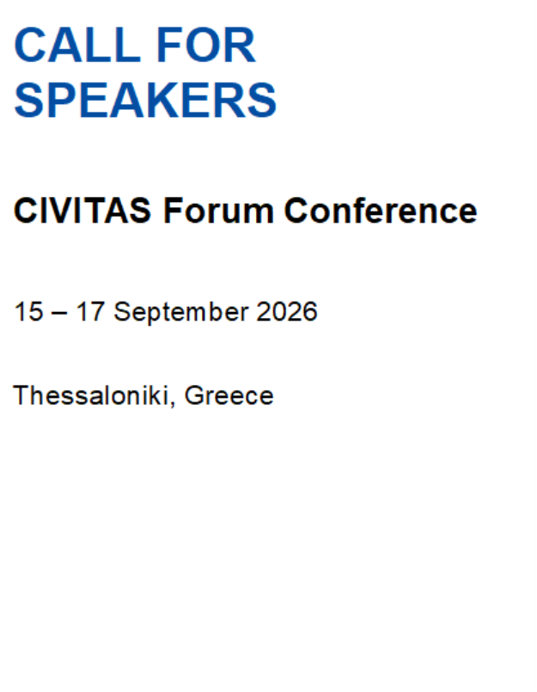
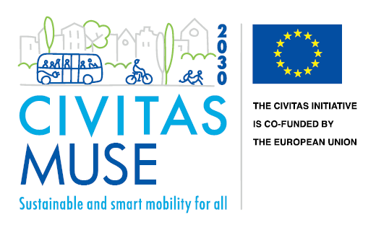


The CIVITAS Forum 2026
The CIVITAS Forum makes its return with a dynamic three-day conference, serving as the flagship event of the CIVITAS Initiative. Since its creation in 2003, the CIVITAS Forum has become an essential platform for participants to learn from leaders and experts of sustainable and smart mobility. It also promotes the sharing of ideas and helps build relationships among important players involved in transforming urban mobility across Europe.
The CIVITAS Forum 2026 will take place in the picturesque city of Thessaloniki, Greece, from 15-17 September 2026.

Why would you benefit from being part of the exhibition Forum?
Participating in the CIVITAS Forum 2026 offers many benefits for stakeholders. You can learn from top experts about the latest trends and best practices in sustainable and smart mobility. The forum also provides excellent networking opportunities, allowing you to meet and collaborate with important players in the urban mobility field.
Exhibiting at the forum gives you a chance to showcase your innovative solutions and projects to around 500 attendees, including city representatives, policymakers, and academics. This exposure can increase your visibility and influence, helping you make a bigger impact in transforming urban mobility across Europe.

The details – What is different this year?
This year’s CIVITAS Forum will feature an exhibition area designed around three main zones, reflecting the event’s evolving approach to engagement:
- Institutional Stands: Dedicated booths will be available for the main organisations that are funding and organising the CIVITAS Forum such as the city of Thessaloniki, the European Commission and the CIVITAS Initiative, providing a focused area for these entities to present their work.
- Networking Zones: These are informal, flexible spaces designed for one-on-one meetings and group discussions, fostering more dynamic and spontaneous interactions.
- Thematic Corners: This year’s call for exhibitors is focused on the thematic corners. Each thematic corner will be a collaborative space shared by different projects and stakeholders working within the same thematic area, fostering an environment conducive to discussion and exchange. This arrangement encourages meaningful interactions among exhibitors and visitors, promoting deeper engagement on specific topics. Additionally, this setup offers greater flexibility for exhibitors, as they will not be required to remain in the same space all day. Instead, small presentations can be scheduled in various timeslots, allowing exhibitors to showcase their work at designated intervals. Each thematic cluster will have a structured schedule, ensuring that all participants have the opportunity to present and discuss their initiatives while maximizing the benefits of shared space and collaborative engagement.
More specifications about exhibition area and equipment will be given at a later stage.
The CIVITAS Forum 2026 organising team kindly asks you to try to reduce the number of printing materials in your exhibition space. Let’s try to make an event with as little waste as possible!

Additionally, exhibitors will be featured on the CIVITAS Forum 2026 website. This online presence will provide further visibility and recognition for your organisation, allowing you to reach a wider audience beyond the event itself.

Note: Exhibitors selected for the thematic corners will be informed of the material submission specifications in the coming weeks.

Apply to be part of the Thematic Corners!
To guarantee your presence at one of the Thematic Corners, please fill in the form available below and send it via email to forum@civitas.eu by 29 May 2026!

Form (mandatory questions are marked with *)

Form
Type of Exhibitor * | CIVITAS Project Other
Identification *
Please identify the name of the project/Entity/Initiative you would like to promote/showcase at the CIVITAS Forum 2026
Content *
Please briefly describe the content you will showcase at the CIVITAS Forum 2026 and how it will be presented (e.g. presentation, video, mock-up, platform, interactive demo, promotional materials).
(Max. 400 characters)
Please indicate the thematic area(s) that best align with the project/ initiative/ organisation you intend to promote  (if applicable) | Active Mobility  Behavioural change & mobility management  Clean & energy-efficient vehicles  Collective passenger transport & shared mobility  Demand & urban space management  Integrated & inclusive planning  Public participation & co-creation  Road safety & security  Smart, Sustainable, Connected and Shared mobility  Urban logistics
Name of Person of Contact *
Organisation that the Person of Contact represents *
Email *
Phone *

Registration:
Please, take into consideration that your application to this questionnaire does not replace the CIVITAS Forum registration process. In this sense, if you wish to participate in the conference, please register at the following link.

Disclaimer:
The exhibition spaces and the thematic corners will be allocated by the CIVITAS Forum 2026 organising team, prioritising stakeholders from the CIVITAS community. You will receive an update from the organising team regarding your selection to be part of a thematic corner, at the latest, by 30 June 2026.

If you have any questions, please contact the CIVITAS Forum organising team at the following address: forum@civitas.eu

We look forward to seeing you in Thessaloniki!

