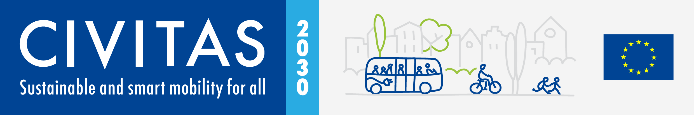

CIVITAS AWARDS 2022

CIVITAS Transformation

Call for applications

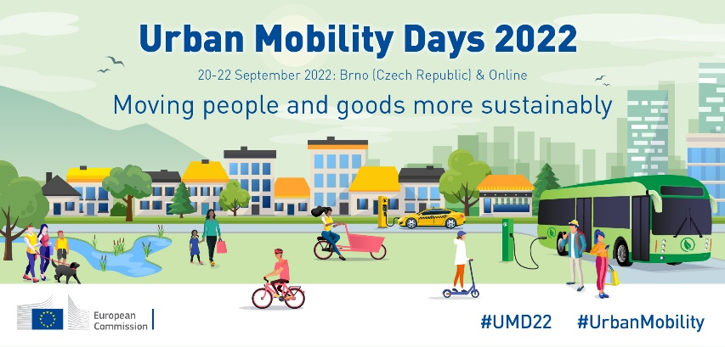
About the Urban Mobility Days Conference

The CIVITAS Initiative, established in 2002 by the European Commission, supports cities by developing and implementing sustainable urban mobility measures.
Attracting policymakers, local authorities, academics, NGOs, urban transport practitioners and more, the Urban Mobility Days provide a valuable opportunity to exchange knowledge on current mobility topics. The conference combines two leading events from Europe’s transport calendar: the CIVITAS Forum and the former European Conference on Sustainable Urban Mobility Plans (SUMPs).
With the theme “Moving people and goods more sustainably”, this year’s edition will make frequent links to the new EU Urban Mobility Framework. This event will also celebrate the 20th anniversary of the CIVITAS Initiative and the European Year of Youth.
© Pavel Gabzdyl
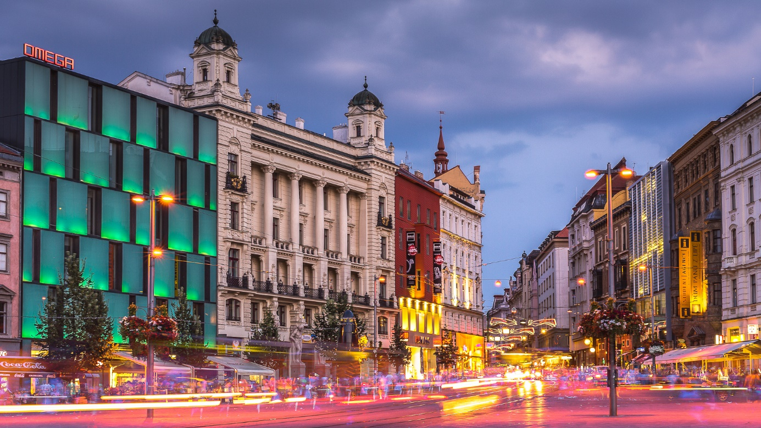
The 2nd edition of the Urban Mobility Days Conference will take place on 20-22 September 2022 in Brno (Czech Republic), in a hybrid format, allowing for participation in person or online.

Call for applications – CIVITAS Transformation

This document serves as a guide for submission for the CIVITAS Transformation Award. Please read this document carefully and only then submit the application form (available on page 6).
In case you need any assistance in this process, please feel free to contact the organising team at secretariat@civitas.eu.

Brief description
The CIVITAS Transformation Award category aims to demonstrate how an integrated set of mobility measures that a city implemented has transformed the city into a smarter and more liveable place. This award was established by the members of the CIVITAS Policy Advisory Committee (PAC) in 2016, and, following tradition, it is this same committee that will take the role of the jury.

Eligibility
The CIVITAS Transformation Award is open to all cities and municipalities that have signed the CIVITAS City Declaration and are members of the CIVITAS Network. If a candidate city is not yet a member, it must complete and sign the CIVITAS City Declaration to become eligible. Only one application per city will be considered.
Winners of the last two editions (2021 and 2019) of this award are not eligible for this category. PAC members’ cities are eligible to apply for the CIVITAS Transformation Award. However, PAC members cannot vote for their respective cities if they stand for election.
As part of the application, the city will also have to confirm that, at the time of signing, it is not under any relevant juridical ongoing/ pending legal proceedings at a National or European level. This will be validated in collaboration with DG MOVE and CINEA to confirm the eligibility of the application.

Evaluation criteria
To be rewarded, the application should demonstrate how an integrated set of implemented mobility measures has transformed the applicant city and helped make it a smarter and more liveable place. The approaches and solutions of the city should be clearly highlighted in the application form and justified with pictures (i.e. before/ after pictures), video(s), or other types of testimonial. The Transformation Award will honour the magnitude of the transformation realised. This transformation should have occurred in the last 2 years.

Jury Composition
The jury for this award are the members of the current PAC mandate (2020-2022), namely:

- Koen Kennis, Chair (Antwerp, Belgium);
- Grigoris Konstantellos, Vice-chair (Vari Voula Vouloiagmeni, Greece);
- Adelheid Byttebier (Schaarbeek, Belgium);
- Ana Oregi Bastarrika (Victoria-Gasteiz, Spain)
- Carl Hanssens (Sint-Niklaas, Belgium);
- Daniel Helldén (Stockholm, Sweden);
- Dejan Crnek (Ljubljana, Slovenia);
- Georgios Marinakis (Rethymno, Greece);
- Günter Riegler (Graz, Austria);
- Philip Broeksma (Groningen, Netherlands);
- Susanne Muller-Hubsch (Anderlecht, Belgium);
- Tiziana Benassi (Parma, Italy);
- Vasileios Tsiakos (Karditsa, Greece);
- Vasilena Mitsiady (Trikala, Greece).

Selection Process
The CIVITAS Transformation award winner will be selected by the Jury, based on the individual merit of the award application. The three finalist cities will be invited to make a video and invite a high-level politician to receive the recognition in person during the Awards Ceremony at the UMD2022, in Brno.

Prizes and benefits
High-level politicians representing the three finalist cities will be called on stage to receive a customised certificate, signed by a high-level representative of DG MOVE, recognising their city’s commitment to cleaner, more sustainable public transport. In addition to this moment of recognition on stage, the finalists’ videos will be shown in the presence of all the participants of the Awards Ceremony, this achievement will also be disseminated on the CIVITAS website and throughout the CIVITAS social media channels.
The representative of the winning city will receive a trophy, handed over by the PAC Chair (Mr Koen Kennis) on behalf of the Jury. After this moment, the representative will have the opportunity to say a few words to the audience.
Similarly to what happened in previous years, a dedicated webpage will be created on the CIVITAS website containing a short news item about the winner of each award, thus allowing the winning city to earn a place on the "wall of fame" of the CIVITAS Initiative.

Deadlines
 | Date/ Deadline
Deadline to submit the application. | 08/07/2022
Jury decision. | 05/08/2022
Announcement of the results to the candidates and consequent video request to the 3 finalists. | 09/08/2022
Finalists' video submissions. | 05/09/2022
Sharing of the finalists on CIVITAS' social networks | 12/09/2022
CIVITAS Awards Ceremony 2022 | 20/09/2022

This call deadline is 8 July 2022.
Apply bellow!

CIVITAS TRANSFORMATION AWARD
APPLICATION FORM

Please fill in this document completely and send it to secretariat@civitas.eu before the deadline. As explained above, photos, videos and other testimonials supporting this application are welcomed and should be sent to the same email address.

APPLICANT DETAILS
City *
Country *
Nº of city inhabitants *
Member of the CIVITAS Network since *
Name of contact person 1 *
Email *
Telephone *
☐* I hereby confirm that the persons with representative power of the city applying for this award are aware of their participation in the application process and agree to this submission.
☐* I hereby confirm that the information contained within this application for the CIVITAS Transformation Award 2022 is accurate and that the applicant town/city has no relevant ongoing/pending legal proceedings at the national nor the European level.”
Name of contact person 2 *
Email *
Telephone
* Mandatory answer.

Let us know why your city deserves to receive the CIVITAS Transformation Award 2022!
Please describe the integrated mobility solutions that have triggered a transformation in your city and made it a smarter and more liveable place.*
Please identify and describe those aspects of city liveability and connectivity that have been improved by the mobility measures implemented – use comparative examples and figures.*
Please describe the efforts undertaken to promote your accomplishments and achievements beyond your city.*
* Mandatory answer. Please try to stay below 300 words per response.

If any irregularity is detected at the time of its validation, the city will be withdrawn from the competition (regardless of the evaluation stage it is at).
The request for this video, and the respective requirements for it, will happen as a consequence of the announcement of the results to the candidates.

