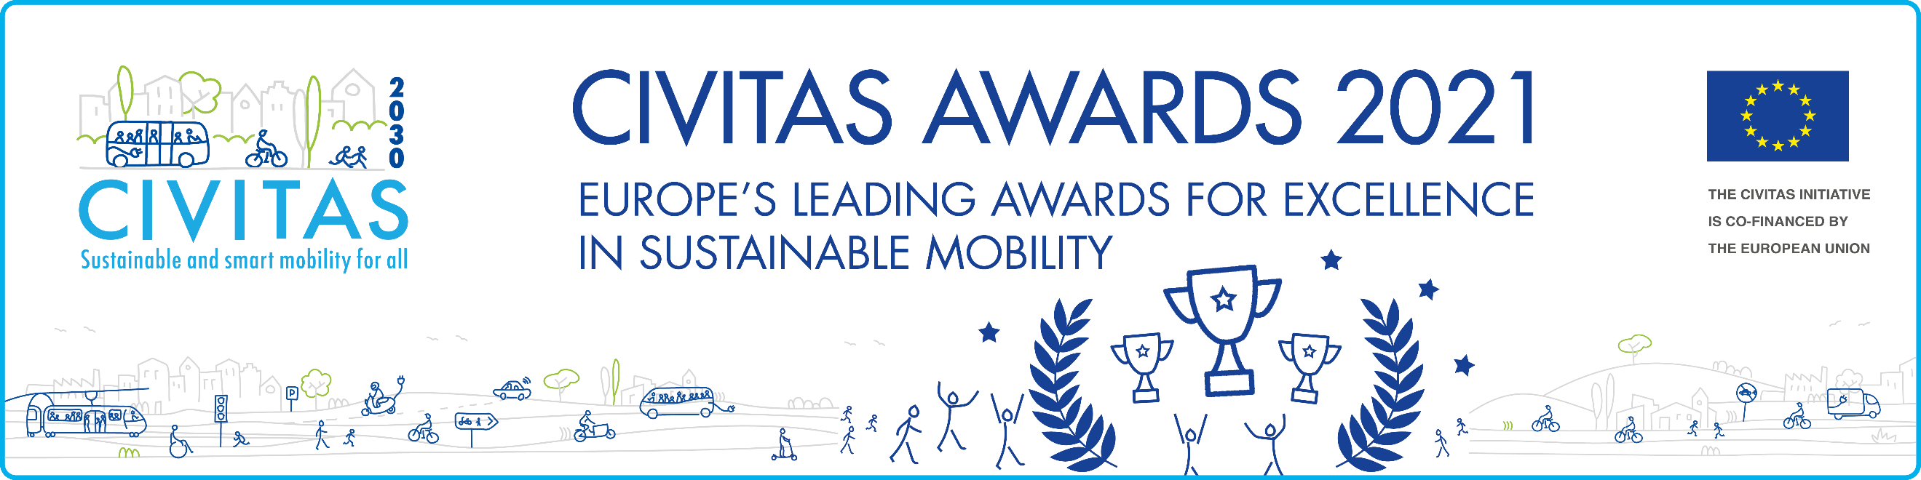
Eligibility
The CIVITAS Awards are open to all cities that have signed the CIVITAS Declaration and are a member of the CIVITAS Forum Network. In case your city is not yet a Forum member, please complete and sign the CIVITAS Forum Declaration. Cities may apply for all awards, but no more than one application may be submitted per award.

Evaluation criteria
Your application should demonstrate how an integrated set of mobility measures you have implemented has transformed your city, and helped make it a smarter and more liveable place. Your city’s approaches and solutions should be clearly highlighted in the application form and justified with pictures (i.e. before & after pictures), video(s), or other testimonials. The Transformation Award will honour the magnitude of the transformation realised. This transformation should have occurred in the last 2 years.

Selection Process
The award winner will be selected by the CIVITAS Award Jury, based on the individual merit of the award application. The Jury will be composed of independent and experienced experts in the urban mobility field, and individuals involved in the 2030 European mission towards climate neural cities. The results will be available in late September 2021.

This year’s CIVITAS Awards winners will be announced during the CIVITAS Forum Conference 2021, which will be held in a hybrid format in Aachen, Germany, and online.

The deadline to apply is 27 August 2021!
CIVITAS transformation award 2021
APPLICANT DETAILS

City* | Contact Person 1* | Contact Person 2*
Country* | Telephone* | Telephone
Number of city inhabitants* | Email* | Email*
Member of the CIVITAS network since*

Let us know why your city
deserves to receive the CIVITAS
TRANSFORMATION AWARD 2021

- Please describe the integrated mobility solutions that have triggered a transformation in your city and made it a smarter and more liveable place.* (300 words)
- Please identify and describe those aspects of city liveability and connectivity that have been improved by the mobility measures implemented – use comparative examples and figures.* (300 words)
- Please describe the efforts undertaken to promote your accomplishments and achievements beyond your city.* (300 words)

