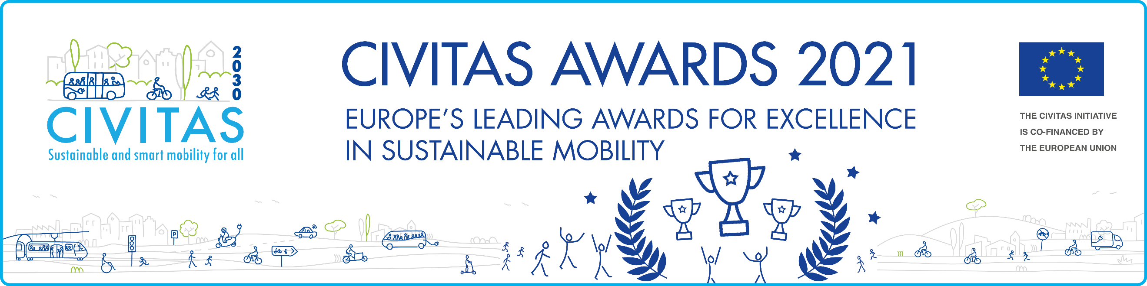
Eligibility
The CIVITAS Awards are open to all cities that have signed the CIVITAS Declaration and are a member of the CIVITAS Forum Network. Applications for this award are only open to cities that have been part of the CIVITAS Forum Network for at least 4 years. Cities may apply for all awards, but no more than one application may be submitted per award.

Evaluation criteria
Your application must clearly outline how your city has engaged with CIVITAS and successfully translated this into the long-term implementation of an innovative package of mobility measures. A winning application will demonstrate continuous implementation of ambitious policies dedicated to sustainable urban mobility over the last four years (or more); a clear vision regarding the long-term sustainability of the adopted approach; clear advocacy for the policies adopted; and active involvement in the CIVITAS Initiative over the last four years (or more).

Selection Process
The Legacy award winner will be selected by the CIVITAS Award Jury, based on the individual merit of the award application. The Jury will be composed of independent and experienced experts in the urban mobility field, and individuals involved in the 2030 European mission towards climate neural cities. The results will be available in late September 2021.

This year’s CIVITAS Awards winners will be announced during the CIVITAS Forum Conference 2021, which will be held in a hybrid format in Aachen, Germany, and online.

The deadline to apply is 27 August 2021!
CIVITAS LEGACY award 2021
APPLICANT DETAILS

City* | Contact Person 1* | Contact Person 2*
Country* | Telephone* | Telephone
Number of city inhabitants* | Email* | Email*
Member of the CIVITAS network since*

Let us know why your city deserves to receive the CIVITAS LEGACY AWARD 2021

- Please describe the innovative package of mobility measures and policies that your city has successfully implemented, including their long-term impact on city liveability.* (300 words)
- Please summarise your city’s legacy and commitment to the CIVITAS community over the last four years.* (300 words)
- Please explain your plans to encourage the replication of the measures and policies described beyond your city.* (300 words)

