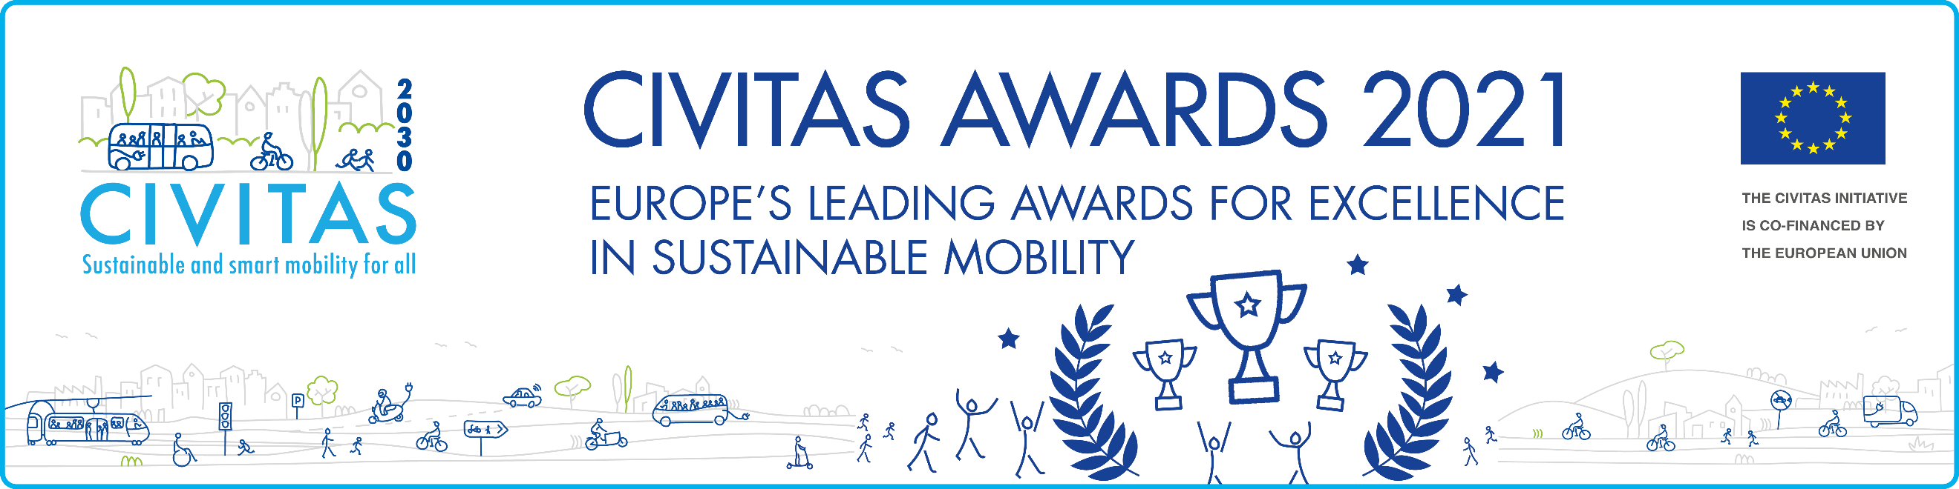
Eligibility
The CIVITAS Awards are open to all cities that have signed the CIVITAS Declaration and are a member of the CIVITAS Forum Network. In case your city is not yet a Forum member, please complete and sign the CIVITAS Forum Declaration. Cities may apply for all awards, but no more than one application may be submitted per award.

Evaluation criteria
Your application should identify innovative and high-impact measures that are being developed and/or implemented in your city, and may be considered an example to follow when it comes to the process of cities’ decarbonisation. Please, take into consideration that cities should present not only the pack of actions they intend to/are implementing, but also Key Performance Indicators (KPIs) to measure their impact, as accurately and reliably as possible. All measures and policies must produce effects by no later than 2030.

Selection Process
The award winner will be selected by the CIVITAS Award Jury, based on the individual merit of the award application. The Jury will be composed of independent and experienced experts in the urban mobility field, and individuals involved in the 2030 European mission towards climate neural cities. The results will be available in late September 2021.

This year’s CIVITAS Awards winners will be announced during the CIVITAS Forum Conference 2021, which will be held in a hybrid format in Aachen, Germany, and online.

The deadline to apply is 27 August 2021!
CIVITAS CLIMATE-NEUTRAL award 2021
APPLICANT DETAILS

City* | Contact Person 1* | Contact Person 2*
Country* | Telephone* | Telephone
Number of city inhabitants* | Email* | Email*
Member of the CIVITAS network since*

Let us know why your city deserves
to receive the CIVITAS CLIMATE-NEUTRAL AWARD 2021

- Please describe the innovative, high-impact package of mobility measures and policies that your city will implement, or is already implementing, in order to work towards becoming a climate-neutral city.* (300 words)
- Please indicated how you intend to measure the impact of the decarborisation measures your city will implement/is implementing (indicate the respective KPIs and milestones).* (500 words)

