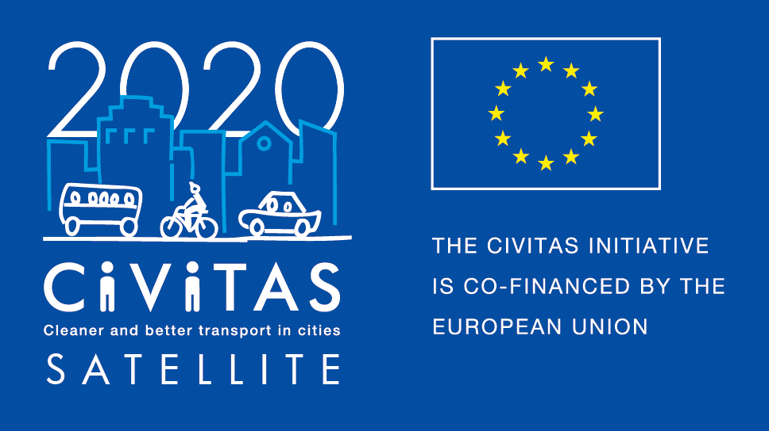
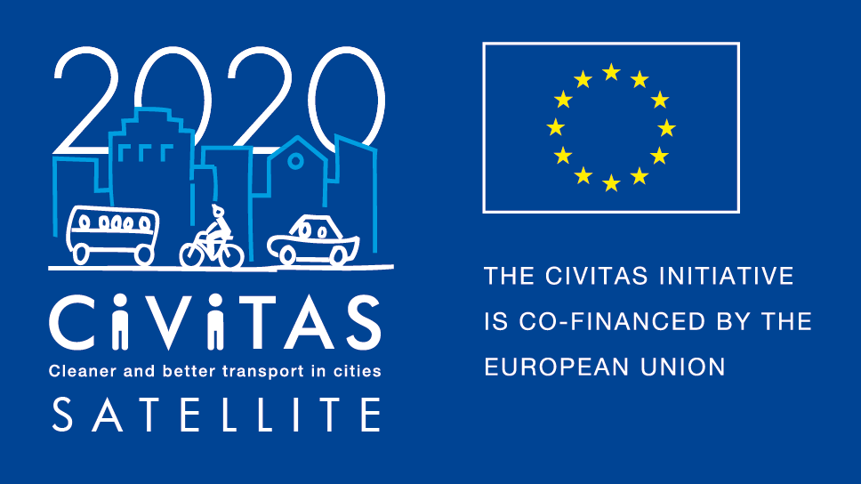
w
Study visit on cycling
Zagreb, 24-26/05/2017

Draft Agenda

Contact person
Darinka Jug
Zagreb Cycling Unit Coordinator, City of Zagreb
Phone: +385(0)916107735
E-mail: darinka.jug@zagreb.hr

Location
City of Zagreb
Smart Room, Level 1
Trg Stjepana Radića 1
Zagreb, Croatia

Wednesday, 24 May 2017 (Venue: Smart Room)
Time | Subject | Notes / Objectives
14:00-14:30 | Registration
14:30-14:45 | Opening and welcome by Dinko Bilić, Head of Transport, Zagreb  Introductions  Chair: Darinka Jug, Zagreb Cycling Unit
14:45–16:55 | Session 1  Laws and regulations governing cycling infrastructure  - Presentation by the City of Zagreb  - Group discussion, with opportunity for participants to present ‘Case Study’ from their city
16:55–17:00 | Closing remarks & summary
18:30–20:30 | Conference Dinner hosted by the Office of the Mayor of Zagreb

Thursday, 25 May 2017 (Venue: Smart Room)
Time | Subject | Notes / Objectives
9:00–13:00 | Expert Roundtable  - Greenway Project and Cycle Tourism in Zagreb  - Public Bikes  - Bike-on-Bus  Participating in this session will be experts from the City of Zagreb, NGOs and academics.  Each topic will be discussed for approximately an hour and the session will include a coffee/refreshment break.  Person, role
13:00-13:15 | Press Conference
13:15-14:15 | Lunch
14:15-17:00 | Site Visit  Areas to be visited will include examples of cycling infrastructure in the city and the Bike–on-Bus project
19:00–21:00 | Conference Dinner hosted by the Tourist Board of the City of Zagreb

Friday, 26 May 2017 (Venue: Smart Room)
Time | Subject | Notes / Objectives
9:00- 13:00 | Cycling promotion through events  - Key events in Zagreb  - Group discussion with all participants presenting examples from their cities.
13:00-14:00 | Closing remarks, thanks and lunch

Information for Participants
- Zagreb International Airport is approximately 30 mins from the centre of the city – buses operate every 1/2hour and taxi services are also available.
- The national currency of Croatia is the Kuna, money exchanges and Automatic Teller Machines or ‘Bank-o-mats’ are plentiful and all major credit cards are accepted.
- All presentations will be in English.
- All participants should arrive at the offices of the City of Zagreb between 14:00 and 14.30 on Wednesday, 24 May 2017 at:
City of Zagreb
Smart Room, Level 1
Trg Stjepana Radića 1
Zagreb, Croatia.
- For trips on the Zagreb bus and tram service participants will be given a free pass (this does not include the airport bus). Free public bikes will also be made available for participants.

For all inquires please contact Darinka Jug at darinka.jug@zagreb.hr or phone +385(0)916107735
Hotel
Pre-booking discount available through the city of Zagreb.
Information to be included
Map and directions to venues and hotels
To be included

