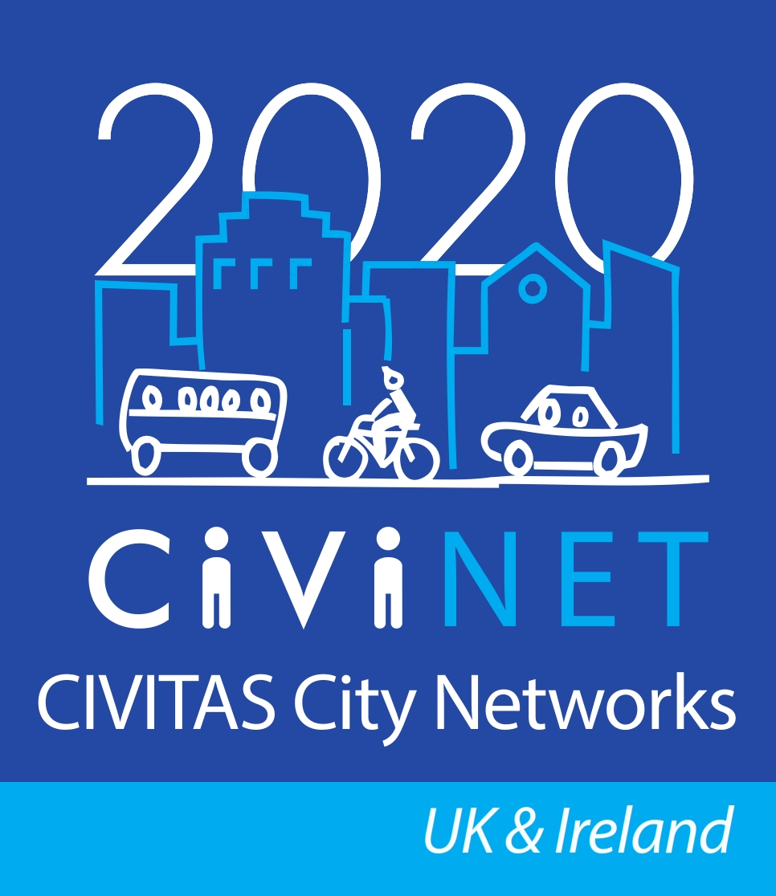
A training workshop on accessing EU funds for sustainable transport

9.30am – 14.20pm Thursday 21 January 2016

Conference Room, Ground Floor,
Victoria Quay, Edinburgh

Chair – Chris Hadfield, Lancashire County Council

Programme
9.30-9.45 | Registration and coffee/tea
9.45-10.00 | Welcome and participant introductions | Chris Hadfield  Project Manager, Lancashire County Council, and National Network Manager, CIVINET /  Participants
10.00-10.20 | An introduction to EU funding schemes relating to sustainable transport | Daniela Rosca  Head of Unit, Clean Transport & Sustainable Urban Mobility, DG Mobility and Transport (MOVE), EC
10.20.-11.20 | Group exercise:  The pros and cons of involvement in EU funding bids and projects:  - Discussion in two groups  - Report back to full group | Facilitator: Transport & Travel Research Ltd (TTR)
11.20-11.40 | Coffee/tea break
11.40-12.00 | Spotlight on Horizon 2020 | Stephen Alexander  Horizon 2020 Legal & Financial National Contact Point, Innovate UK
12.00-13.00 | Group exercise: Co-ordinating an EU bid  To focus on the PEACE INTERREG programme and bids to Transport Scotland for ERDF funding (Transport Scotland Strategic Intervention):  - Discussion in two groups  - Report back to full group | Facilitator: Transport Scotland
13.00-13.45 | Lunch
13.45-14.15 | One to one advice surgery with presenters and facilitators (TBC)
14.15-14.20 | Conclusion | Chris Hadfield, Lancashire County Council

