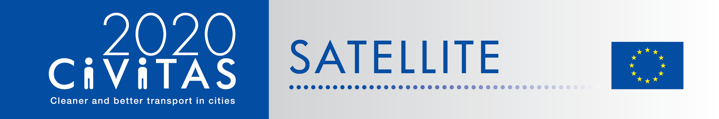
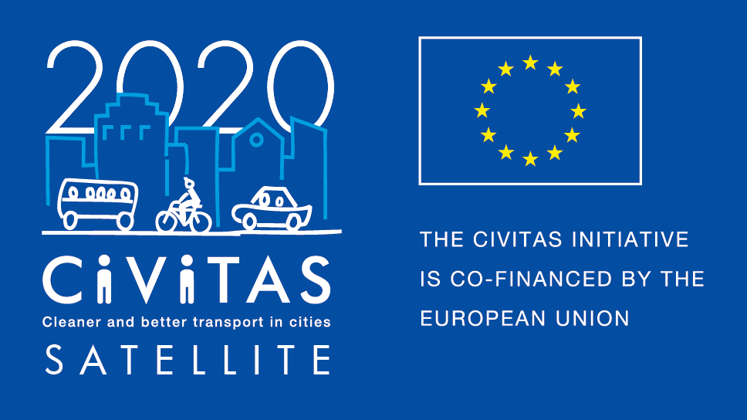
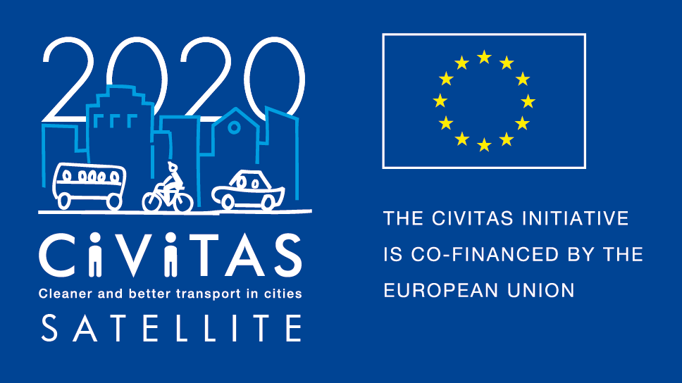
w

THE CIVITAS POLITICAL ADVISORY COMMITTEE

STATEMENT

PREPARING CIVITAS FOR THE NEXT DECADE

Dear Urban Mobility decision maker,

With this statement, we present our proposals to shape CIVITAS for the foreseeable future.

CIVITAS has delivered in the past, and can deliver on the EU’s new policy objectives. For almost 20 years CIVITAS has been a community of inspiration. The productive dialogue between local decision makers, transport practitioners and the EU’s institutions will continue to inspire the European urban mobility community.

To ensure this continuity, the CIVITAS community is preparing for the future. The initiative can be deepened (through increasing its involvement in research and innovation), broadened (by engaging with the EUROPEANMOBILITYWEEK community and further developing the CIVINETs), and made more tangible (by delivering practical tools and methodologies alongside policy dialogue). Overall, the impact of CIVITAS should increase and be made more obvious, by means of a common monitoring and evaluation framework.

CIVITAS can be seen as one element in a coherent chain of EU urban mobility initiatives (ELTIS, EUROPEANMOBILITYWEEK, EIP-SCC). In this way, CIVITAS can deliver on the EU’s policy objectives, i.e. decarbonisation and digitalisation.

We look forward to continuing to cooperate with you in the framework of CIVITAS, and promise to inspire ourselves!

Yours sincerely,

The CIVITAS Political Advisory Committee

Table of Contents

Why this statement? 9
CIVITAS has delivered in the past on local goals 10
CIVITAS can deliver against the EU’s new policy objectives 10
The CIVITAS Initiative: part of a coherent offer to European cities 12
Preparing the CIVITAS community for the future 12
About CIVITAS 2020 15
About the CIVITAS Political Advisory Committee (PAC) 15

Why this statement?
The CIVITAS community is concerned for its future. The CIVITAS stakeholders are aware that the initiative is unique: no other EU initiative has survived so long within the Framework Programmes for Research and Innovation and no other EU initiative combines the community building elements so well with research and innovation activities. The CIVITAS community is concerned, but also convinced that it can play a positive role within and for the EU to support and inform new policy goals: ‘CIVITAS has delivered in the past, and can deliver on the EU’s new policy objectives.’
With this statement, the CIVITAS PAC wants to inform the relevant institutional stakeholders (EU Council, European Commission, Committee of the Regions, European Parliament) of the potential that CIVITAS has to assist in realizing the EU’s new policy goals. The document is also drafted to inform the current discussions within the Partnership on Urban Mobility, set within the process to execute the Pact of Amsterdam (the Urban Agenda for the EU) and improve funding, better regulation and increase knowledge exchange with regards to urban issues.
CIVITAS has delivered in the past on local goals
The CIVITAS initiative was launched by the European Commission in 2002 to support ambitious European cities in introducing and testing ambitious and innovative measures to improve urban transport.
This support was granted by means of a unique combination of demonstration projects and community activities. To date, some 40 projects have been implemented under the banner of CIVITAS (including the 20 current CIVITAS 2020 projects) while some 275 cities today constitute the European CIVITAS Forum community. In addition, eleven CIVINETs involve cities at national and/or regional level, including many not already involved in EU research and innovation activities.
The CIVITAS Declaration – a non-binding voluntary agreement that defines a number of actions that cities wishing to join the CIVITAS Forum community can implement – encompasses practical and policy measures and focuses to a high degree on process elements (planning, integration) and inputs (the type of measures along within eight thematic categories. It requires of local decision makers to commit to making urban transport more sustainable, ambitious and innovative based on local conditions. The declaration has convinced some 275 cities in Europe to sign up, and to actively engage in ‘CIVITAS’ activities.

CIVITAS can deliver against the EU’s new policy objectives
Within the lifetime of the CIVITAS Initiative, global and EU policies related to urban mobility have grown in importance. The EU has increasingly addressed urban mobility (although there is no direct EU competence) across all its institutions (e.g. the EC through the Urban Mobility Action Plan, the European Parliament with its report on urban mobility).
In addition, policy targets have grown more concrete (for instance, the Transport White Paper’s vision to realise CO2 neutral logistics in cities by 2030). Policy guidelines’ detail has increased (e.g. the SUMP guidelines) and the effects and impact of urban mobility measures are growing in importance. We have also the EC’s endorsement of the WBCSD’s sustainable urban mobility indicators.
Step by step, the EU urban mobility policy agenda is changing towards a structured programme of deployment, supporting strategic EU goals. The CIVITAS PAC is confident that the CIVITAS Initiative can assist in realizing important aspects of this new policy agenda. The following is a list of strategic topics currently under discussion within the CIVITAS 2020 community:

- Low-emission mobility:
- In its 2016 communication, the EC describes this as an essential component of the broader shift to the low-carbon, circular economy needed for Europe to stay competitive and be able to cater to the mobility needs of people and goods.
- The CIVITAS Initiative has addressed clean fuels and vehicles from its onset, researching the applicability of several technologies, in new as well as in retrofitted vehicles. The current Innovation Actions PORTIS, DESTINATIONS and ECCENTRIC all have a clean vehicle component. The ELIPTIC project addresses electro-mobile systems and projects such as FLOW, EMPOWER, TRACE and CREATE look at decarbonisation through modal shift to active modes. Several CIVITAS measure categories, such as clean fuels and vehicles, and less-car dependent lifestyles, enable low-emission mobility.

- Digitalisation
- EC President Juncker identified Jobs, Growth and Investment and A Digital Single Market as the first two priorities for EU policy. The goal is to foster growth, competitiveness, jobs and the internal market, in particular through making better use of the opportunities offered by digital technologies. Specifically in the transport sector, such tools could improve the use of existing resources and the daily life of citizens: digital technologies are changing every aspect of mobility, including the way we book our journey, the value of transport assets, perceptions of travel time, employment conditions, and the management of traffic flows.

- In the realm of smart telematics, the CIVITAS community has addressed Intelligent Transport Systems (ITS) for public transport, traffic management and parking since the start of the initiative. Current projects such as TRACE and EMPOWER link up to the world of apps for mobility management and all rely on ITS to realise their solutions. The CIVITAS Initiative connects with Cooperative-ITS through its attention to big data and automated vehicles communities.

- Integrated planning: Sustainable Urban Mobility Plans and TEN-T
- In 2014, the EC published the SUMP guidelines. These guidelines are intended for urban transport mobility practitioners and other stakeholders involved in the development and implementation of a SUMP. The guidelines specifically refer to these plans’ role in reaching the European climate and energy targets set by EU leaders. In parallel, the EU has recognized the role of urban nodes on the Trans-European Networks for Transport as a constitutive element of the Trans-European Transport Network (TEN-T) in order to foster the integration of the network into urban circumstances like spatial structure, economy and regional development.
- SUMP is high on the CIVITAS 2020 agenda, with three projects (SUMPs-UP, PROSPERITY and SUITS) supporting their take up in over 200 cities. This +€10 million investment in SUMP development should help cities to be ready to plan for urban mobility investments in the post-2020 timeframe. From November 2017 onwards, the VITALNODES project will look into the networking of all 88 identified urban nodes on the TEN-T Network.

The CIVITAS Initiative: part of a coherent offer to European cities
The CIVITAS Initiative addresses policy priorities such as decarbonisation and digitalisation complementary to other European initiatives. CIVITAS fully commits to representing and serving a community with an interest in innovation and transition through the implementation of practical and policy-related measures that are emphasized through capacity building. In this way it builds on what EUROPEANMOBILITYWEEK accomplishes with respect to awareness raising and direct communication with EU citizens, while ELTIS serves information and the EIP-Smart Cities and Communities creates markets and accelerates take-up.

Preparing the CIVITAS community for the future
In order to position CIVITAS for the future, the PAC would like to make the following recommendations:

The CIVITAS Initiative can be deepened: CIVITAS has always thrived on its direct access to the knowledge and insights of EU funded research and development projects. As of 2014, the community has not only been connected to larger demonstration projects, but also to ‘knowledge generating projects’ (the so-called Horizon 2020 Research and Innovation Actions and Coordination and Support Actions). Twenty projects are now grouped under the CIVITAS 2020 umbrella. In the final years of Horizon 2020 and beyond, under the ‘Ninth’ Framework Programme for Research and Innovation, knowledge generated through research and innovation that has high urban relevance should involve the CIVITAS community (the ‘living labs’). Automated driving, Mobility as a Service and electrification are top of this list.

The CIVITAS can be broadened: Although there are over 275 cities that have signed the CIVITAS declaration, the community has the potential to grow in numbers. Specifically the PAC has already invited the EUROPEANMOBILITYWEEK (EMW) community (in which over 2500 municipalities undertake concrete actions as part of the annual citizens’ awareness raising campaign) and can repeat this invite biennially.
(This relationship can work both ways, for instance, a slot can be regularly accorded to EMW on the annual CIVITAS Forum agenda).
Another important channel to broaden the reach of CIVITAS are the CIVINETs. CIVINETs are national and Euro-regional city networks that promote the CIVITAS approach at the local level, overcoming language and contextual barriers for local authorities and organisations interested in urban sustainable mobility. Members exchange information in their own language and work together to engage with the European Union and national governments over urban mobility issues in regards to policy, legislation, regulation, and funding. With the current expansion of the CIVINET community by three new CIVINETs, the PAC expresses its hope that the CIVINET funding mechanism can be enhanced on short notice, in order to increase the CIVITAS impact.

CIVITAS will increase and measure impact: Almost 20 years of EU action on urban mobility with and for cities have changed daily practices in policy making, mobility planning and management. Throughout the CIVITAS Initiative, evaluation and monitoring has produced tangible facts and figures as to the impact of the activities undertaken. But more can be done. The introduction of a common monitoring approach by means of the WBCSD urban mobility indicators, and a common evaluation approach (CIVITAS evaluation framework) will deliver insight in regards to the effectiveness of urban mobility measures. These tools are aimed at achieving local as well as EU policy objectives so as to inform local and EU decision makers.

CIVITAS will continue to inspire the European urban mobility community
Since its inception, the CIVITAS Initiative has fostered the exchange of dialogue between local decision makers, with the goal being to inspire and create a common, European understanding of urban mobility problems and solutions. This political ‘spark’, the creation of a trustworthy environment where success and failure can be shared between decisionmakers is also an important element of CIVITAS that should be in the years to come.
The PAC will ensure a direct dialogue with decision makers in cities that are part of the CIVITAS 2020 project consortia, and will discuss themes pertinent to today’s challenges and the experiences of the CIVITAS community at its annual politicians’ forum. As a consequence, the CIVITAS Declaration will be updated through a collaborative process to better capture current and future urban mobility challenges. The PAC will continue to translate the needs of cities up to the EU’s decisionmakers.

About CIVITAS 2020
CIVITAS is the EU’s longest standing urban mobility initiative, involving over 275 European cities. Since it was launched by the European Commission in 2002, the CIVITAS Initiative has tested and implemented over 800 measures and urban transport solutions as part of demonstration projects in more than 80 ‘Living Lab’ cities Europe-wide. The current phase of the CIVITAS Initiative is called CIVITAS 2020.
Twenty HORIZON 2020 research and innovation projects on urban mobility operate within CIVITAS 2020. These research projects look at ways of building a more resource efficient and competitive transport system in Europe. The research and innovation projects deliver the basis for community activities within the CIVITAS Forum, a network of cities for cities dedicated to cleaner, better transport in Europe.

About the CIVITAS Political Advisory Committee (PAC)
The PAC is a small group of committed politicians that acts as the steering group of the CIVITAS initiative and network of cities. Its members participate in a personal capacity. PAC members are mainly responsible for:
- Delivering policy recommendations to the European Commission (EC)’s Directorate-General for Mobility and Transport (DG MOVE) – such as this PAC statement;
- Facilitating cooperation between the EC and the CIVITAS city network, and CIVINET national and regional networks;
- Taking part in key CIVITAS activities, including study tours, peer reviews, and thematic working groups;
- Ensuring and strengthening the involvement of politicians from CIVITAS cities in the initiative's activities.

According to regulation 1315/2013 of the EU, article 3 (p), "urban node means an urban area where the transport infrastructure of the trans-European transport network, such as ports including passenger terminals, airports, railway stations, logistic platforms and freight terminals located in and around an urban area, is connected with other parts of that infrastructure and with the infrastructure for regional and local traffic."

