Title | ITS for traffic-monitoring, management and enforcement
Author | DTV
Peer-review
Proof-reading
Copy-editing
Date of version | 04 July 2016

CIVITAS INSIGHT

ITS for traffic monitoring, management and enforcement

The purpose of traffic management is to inform, guide and if necessary direct road users. It is a management process that contributes to achieving policy objectives. Policy objectives in the urban context that ITS and traffic management can contribute to are for example: Accessibility of the city., a clean environment, low energy use, a safe city, and attractiveness of the city for tourists.

What is ITS for traffic - monitoring, management and enforcement about?

Cities throughout the EU are working on Sustainable Urban Mobility Plans (SUMP’s), these plans include measures aimed at improving the sustainable mobility in cities. ITS can play a crucial role when it comes to creating mode shift towards more sustainable modes of transport, but also when it comes to reducing pollution from vehicles by smart monitoring and management of the infrastructure and its use. Dynamic traffic management can e.g. reduce the number of starts and stops of trucks and passenger cars traveling in a city and as such be an effective measure to reduce polluting emissions. In addition, ITS contributes to the overall policy goals of improving accessibility, liveability and traffic safety.
Basically ITS provide 5 types of services:
- Flow control: this is an option for relatively minor (throughput) bottlenecks, for which you want to achieve a calmer traffic situation by smoothening the traffic flow.
- Traffic flow redistribution: this is an option when there are throughput bottlenecks, and here are alternative roads and routes available.
- Traffic and travel demand control: this goes a step further than the previous two services in that you want to control traffic and travel directly, e.g. by discouraging people to travel, encouraging them to use another mode of transport or choose another departure time.
- Road capacity control: this service goes furthest. Extra capacity is offered to (part of) the road users. Usually the local effect on traffic flow will be considerable, but there may also be effects on other parts of the network.
- Information: this category comprises services (not falling under one of the other service groups) that provide information to travellers.
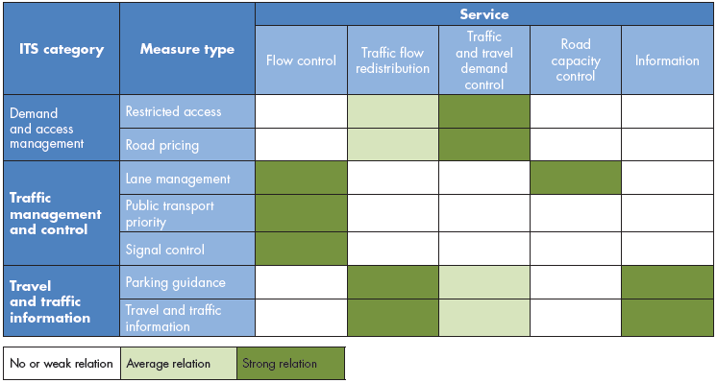
To gain some insight in the contribution of these services to policy goals, these services have to be further specified into measure types. The first table below shows an overview of services and measure types and the relation (strong in dark green, weaker in light green) between them. The second table shows the relationship between the measure types and the goals cities might have.

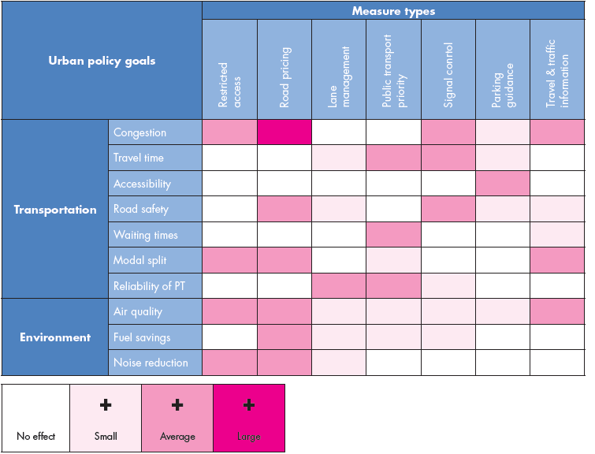

CIVITAS provides significant efficiency benefits for both public and private transport

Intelligent transport systems (ITS) could make an effective contribution to the sustainable city goals of CIVITAS. The suite of traffic and congestion monitoring and management systems such as traffic control centres can facilitate access control and route guidance systems offering instruments to ‘steer’ traffic to desired routes and locations. At the same time, they can be used to influence traffic demand. From the private side such systems offer sustainability benefits as well. Goods delivery companies often introduce ITS because they can optimize trips with the combination of global positioning system (GPS) technologies and supply chain management and operations. Such systems have significant efficiency benefits for both public and private transport. The CIVITAS Initiative’s Thematic Group on Transport Telematics provides a number of resources, such as training and guidance materials, policy recommendations, and learning opportunities such as trainings, study tours or workshops. The group allows also getting in contact with the city officials and experts of the presented best practices.

CIVITAS PLUS | Utrecht (The Netherlands): Clean route planning for freight transport
In December 2009, Utrecht Launched the “Air Quality Action plan” of the City of Utrecht (ALU Actieplan Luchtkwaliteit Utrecht). The plan set out an ambitious goal: Clean air, an accessible city, and sustainable growth. One of the measures aimed to contribute significantly to these goals was a CIVITAS funded measure: “clean route planning for freight traffic”. The measure focused on defining a method to guide, in real-time, freight traffic along routes that are less congested, based on air quality measurement. On a strategic level the objective was to achieve a better and more efficient use of the regional network and to improve reliability of travel times. The measure specific objectives were:
- To determine the feasibility of guiding road freight traffic along routes that are most appropriate at that particular time, based on the real-time air quality situation.
- Adapt route planning based on real-time air quality situation.
- To improve the air quality in zones covered by the measure.
Utrecht aimed for a highly innovative measure: road traffic management based on air quality; linking with navigation and route-guidance systems. At the time of the project there were many navigation systems on the market, yet applications that were specifically dedicated to guiding freight traffic; including “real time” information on road conditions were rather scarce at the time. Systems that guide freight traffic based on local air quality were innovative at the time and still are today. Research has been carried out on the feasibility of guiding trucks away from much polluted roads towards routes that are suffering less from emissions. Assessing the current state of technology was the first step in the process of implementation. From September 2010 till April 2011 an investigation in to the feasibility and available technical possibilities for clean route planning for freight transport was conducted. The results of the study were clear:
- It showed that the potential of the measure and the ex-ante analysis showed that the measure would contribute to reduction of traffic pollution on the city level.
- The report provided a technical basis for the further stages of the measure.
- Following a go/no go decision, work was carried out to test the standard route planner for freight traffic (the so called TLN-planner) that calculates emissions. The tests should lead to insight into how the planner performs, and if improvements are possible. The report should give the market detailed insight into how to develop an application which measures the air-quality. A navigation application for cellular phones is in production and is foreseen to be available on the market in 2013.
The measure aimed at preparing the ground for the implementation of a rerouting device for freight transport at given routes in the city center taking into account the “real time” level of congestion, and air quality. The actual application was never developed so impacts can only be assessed of simulated on an ex-ante level, the ex-ante analyses showed that the measure would contribute to reduction of traffic pollution on the city level.

CIVITAS PLUS II | Stuttgart (Germany): Emission based traffic management
In 2012 the city of Stuttgart faced a huge air quality challenge. The large amount of car trips in the city combined with the geographical characteristics (basin-like surface), resulted in high levels of local air pollution. To maintain continuous low-level movement of traffic by decreasing stop-and-go incidences the city introduced a dynamic (i.e. constantly shifting) speed limit to help address air pollution levels. At the same time the measure also lessens any negative effects on pedestrians, public transportation and bicycle traffic. Equally important, the priority traffic network should be maintained to avoid crowding of surrounding residential areas.
The municipality implemented a dynamic speed advice measure in the Cannstatter Strasse. This measure involved constantly changing signposted messages and will show the car driver the 'right' dynamic speed required to get to the next green traffic light. The dynamic speed changes according to traffic-light programming and includes traffic jam recognition. This measure can be considered a soft measure. Measurements of indicators taken before the implementation of the measure, including traffic volumes, travel times, noise and air pollution indicators have all been completed. The second pre-measuring after the implementation of the measure Cannstatter Strasse and before the implementation of the 2MOVE2 test site, including traffic volumes, travel times, noise and air pollution indicators was done in May 2014.
Expectations of the test site in the Cannstatter Strasse were high. However, an expert report on a similar test site in the Hohenheimer Strasse in Stuttgart has revealed that reducing the braking and acceleration process on an inclined road can also reduce emissions (NO_{x}). Furthermore, the results show that the negative effects on traffic migration into residential areas are non-existent. Based on the results of the Cannstatter Strasse it is expected that pollutant emissions are reduced significantly, especially during rush-hour. For NO_{x} a 10 percent reduction is expected and for PM10 a 15% reduction is expected. The measure will also provide a micro simulation on the peak hours. This also involves safeguarding the primary road network in order to avoid migration of traffic to residential areas. Another important objective is to raise public awareness for the measure. At this moment (July 2016) no further results are communicated and this is an ongoing measure in Stuttgart.

CIVITAS PLUS II | Malaga (Spain): Intelligent traffic control and software development for Management Centre of Mobility (MOVIMA)
On a working day 50% of the urban trips that take place are made by a motor vehicle, of which 61% are private car trips. To supervise and control all this traffic Malaga has an integrated traffic control centre in Malaga (MOVIMA). In case of incidences (accidents, roadworks, etc.) the traffic controllers intervene with daily traffic and make sure hours lost for traffic are reduced as much as possible. Since 2012 new European limits also requires the measures taken by traffic controllers to contribute to a reduction of emissions in the city centre.
To reduce pollutant emissions in the city Centre Malaga aims to implement ITS measures aimed at:
- Reducing stop-and-go traffic.
- Reducing/adapting speed.
- Maximizing the reduction of emissions through traffic control (NOx, PM10).
As part of the CIVITAS 2MOVE2 project the city of Malaga has implemented the following tools:
- A traffic incidents control system in order to reduce “stop & go” traffic. This included a traffic congestion prediction algorithm that will be included within the system for the dynamic control of vehicles traffic. The traffic congestion prediction will offer a new conceptual approach for traffic management, which will allow making forecasts and planning preventive measures instead of carrying out solutions after the congestions formation.
- Software to monitor and control sustainable mobility indicators related to the sustainable urban mobility plan (PMMS 2011-2025).
The measures are currently under implementation. The technical systems - such as cameras and associated software for traffic intensity prediction – have been acquired and are in operation. The implementation was prepared by means of an evaluation of the baseline situation and a benchmark study on ITS solutions. The impact and process evaluation still have to be conducted. To evaluate the baseline situation a traffic flow study was performed. In this study the traffic volume and congestion in the main road network of the city were analysed. Reference indicators such as the average trip duration of private motorized vehicles, average trip length, average number of stops during the trip, and average circulation speed, etc. were measured. A benchmark study on ITS solutions used by other cities at European level was carried out, identifying those technological options and traffic control solutions which could be better implemented according to Malaga objectives.

What is happening now?

The field of ITS is emerging into next generations of development: ‘connected’, ‘cooperative’ and ‘automated’. Through these phases ITS facilitated connections (communication) between individuals and systems (in car and road side). Enhanced by smart technologies cooperation becomes possible. For instance, traffic lights are able to communicate with an approaching vehicle and vice versa. The next step is automation. A situation where (certain) driving tasks become automated and little/no human intervention is necessary anymore.
In this context in April 2016 the Ministers of Transport of the 28 member states of the EU signed the Declaration of Amsterdam on cooperation in the field of connected and automated driving Navigating to connected and automated vehicles on European roads. In this declaration the Ministers agree on a set of steps that are needed to develop automated driving technology in the EU. With this declaration, which is an initiative of the Dutch precedency of the EU, the individual member states, the European Commission and the industry cooperate to develop rules and regulation aimed at enabling automated driving.
Currently all kinds of new technologies and innovations are implemented and tested. Looking at the Figure below, we are currently moving from the connected technology phase to entering the cooperative phase. In the connected phase cellular technology is used to generate an individual advice based on available information. In the cooperative phase so called Wi-Fi-P beacons are used to generate more real-time advice, this also allows for vehicle to vehicle information. Complexity in these developments are the arrive at common standards and architectures. These are relevant to make the systems work regardless the country or city of implementation.
One of the European initiatives is the Cooperative ITS Corridor Rotterdam – Frankfurt/M. – Vienna. Part of this corridor has been equipped with roadside cooperative ITS infrastructure. The EU Member States the Netherlands, Germany and Austria have signed a Memorandum of understanding to realize this new technology in close cooperation. In addition, industry committed to the deployment of the corridor and promised to bring the first vehicles and telematics infrastructure onto the market starting 2015. Two cooperative ITS services are first planned for use: Roadworks warning systems (RWW) and Probe Vehicle Data (PVD) vehicles transmit data about the current situation on the road to the roadside infrastructure and the traffic control centers. In both cases, communication from the vehicle and infrastructure is established via short range communication (Wi-Fi 802.11p, 5.9GHz) or the cellular network (3G, 4G). Both initial applications increase road safety and provide the basis for an improved traffic flow and reduced emissions.
In the different member states connected services have been tested and implemented. Here different connected services are provided to reduce shockwave traffic jams. Smartphone applications provide users with speed and traffic advice aimed at reducing the Shockwave traffic jams. These jams are caused by shockwaves that are the result of driver behaviour on busy roads. If one driver has to brake suddenly, this could result in a chain reaction of suddenly braking traffic. The shockwave traffic jam service consists of a smartphone app where participating motorists are given personal in-car advice about the ideal driving behaviour and ideal driving speed to prevent shockwaves. Currently 1200 users are equipped with the cooperative technology, this requires them to have a talking traffic kit on-board. This kit allows the on-board unit (smartphone) to connect to the Wi-Fi-P beacons.

Future outlook

The future of Intelligent Transport Systems is highly uncertain. On the one hand ITS seem highly promising in reducing road congestion, traffic danger and environmental stress. However, up until now, large scale real-world implementation of ITS has been a slow process. On the other-hand the recent Final Report of the EU’s C-ITS Platform indicated that the technology is ready to be implemented, but implementation is hampered by several general barriers for implementation:
- First, a unique legal and technical framework is essential and coordinated efforts to ensure quick uptake of C-ITS are requested;
- Second, the technology is ready, the industry is already deploying C-ITS equipped vehicles in other parts of the world and announced to be ready to deploy in the EU by 2019, provided that the above-mentioned framework is in place sufficiently in time;
- Regarding access to in-vehicle data and resources, a scenario-based analysis on legal, liability, technical and cost-benefits aspects is required to further progress and also to help answering legislators' request regarding an open-access platform.
The above said, technical developments are advancing quickly. Cellular technologies and the introduction of the smartphone enabled new possibilities for ITS. Hand-held devices with ITS applications are more common than ever and fast data connections in combination with real time open data allow for all kind of services that a decade ago were almost beyond imagination. In the past years, new automotive manufacturers entered the market (Tesla, Google, Apple, etc.) each with new ideas on what the car of the future should look like and what the road to autonomous driving looks like. Recent updates allow the Tesla to drive partly autonomous and google cars already drove for over 1,6 million miles in autonomous mode adding 10-15k miles a week. So the future of ITS and autonomous driving is might well be nearer than we think.

From ITS service to policy goal. Source: CIVITAS Policy Note: Intelligent Transport Systems and traffic management in urban areas
CIVITAS Initiative – Thematic Group on Transport Telematics, accessed July 04, 2016, http://civitas.eu/TG/transport-telematics
CIVITAS POINTER, Overview of Evaluation Findings, Deliverable D2.6.1
"Feasibility Report on Clean Route Planning for Freight Transport" - Deliverable 8.2.2 – (March 2011)
Clean route planning for freight transport, CIVITAS Initiative, accessed July 04, 2016, http://civitas.eu/content/clean-route-planning-freight-transport
Emission based traffic management, CIVITAS Initiative, accessed July 04, 2016, http://civitas.eu/content/emission-based-traffic-management
Intelligent traffic control and software development for Management Centre of Mobility (MOVIMA), , CIVITAS Initiative, accessed July 04, 2016, http://civitas.eu/content/intelligent-traffic-control-and-software-development-malaga-mobility-management-centre
Declaration of Amsterdam, accessed July 04, 2016, http://www.eu2016.nl/documenten/publicaties/2016/04/14/declaration-of-amsterdam
https://www.bmvi.de/SharedDocs/EN/Anlagen/VerkehrUndMobilitaet/Strasse/cooperative-its-corridor.pdf?__blob=publicationFil
http://ec.europa.eu/transport/themes/its/doc/c-its-platform-final-report-january-2016.pdf
https://static.googleusercontent.com/media/www.google.com/nl//selfdrivingcar/files/reports/report-0516.pdf

