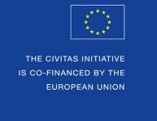

CIVITAS Forum 2016 Annual Conference

Gdynia, Poland
28-30 September 2016

Speakers’ Contributions to the CIVITAS Forum Conference
(Parallel session & Pecha Kucha)
Guidelines and Proposal Form

The CIVITAS Forum Conference
The 2016 Annual CIVITAS Forum Conference will be hosted by the city of Gdynia, Poland, between 28th and 30th September 2016. The leading theme of the CIVITAS Forum 2016 will be Shaping the Mobility of Tomorrow.
The CIVITAS Forum Conference is the annual flagship event of the CIVITAS Forum Network of cities as well as a very important conference in the urban mobility field. The event has been organized since 2003. The 2016 conference will be the 14th such annual event, following in the footsteps of Ljubljana, Casablanca, Brest, Victoria-Gasteiz, Funchal, Malmö, Krakow, Bologna, Kaunas, Burgos, Nantes, Rotterdam and Graz.
Currently, The CIVITAS Forum Network includes over 246 cities from 37 countries from Europe and beyond, that have formally committed to clean and sustainable urban transport. The Conference therefore is a fantastic opportunity for vivid dialogue and knowledge exchange between cities and European politicians on the one hand, and experts in the field of urban mobility on the other.
Furthermore, as always, the Forum Conference will be a significant occasion for high level representatives of the European Commission and the CIVITAS community to share news and information on its policy and programme initiatives and to hear the views of local politicians, mobility practitioners, academics, and NGOs.

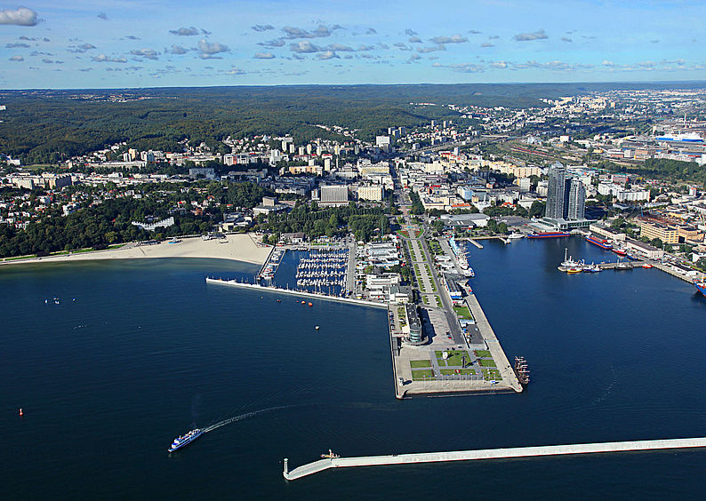

SUBMISSION

Submission of a proposal form
This document serves as the proposal form for speakers interested in contributing to the parallel sessions and to the Pecha Kucha of the CIVITAS Forum Conference 2016. Please carefully read these guidelines, complete the form available below (page 5) and send it via email to forum.contributions@civitas.eu.

Deadline and evaluation procedure
The deadline for sending you proposal form is the 22.04.2016. The CIVITAS Programme Committee (which consists of the leading organisers together with the EC) will evaluate all proposal submissions. Selected speakers will be contacted around mid-May, when they will be invited to confirm their participation.
Call for contributions (Deadline) April 22nd 2016
Selected speakers (Announcement) May 16th 2016
Speakers to confirm (Deadline) May 20th 2016

List of topics
Your proposal should be in line with one (or more) of the proposed list of topics:
Company mobility management: Companies located in cities have an ethical responsibility to render the mobility of their employees more sustainable. How can they do that? Are they willing to invest in an electric car fleet, to install recharging points on their premises, to give financial incentives to bikers, to foresee good and sufficient shower facilities etc.? What works and what doesn't? How can local authorities encourage/stimulate companies to run social responsible business? We are looking for presentations from companies who have implemented mobility management schemes and can explain them in a very concrete, practical way, focusing on the learnings.
E-buses – the backbone of the smart city: Buses are where electro mobility can quickly address a lot of people. E-buses can be free-standing or trolley-buses. We are looking for presentations from relevant projects and stakeholders, focusing on what to do, how to do it and learnings from practical experience.
Energy-efficiency in all modes of transport: Energy-efficiency is a hot topic. Not only to reduce the energy consumption bill but also to reduce emissions. From eco-driving to better motors to alternative cleaner fuels (i.e. bio-fuels, CNG or LPG), many ways are being explored and deployed. We are looking for presentations from relevant projects and stakeholders, focusing on what to do, how to do it and learnings from practical experience.
Inclusive mobility: Mobility can do wonders but can also be extremely discriminatory towards people with low income and people with physical impairments. How can cities manage this? How can they maximize the mobility of those specific groups? We are looking for presentations from cities who have implemented inclusive mobility schemes and measures and from relevant stakeholders and experts, focusing on what to do, how to do it and learnings from practical experience.
Influence of automation on urban mobility: Some say driverless vehicles are just around the corner and others think it will still take a few decades to see them on our streets. But whatever the actual time scale, they will eventually become a reality. What are the key challenges and opportunities with automated vehicles and how can cities best get prepared for them, in a cost-effective way? We are looking for presentations on this topic, ideally from a variety of perspectives, from strong believers to sceptics to anything in the middle, based on studies.
ITS in urban areas: Intelligent transport systems (ITS) are very varied. They can achieve a lot but they are also costly. Which are the most cost-effective ITS applications? How can cities be guided in their choices? We are looking for presentations from ITS projects, from cities who have implemented ITS and from stakeholders and experts, focusing on what to do, how to do it and learnings from practical experience.
Managing city centre access: Access restrictions are not new but still an effective type of measures to render urban mobility more sustainable. From pricing and parking policies, through low-emission zones to limited speeds zones to fully pedestrianized areas, the variety is great. What are the most-effective restrictions? What should cities pay attention to when considering or implementing such a scheme? Noteworthy, the Commission is preparing Guidelines on this topic. We are looking for presentations from cities who have implemented access restrictions and experts, focusing on what to do, how to do it and learnings from practical experience.
Mobility as a service: Can a citizen be offered mobility as a service? Can he or she decide on a day-to-day basis which means of transport to use based on his or her activity? How would that work? Can it be made easy to do? We are looking for presentations from entrepreneurs and other private stakeholders who are developing mobility services and can explain things in a very concrete, practical way.
Monitoring impacts of urban mobility measures/policies: How can we measure the impact of urban mobility measures in terms of their sustainability? Indicators can be defined, but how can cities collect data in a cost-effective way and how can they properly analyse and interpret the data? How can we avoid that data is misused for window-dressing or, even worse, calls for the wrong measures or leads to setting aside the right ones? Measuring and comparing the effectiveness of cities’ policy-making, using e.g. self-assessment tools. We are looking for presentations from experts and from cities, focusing on how to use and collect data in practice.
Neighbourhood mobility management: Managing mobility at the scale of the whole city is one thing, but how can one best ensure the sustainability of mobility at the level of a smaller neighbourhood. Is the approach or are the measures different and how? How can cities cope with this micro-management in view of limited people resources? We are looking for presentations from cities who have implemented neighbourhood mobility management and from projects, focusing on what to do, how to do it and learnings from practical experience.
Participation: involving citizens, stakeholders and experts: Urban mobility can only be improved on the basis of good ideas which are adopted by the users. This requires de facto a good inclusion of the citizens of the city as well as the relevant stakeholders and possible experts. How can a city best ensure their participation and best leverage the advice and suggestions it is getting from those actors? We are looking for presentations from cities who have implemented participation to improve their urban mobility, focusing on what to do, how to do it and learnings from practical experience.
Shared mobility: Shared mobility continues to develop. Car-sharing, car-pooling, ride-sharing, bike-sharing etc. From organized schemes to private individual initiatives. What can we learn from these initiatives and how can we expect them to develop? What are the challenges of shared mobility and the solutions to overcome them? We are looking for presentations from shared mobility initiatives and stakeholders, focusing on what to do, how to do it and learnings from practical experience.
Tackling congestion: Tackling congestion is socially the most recognizable and convincing purpose of efforts towards sustainable transport. This complex process can be a combination of different actions and measures, depending on individual conditions and potential of the cities. In tackling congestion cities can use tools such as, complex transport models, mobility management software or ITS systems. How can we characterize its individual elements and find out the way to combine them in one efficient and successful system? We are looking for presentations from cities who have implemented congestion-reduction schemes and measures and from relevant stakeholders and experts, focusing on what to do, how to do it and learnings from practical experience.
Travel behaviour change: The private car is still the preferred means of transport for a large share of the EU population. How can we drive change in travel behaviours towards more sustainable choices? Although a very important topic, it is not yet all well set and clear. At the basis of this lays the understanding of current travel behaviour and how people form their preferences. We are looking for presentations from travel behaviour projects and experts, focusing on what to do, how to do it and learnings from practical experience.
Urban freight logistics: Urban freight has an important impact on the sustainability of urban mobility and is often neglected by city authorities. Knowledge in the field is developing rapidly and the European Commission has launched three specific CIVITAS knowledge-generating projects and is preparing specific Guidelines. It is also partnering with the US to exchange learnings and best practice. We are looking for presentations from urban freight logistics projects and stakeholders, focusing on what to do, how to do it and learnings from practical experience.
Urban nodes of the TEN-T network: The case of the cities on the core TEN-T network is a specific one. Not only do they face the same challenges as the other cities, but they are also expected to ensure smooth first and last miles’ connections for the people and goods travelling on the network. The European Commission started to support them financially in 2014 and 2015. It is also conducting a study to identify cost-effective measures and is developing a strategic paper. We are looking for presentations from cities of the core TEN-T network, focusing on what to do, how to do it and learnings from practical experience.

GUIDELINES FOR A SUCCESSFUL PROPOSAL

Parallel sessions
Be clear and concise about your contribution, stick to the word limitation where appropriate.
Be creative and innovative in the presentation of your ideas and in the format to be used for presenting your ideas to the public.
Be ready to present results and the reasons for a measure’s success.
If your abstract is selected, you will be request to prepare a presentation of maximum 10 slides.
Highlight the added-value of CIVITAS or any other experience in urban mobility and its potential for transferability.

Pecha Kucha
Pecha Kucha is a presentation format that is based on a simple idea: 20 images, each in 20 seconds. With support of exactly 20 PowerPoint slides the speakers are expected to give their presentation of 6 minutes and 40 seconds, with short breaks between presentations. CIVITAS Forum Conferences have used pecha kuchas as an alternative presentation format already for several years.
The presentation slides can only contain images, no words, graphs but NO animation, video or music. Make your picture slides simple, straightforward and self-explanatory (and one title page to start with). Humour and metaphor are good approaches for these presentations. You are requested to send a copy of the presentation beforehand.
Pecha kucha presentation cannot be commercial, nor can it be a “reduced” version of the talk you are giving at the conference anyway.

PROPOSAL FORM

PART I. Your Contact Details
Name:
Organisation:
Address:
Email:
Telephone:
CIVITAS project
(if appropriate):

CIVITAS | CIVITAS Plus II CIVITAS Plus CIVITAS II CIVITAS I  CIVITAS Forum Member Non-CIVITAS personality  Knowledge Generating Research Project

PART II. Your Contribution
Technical session Pecha Kucha
Presentation title:
Abstract:
Innovative approach for your country/region
(max 500 words)
Broader context of your city’s/country’s mobility strategy or of the solution presented
(max 500 words)
As per the integrated approach, please describe the “winning combination” of mobility measures and how they reinforced one another
(max 500 words)
4 Keywords

Topic addressed  (maximum 2) | Company mobility management  E-buses – the backbone of the smart city  Energy-efficiency in all modes of transport  Inclusive mobility  Influence of automation on urban mobility  ITS in urban areas  Managing city centre access  Mobility as a service  Monitoring impacts of urban mobility measures/policies  Neighbourhood mobility management  Participation: involving citizens, stakeholders and experts  Shared mobility  Tackling congestion  Travel behaviour change  Urban freight logistics  Urban nodes of the TEN-T network
Should you have any question, please contact forum.contributions@civitas.eu

