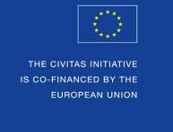

CIVITAS Forum 2015
Annual Conference

Ljubljana, Slovenia
7-9 October 2015

Speakers’ Contributions to the CIVITAS Forum Conference
(Parallel session & Pecha Kucha)
Guidelines and Proposal Form

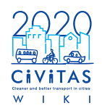

The CIVITAS Forum Conference – Great chance for Learning!

The CIVITAS Forum Conference is the annual flagship event of the CIVITAS Forum Network of cities as well as a very important conference in the urban mobility field.

The 2015 Annual CIVITAS Forum Conference will be hosted by the city of Ljubljana, Slovenia, between 7th and 9th October 2015.

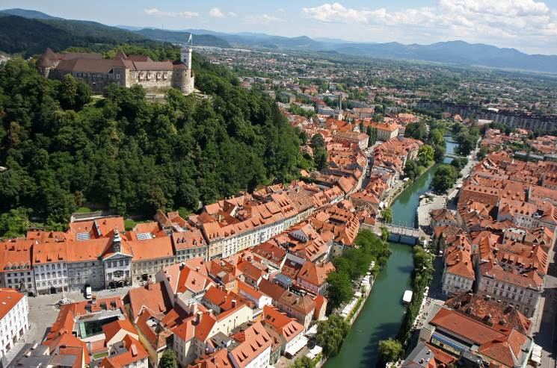The Conference is an opportunity for dialogue and the exchange of views between cities and European politicians on the one hand, and experts in the field of urban mobility on the other. The 2015 conference will be the 13th such annual event, following fora previously hosted in Casablanca, Brest, Victoria-Gasteiz, Funchal, Malmö, Krakow, Bologna, Kaunas, Burgos, Nantes, Rotterdam and Graz, where the series started in 2003.

The CIVITAS Forum Network currently includes over 220 cities from 32 countries from Europe and beyond, that have formally committed to clean and sustainable urban transport.

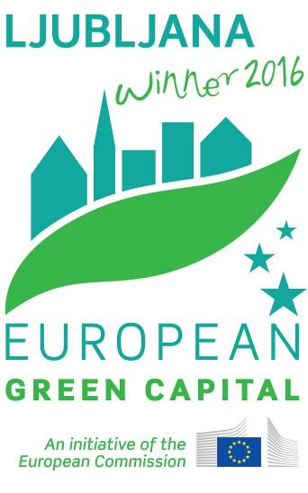As always, the Forum Conference will be a significant occasion for high level representatives of the European Commission and the CIVITAS community to share news and information on its policy and programme initiatives and to hear the views of local politicians, mobility practitioners, academics, and non-governmental organisations.

Following the experience of Ljubljana as well as of many European cities, the leading theme of the CIVITAS Forum 2015 will be Sharing the city.

There will be plenty of opportunities for the exchange of experiences and know-how among urban mobility practitioners from Europe and beyond, via Technical Sessions, training sessions, networking activities, etc…

The CIVITAS Forum Conference – Great chance for sharing ideas!

Submission of a proposal form and evaluation procedure
This document serves as the proposal form for speakers interested in contributing to the parallel sessions and to the Pecha Kucha of the CIVITAS Forum Conference 2015.
Please carefully read these guidelines, complete the form available below (page 5) and send it via email to Forum.contributions@civitas.eu

The deadline for sending you proposal form is the 24.04.2015!

The CIVITAS Programme Committee (which consists of the leading organisers together with the EC) will evaluate all proposal submissions. Selected speakers will be contacted around mid-May, when they will be invited to confirm their participation.
Deadline - call for contributions | 24th April 2015
Announcement - selected speakers | 11th May 2015 (indicative)
Deadline - speakers to confirm | 18th May 2015  (indicative)

Guidelines for a successful parallel session proposal:
- You proposal should be in line with one (or more) of the proposed list of topics:
  - The implementation of shared space areas in Europe.
  - How bike, car and parking sharing new trends can change you city.
  - E-mobility (e-bike, e-car, e-bus) and other alternative fuels (hydrogen & fuel cells, and natural gas): new trends, market uptake and future opportunities.
  - Intermodality, multimodality and co-modality: HUB design and business schemes.
  - Shared infrastructures for Urban Freight Delivery and Passenger Transport.
  - Urban planning, use of land and mobility: does your city have a shared vision?
  - Planning and implementing urban mobility: the importance of shared governance.
  - Create new opportunities for collective mobility: network simplification and efficiency improvement.
  - Integrated and shared energy, transport and ICT infrastructure for a more liveable/accessible city (link with Smart Cities and Communities).
  - Interoperability and ICT standardisation: the impact in urban mobility.
  - From theory to practice: concrete and successful example of SUMP national approach/ SUMPs as drivers of equity in sharing the city.
  - Clean Vehicles Directive: how cities can influence their national authorities in their development of the corresponding national framework.
  - Gender issue and mobility for venerable users (elderly, children, disable).
  - How open-data and cooperative ITS can improve urban mobility in your city.
  - Long distance travel and urban nodes: latest developments in Europe.
  - Shared procurement and the application of the Clean Vehicle Directive.
- Be clear and concise about your contribution, stick to the word limitation where appropriate;
- Be creative and innovative in the presentation of your ideas and in the format to be used for presenting your ideas to the public;
- Be ready to present results and the reasons for a measure’s success;
- Don’t forget: if your abstract is selected you will be request to prepare a presentation of maximum 10 slides;
- Highlight the added-value of CIVITAS or any other experience in urban mobility and its potential for transferability;

Tips for a successful Pecha Kucha proposal
Pecha Kucha, devised in Tokyo in 2003 and drawing its name from the Japanese term for the sound of "chit chat", it rests on a presentation format that is based on a simple idea: 20 images, each in 20 seconds. It's a format that makes presentations concise, and keeps things moving at a rapid pace.

As urban mobility faces toward new approaches and new ways of thinking, Pecha Kucha, as format of dissemination, is more and more popular among stakeholders of urban mobility and recently it has become an usual element of the CIVITAS annual conferences agenda.
Therefore CIVITAS Forum Conference 2014 also issues a call for Pecha Kucha presentations. We would like to have a happy bunch of colourful ideas from very different spheres. As introducing presentations from very different areas of urban mobility, we would like to suggest how complex our common thinking can be.
With support of exactly 20 PowerPoint slides the speakers are expected to give their presentation of 6 minutes and 40 seconds, with short breaks between presentations, allowing some Q&A.
Your talk cannot be commercial. Nor can it be a “reduced” version of the talk or workshop you are giving at the conference anyway.

The presentation slides can only contain images, no words, graphs but NO animation, video or music. Make your picture slides simple, straightforward and self-explanatory (and one title page to start with). You are requested to send a copy of the presentation beforehand.

Some tips for what using in your Pecha Kucha presentation:
- Funny pictures, jokes, humour
- Metaphor
- Good quality pictures, possibly one big one per slide
- Avoid all text. This is for emotions, not for logic.

PROPOSAL FORM

PART I. Your Contact Details
Name:
Organisation:
Address:
Email:
Telephone:
CIVITAS project
(if appropriate):

CIVITAS | CIVITAS Plus II CIVITAS Plus CIVITAS II CIVITAS I  CIVITAS Forum Member Non-CIVITAS personality

PART II. Your Contribution
Technical session Pecha Kucha
Presentation title:
Abstract:
Innovative approach for your country/region
(max 500 words)
Broader context of your city’s/country’s mobility strategy or of the solution presented
(max 500 words)
As per the integrated approach, please describe the “winning combination” of mobility measures and how they reinforced one another
(max 500 words)
4 Keywords

Topic addressed  (maximum 2) | The implementation of shared space areas in Europe.  How bike, car and parking sharing new trends can change you city.  E-mobility (e-bike, e-car, e-bus) and other alternative fuels (hydrogen & fuel cells, and natural gas): new trends, market uptake and future opportunities.  Intermodality, multimodality and co-modality: HUB design and business schemes.  Shared infrastructures for Urban Freight Delivery and Passenger Transport.  Urban planning, use of land and mobility: does your city have a shared vision?  Planning and implementing urban mobility: the importance of shared governance.  Create new opportunities for collective mobility: network simplification and efficiency improvement.  Integrated and shared energy, transport and ICT infrastructure for a more liveable/accessible city (link with Smart Cities and Communities).  Interoperability and ICT standardisation: the impact in urban mobility.  From theory to practice: concrete and successful example of SUMP national approach/ SUMPs as drivers of equity in sharing the city.  Clean Vehicles Directive: how cities can influence their national authorities in their development of the corresponding national framework.  Gender issue and mobility for venerable users (elderly, children, disable).  How open-data and cooperative ITS can improve urban mobility in your city.  Long distance travel and urban nodes: latest developments in Europe.  Shared procurement and the application of the Clean Vehicle Directive  The social dimension of transport, including communicating and involving stakeholder and citizens.

Should you have any question, please contact Chiara Frencia at forum.contributions@civitas.eu

