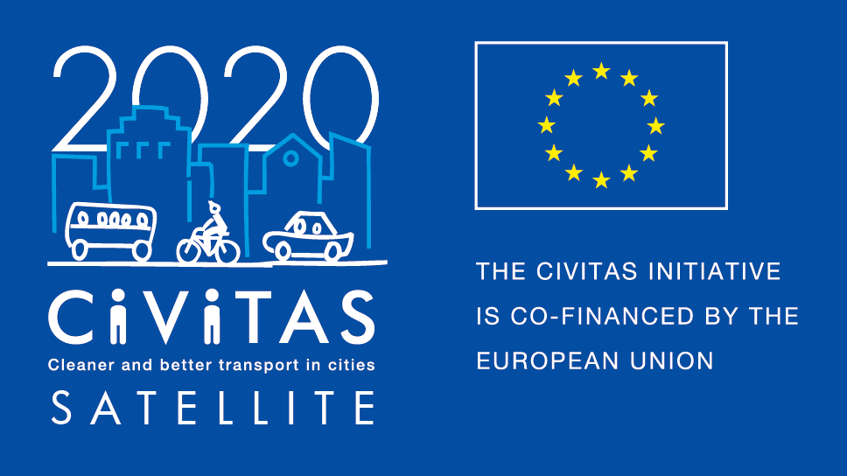
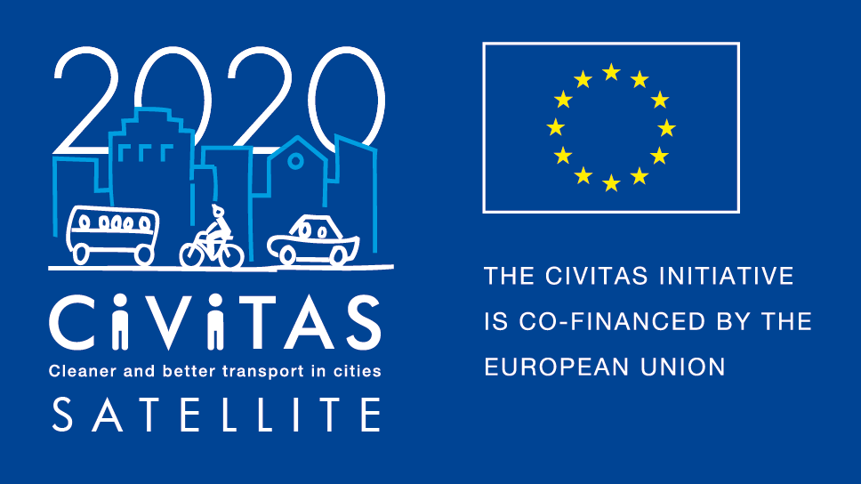
w

Draft Agenda Study visit
Braga, February 2019

Contact person
Pedro Vale Moreira, Mobility Department Technician, Braga Municipality
Mobile: +351 966412621
E-mail: pedro.moreira@cm-braga.pt

Location
City Offices (technical services):
https://www.google.pt/maps/place/Convento+do+P%C3%B3pulo/@41.5523895,-8.42894,19.22z/data=!4m5!3m4!1s0x0:0x78efeb176cc86c19!8m2!3d41.5523322!4d-8.4288003

Day 1 (Venue: City Offices)
Time | Subject | Notes / Objectives
AM | Arrivals | Participants arrive in Braga
14.00-14.30 | Introduction and roundtable  City of Braga  All | Introduction in the City’s strategy and ongoing projects in transport and mobility. Participants present themselves.
14.30-15.30 | Speed-networking session, expectations for the visit  All | Participants get to know each other.  Discussion on expectations on this site visit.
15.30-16.00 | Coffee break
16.00-18.00 | Site visit: TUB – Public Transportation Company of Braga  e-mobility on public transportation  TUB – Transportes Urbanos de Braga | Visiting the Municipal company for public Transportation – electric buses.
18.00 | Official Networking reception

Day 2 (Venue: City Offices)
Time | Subject | Notes / Objectives
9.00-12.00 | Session 1 Site visits on autonomous car  Bosch car | Visiting the Bosch factory, and the autonomous car that is being developed there.
12.00-13.00 | Lunch
14.00-18.00 | Session 2 – Site visit Urban Innovation Laboratories (Living Laboratories For Decarbonisation)  Centro de Computação Gráfica/Minho University | Presentation of the BUILD project, a smart city project developed with universities, industry and investigation centres
18.00 | Networking dinner

Day 3 (Venue: City Offices )
Time | Subject | Notes / Objectives
9.00-12.00 | Session 1: Humanizing the City – Connecting Neighbourhoods | Policy for the neighbourhoods in Braga.
12.00-13.00 | Lunch
13.00–15.00 | Evaluation and transferability session | Discussion on the output of the visit and drafting of the evaluation report
15.00 | End of the visit

Hotels
- Hotel Dona Sofia
http://hoteldonasofia.com/hotelds/
- Hotel Bracara Augusta
http://www.bracaraaugusta.com/
- Urban Hotel da Estação - Braga
https://pt.hoteis.com/ho346452/urban-hotel-da-estacao-braga-portugal/
- Basic Braga
http://www.axishoteis.com/pt/Axis-Hoteis/Hoteis/Basic-Braga-by-Axis/O-Hotel.aspx
- Hotel Ibis Braga Centro
http://www.ibis.com/pt/hotel-1802-ibis-braga-centro/index.shtml
These are some suggestions, however, the participants should feel free to choose among other options, as there are some more nice and good located places to stay.

Map and directions to venues and hotels
We’d also like to send you the locations of the places where the activities are planned to occur and other useful sites, so that the partners can be aware of which are the best places to stay at:
- Town Hall (main building):
https://www.google.pt/maps/place/C%C3%A2mara+Municipal+Braga/@41.551493,-8.4288825,19.22z/data=!4m5!3m4!1s0x0:0xc6bd5cc2f635ca02!8m2!3d41.5510169!4d-8.428353

- Town Hall (technical services):
https://www.google.pt/maps/place/Convento+do+P%C3%B3pulo/@41.5523895,-8.42894,19.22z/data=!4m5!3m4!1s0x0:0x78efeb176cc86c19!8m2!3d41.5523322!4d-8.4288003

- GNRation (where most activities shall be hosted):
https://www.google.pt/maps/place/GNRation/@41.5524546,-8.4270961,18.92z/data=!4m5!3m4!1s0x0:0xf715da419f911455!8m2!3d41.5531265!4d-8.42622

- D. Diogo de Sousa Museum (where some activities may take place):
https://www.google.pt/maps/place/D.+Diogo+de+Sousa+Museum/@41.5470304,-8.4286039,17.69z/data=!4m5!3m4!1s0x0:0x7a6bc246b3f973c9!8m2!3d41.5460718!4d-8.4271996

- University of Minho Rectory (where some activities may take place):
https://www.google.pt/maps/place/Reitoria+da+Universidade+Do+Minho/@41.550248,-8.4265477,18z/data=!4m5!3m4!1s0x0:0xf0436ef6772c3f28!8m2!3d41.5507615!4d-8.4264345

- Train station:
https://www.google.pt/maps/place/Braga/@41.5462235,-8.4386483,16.47z/data=!4m5!3m4!1s0xd24fedc2cba201f:0xa50563ed3bab78eb!8m2!3d41.5481505!4d-8.434445

- Bus station:
https://www.google.pt/maps/place/Norton+Matos+(C+Camionagem)/@41.5546444,-8.4263518,18z/data=!4m5!3m4!1s0x0:0xae2d2a6f3f4e7410!8m2!3d41.5552639!4d-8.4248551
Finally, we inform that the possible ways to get from the airport of Porto to Braga are the following:
- GetBus

GetBus is a shuttle bus that drives the passengers from Porto Airport to Braga’s Bus Station and vice-versa. It stops right outside of the airport door.
The ticket can be bought directly with the bus driver, which will be dependent on availability of seats, or beforehand on the website
The cost of the ticket is 8€. If you buy a return ticket, it will cost 14€
The frequency of the buses is around every 2 hours and the trip takes about 50min
More info on GetBus: https://getbus.eu/en/

- Metro + Train

In the airport, take Metro do Porto’s E Line to Campanhã.
Type and cost of ticket: Z4, 1,95€
You’ll need an Andante Card which you can charge with how many tickets you need. The card can only be used by one person at a time and it costs 0,60€
The E line has a frequency of around 20min on weekdays
The trip to Campanhã takes 33min
More info on Metro do Porto: http://en.metrodoporto.pt/
In Campanhã, take the train Urbano to Braga.
When you buy the ticket on the machines or at the counters with the train station’s staff, you can choose precisely the destination: Braga. The cost will be 3,15€
The chargeable card for the train costs 0,50€ and works the same way as the metro one
There is at least one train per hour from Porto to Braga, usually departing from Porto at XX:45 and the trip takes 1h10. At peak hours there are other connections and the trip will be a bit shorter (around 50min).
There are other train services connecting Porto and Braga, which are faster but not so frequent during the day and they cost significantly more.
More info on the trains: https://www.cp.pt/passageiros/en/

