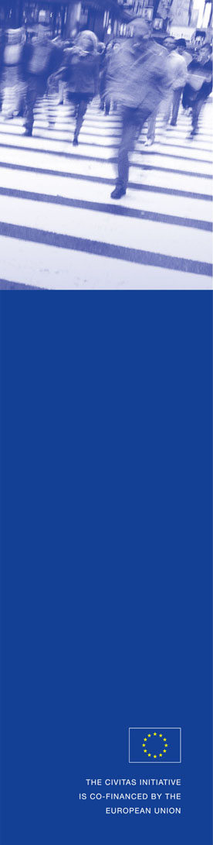
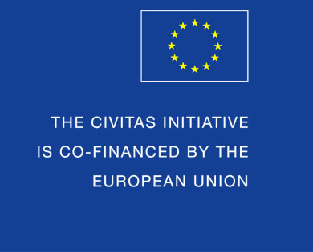

Implementation status report on CNG buses

ELAN Deliverable No. 1.11-D1
Project acronym: ELAN
Project full title: Mobilising citizens for vital cities

Grant Agreement No.: ELAN TREN/FP7TR/218954/”ELAN”

Work package: WP 1 Alternative fuels and clean energy efficient vehicles
Measure: 1.11-LJU Hybrid and CNG bus implementation
Author: Damjan Kregar

Final version

11 February 2012
ELAN deliverable no. | 1.11 - D1
Date / Version | 11 February 2012 / Final version
Dissemination level | CO
Work Package | WP 1 Alternative fuels and clean energy efficient vehicles
Authors | Damjan Kregar
File Name | 1.11 - D1 - Implementation status report on CNG buses.doc

Keywords
 | General |  |  |  | Work package links
x | CIVITAS |  |  | x | WP1 Alternative fuels & clean vehicles |  | WP7 Energy-efficient freight logistics
x | ELAN Project |  |  |  | WP2 Collective transport & intermodal integration |  | WP8 Transport telematics
 |  |  |  |  | WP3 Demand management |  | WP9 Project coordination
 |  |  |  |  | WP4 Influencing travel behaviour |  | WP10 Project management
 |  |  |  |  | WP5 Safety, security & health |  | WP11 Research and Technological Development
 |  |  |  |  | WP6 Innovative mobility services |  | WP12 Impact and process evaluation
 |  |  |  |  |  |  | WP13 Dissemination, citizens’ engagement, training and knowledge transfer

Document history

Date | Person | Action | Status | Circulation
5.1.12 | Damjan Kregar | Preparation of 1st draft | 1st draft | PM
9.2.12 | Marcel Braun | Proof-reading and comments on draft | 2nd Draft | ML
11.2.12 | Damjan Kregar | Preparation of final version | Final | PM, PC

CONTENT

1. Summary 4
2. Introduction 5
2.1. City of Ljubljana 5
2.2. Javno Podjetje Ljubljanski potniški promet - LPP 5
Tramway era (1901–1958) 5
Trolleybus era (1951–1971) 6
Bus era (1950-today) 6
3. Situation before CIVITAS-ELAN 7
4. Measure 1.11-LJU – Hybrid and CNG bus implementation 8
4.1. Hybrid bus implementation 8
4.2. CNG bus implementation 8
5. Measurements, results of comparison and trainings 10
5.1. Hybrid bus versus diesel bus 10
5.2. Hybrid, CNG and diesel buses 11
5.3. Trainings and workshops 11
6. Dissemination 12
7. Conclusion 13
8. Sources, References and Attachments 14
8.1. Sources and references 14
8.2. Appendix 1 14
8.3. Appendix 2 14
8.1. Appendix 3 14
8.2. Appendix 4 15
8.3. Appendix 5 16

Summary

Like many other cities, air pollution is also a big issue in Ljubljana. Especially because of its geographical position – it lies in a valley with less wind than many other cities. Lately some legislation related to heating systems has changed and air quality in Ljubljana improved. A lot of “private” heating systems were changed to district heating, which led to a decrease of the pollution.
On the other hand, there is still a lot of traffic in Ljubljana which is still polluting the city’s air. LPP with its fleet of more than 200 buses is among the biggest “air polluters” caused by traffic. The management and company owners have decided to tackle this problem. The main question was how to reduce the pollution and at the same time keeping or even improving the level of customer satisfaction level and the number of bus passengers. Luckily, reducing pollution goes hand in hand with lower fuel costs. On the other hand, less polluting buses are more expensive.
During the CIVITAS-ELAN measure 1.11-LJU Hybrid and CNG bus implementation, LPP first tried to implement hybrid buses. The original aim was to test five different types of hybrid buses. Because of the very limited market for “hybrid buses” in Slovenia and the very big problems with the first tested hybrid bus (a hydraulic hybrid bus), it was suggested to the EC to change the measure in the direction of testing CNG technology. This was accepted and LPP now has the opportunity to test something completely new for Ljubljana and for Slovenia as a whole. Before the ELAN project, no CNG buses were present on Slovenian territory – also because of the missing infrastructure, e.g. missing CNG fuel filling station.
During the course of the measure a lot of tests, measurements and comparisons were done on diesel, hydraulic hybrid and CNG buses. The results were evaluated. According to the expected results, the management decided to replace up to half of the fleet with CNG buses in the following few years. This decision will definitely have a very positive impact on air pollution, especially with regard to PM₁₀.

Introduction

City of Ljubljana
Ljubljana is the capital of Slovenia and its largest city. It is the centre of the City Municipality of Ljubljana. It is located in the centre of the country in the Ljubljana Basin, and is a mid-sized city of some 270,000 inhabitants. Throughout its history, it has been influenced by its geographic position at the crossroads of Germanic, Latin and Slavic cultures.
For centuries, Ljubljana was the capital of the historical region of Carniola, and in the 20th century it became the cultural, scientific, economic, political and administrative centre of Slovenia, independent since 1991. Its transport connections, concentration of industry, scientific and research institutions and cultural tradition are contributing factors to its leading position.
The city encompasses an area of 275 km². Its location between Austria, Hungary, the Venice region in Italy and Croatia has strongly influenced its history. Ljubljana is located some 140 kilometres west of Zagreb, 520 kilometres northwest of Belgrade, 250 kilometres east of Venice, 350 kilometres southwest of Vienna and 400 kilometres southwest of Budapest.
Among other roles, the city council drafts the municipal budget, and is assisted by various boards active in the fields of health, sports, finances, education, environmental protection and tourism. The City Municipality of Ljubljana is subdivided into 17 quarter communities that work with the municipality council to make known residents’ suggestions and prepare activities in their territories.
The city bus network, run by the public company Ljubljanski potniški promet ("Ljubljana Passenger Transport Operator", LPP), is Ljubljana’s most used means of public transportation. One can also rent bicycles in the city, and there are numerous taxi companies. The city bus rides may be paid with the Urbana payment card (also used for the funicular) or via mobile phone. Sometimes, the buses are called “trole” (trolleys), harking back to the 1951–71 days when Ljubljana had trolleybuses. Until 1958, there were five trolleybus lines in Ljubljana, alongside the tram.
The tram system in Ljubljana was a small one. It was originally built in 1901. In the post World War II era, many Yugoslav towns and cities with tram systems took out their systems, as they took up a lot of space in an era when automobiles were more important. In Ljubljana the tram’s end came in 1958. In its final years the system reached a length of over 21 kilometres.

Javno Podjetje Ljubljanski potniški promet - LPP

Tramway era (1901–1958)
When Ljubljana had about 40,000 inhabitants, the city authorities decided to impose a "mechanized" means of transport and in 1900 Splošna malo železniška družba (English: General little railway company) was officially established. Without special ceremony, the tramway officially started to operate on 6 September 1901. On the first day 6,400 tickets were sold.
In 1929, the Splošna malo železniška družba changed its name to Električna cestna železnica (English: Electric street railway) and since 1930 the city modernized stock and tracks. With purchasing new and used vehicles the rolling stock 1940 considered 52 units. Tramway lines were connecting the city centre with the suburbs. Workshops and garages were moved to the street Celovška cesta in the suburb of Šiška.

Trolleybus era (1951–1971)
After WWII, Ljubljana quickly spread and the tramway no longer withstood the growing transportation needs in the city. When personal cars were spreading to the general population, this was an additional reason for the different arrangements of the public transport which would need less street surface in Ljubljana. On May 1953 the Mestni ljudski odbor Ljubljana (English: City people’s committee of Ljubljana) set up a commission that prepared the proposal on changing tramways with the trolleybus and bus service.
The transition was gradual. In the mid-fifties, Ljubljana started to regularly operate the first trolleybuses and buses. The tramway finally ceased to operate, Električna cestna železnica was renamed to Ljubljana-Transport. The last journey of a tramway was on 20 December 1958. Like the tramways, trolleybuses are also electrically powered and therefore are depending on the power lines installed in the city.
The experiences with the operation of the trolleybuses were not the best. Trolleybus power collectors often "fell off" and had to be reinstalled. In winter time there were additional problems caused by snow and a road-sanding with salt. Salt water often came into contact with electrical wiring and caused short circuits. Sometimes the entire body of the trolleybus was energized with electricity. Passengers were often experienced shock if they touched the metal parts of the vehicle. The last trolleybus vehicle in Ljubljana drove on 4 September 1971. On the next day the trolleybus lines were completely replaced by buses.

Bus era (1950-today)
The sixties and the seventies of the 20th century had brought unimagined development of urban public transport and the company. In 1971 the company was renamed to Viator which gradually expanded its operations throughout Slovenia. Urban transport operations developed into other services which were long distance passenger transport, freight and tourist traffic which boosted tourist-agency activities, and then continued with the construction of lifts to Vogel, Velika planina and Zatrnik. From transport and tourism it was only a small step to catering and taxi services. Since 1971, the company is engaged exclusively in the operation of public transportation with buses.
In 1977, Viator formed a link with the company SAP into SOZD SAP Viator. Further merges and alliances followed between different transport, tourism and hotel organizations throughout Slovenia which resulted in the INTEGRAL SOZD. In this context today’s business name occurred, labour organization Ljubljanski potniški promet.
In 1989, the LPP decided to withdraw from the Integral, since there were any more development opportunities for continuing operations of urban public transport to Ljubljana, its people and its visitors, and its suburbs. LPP has become a public company serving residents of the capital and all those who live in suburban municipalities. Since 1994 LPP acts as a public company under Ljubljana. It is a limited liability company.

Situation before CIVITAS-ELAN

Before the start of the CIVITAS-ELAN project, the first experiment with CNG buses took place in 1994. For testing purpose LPP got two buses which were driving in Ljubljana for a few weeks (LJ-LPP MAJ and LJ-LPP ECO). After this time period, LPP found out that it would be nice and useful to use it, but there was not possibility to build an infrastructure and to use it for that purposes. Therefore, LPP kept on using its diesel-fuelled buses.

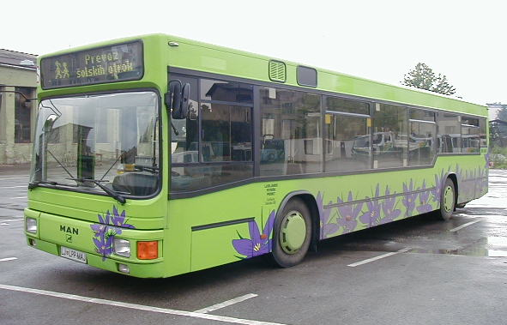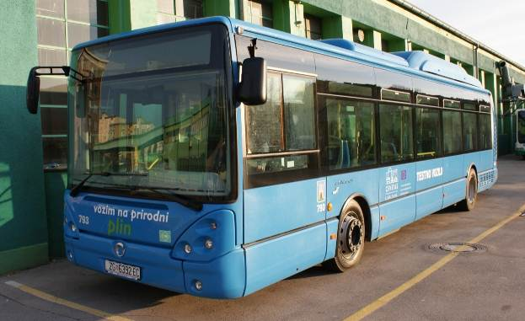

Picture 1: First CNG bus in Ljubljana (year 1994) Picture 2: Hybrid bus from Zagreb (year 2010)

Just before the decision was made to suggest to the EC to change the technology used in the measure from hybrid to CNG, LPP borrowed a CNG bus from Zagreb’s PT operator ZET (purchased within the CIVITAS-ELAN project) to have some test drives around Ljubljana. This test was conducted in April 2010. It is very important for the City of Ljubljana that CNG buses produce almost no PM₁₀ because of its valley location with less wind as other areas and because the possibility of fog is higher, higher is the concentration of particulars (PM₁₀) in the air.

LPP is striving to contribute to the reduction of air pollution. This is a reason why LPP did a lot of projects so far – and plans to do so in the future. For example, during the CIVITAS-MOBILIS project (from 2004 to 2008) LPP conducted tests with biodiesel. LPP found out that biodiesel is not suitable as fuel for buses – maintenance costs increased and there were huge problems starting the buses on biodiesel in winter time when temperatures dropped below 15°C. Consequently, it was decided to keep on using diesel fuel.

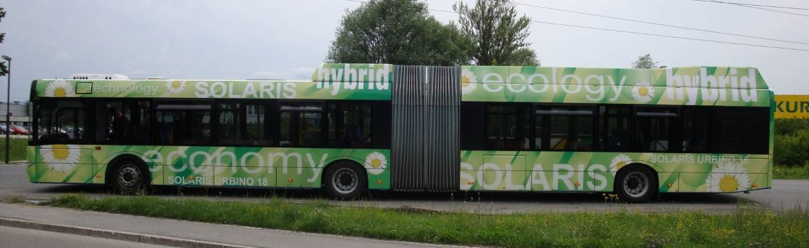

Picture 3: Solaris presented articulated hybrid bus in Ljubljana (year 2009)

Measure 1.11-LJU – Hybrid and CNG bus implementation

LPP is a partner in the CIVITAS-ELAN project which started on 15 September 2008. One of the project’s work packages is dedicated specifically to alternative fuels and clean energy efficient vehicles. The original aim of measure 1.11-LJU was to test hybrid buses which looked attractive to LPP’s managers because hybrid technology promised to reduce emission and at the same time reduce fuel costs.

During the implementation of the measure LPP made very negative experiences with hydraulic hybrid buses and because a) of the fact that on the Slovene market hybrid technology is very rare and expensive and b) tests with the hybrid buses proved to be very unfortunate. Consequently, during the course of the measure the orientation towards hybrid technology was changed towards CNG technology instead. Also this was something completely new for the Slovene market. Before the ELAN project there were no CNG buses operating in Slovenia and there was no accompanying infrastructure.

Hybrid bus implementation

According to the original measure outline it was planned to test five different types of hybrid buses. LPP planned to purchase two buses of four hybrid types, five buses of the fifth hybrid type and after extensive tests of all 13 buses, purchase an additional 14 hybrid buses of the best-performing type. At the beginning of the project LPP learned that there are only two bus producers (Solaris and Van Hool) which offer electric hybrid buses on the Slovene market which in addition are extremely expensive. On the Slovene market there was one producer of hydraulic hybrid buses (Kutsenits), a well-known bus producer on the market in Austrian and Luxemburg. LPP decided to buy five hydraulic hybrid buses and test them. They were delivered to LPP in May 2010. During the first few months in operation two of them caught fire because the oil pipe broke and hot oil was spilled on motor and exhaust area. All five vehicles, one after another, were returned to the producer to be repaired. Soon after the delivery, LPP’s personnel was trained how to maintain and use the hybrid vehicles. Measurements and tests started right after delivery (results see below).

CNG bus implementation

There were two major reasons, why it was suggested to the EC to stop the implementation of the hybrid buses and instead to implement CNG buses. Obviously, the main reason was the negative experiences with the hybrid buses. Another reason were the results from a study ordered by LPP’s owner JHL (“Public Holding of City of Ljubljana”) which was conducted by the Faculty of Machining of the University of Ljubljana (see appendix 3). According to the study it was suggested for the City of Ljubljana to invest in CNG infrastructure and use CNG vehicles also in the PT area. Consequently, LPP asked the EC to purchase and implement 20 CNG vehicles, to conduct tests and measurements and to compare the results of those measurements with classic and hybrid buses. By confirming this amendment request the EC agreed with this suggested change.

Between 1 August 2010 and 30 October 2010 a public tender for 20 CNG buses was prepared, issued and successfully closed. A contract was signed with Dualis, d.o.o. at the beginning of 2011. The expected delivery of the buses was in the middle of September 2011. The buses arrived with a slight delay between 28 August and 7 November 2011, but the biggest problem was the infrastructure. It was planned that a CNG filling station would be built at the same time as the first bus arrived but it took the investors “Energetika Ljubljana, d.o.o.” and “Geoplin, d.o.o.” a long time to overcome two problems: receiving permissions to build the filling station in the foreseen area (usually, receiving these kind of permissions takes two to three years) and with the compressor devices which were imported from Argentina and were delivered with a delay by the producer. In spite of that the filling station was finalized in very short period from a Slovene perspective – normally such projects take two to three years to be finished – on 8 December 2011. The delay in finalization of the filling station caused a delay in putting the CNG buses into operation. The CNG buses were finally put into operation on 8 December 2011, immediately after the CNG filling station was operational.

The big opening event of the station, the first one in Slovenia, was also a great opportunity to present the new CNG buses to the public and to LPP’s stakeholders. There were a lot of press representatives present, managing directors of companies and of course a Mayor of the City of Ljubljana who held a short speech in which he mentioned the importance of CNG buses for the city. Press material was issued in Slovene and English (see appendix 1). The event took place on 8 December 2011 at the filling station. It is built in such a way that three filling lanes are reserved for LPP buses, and one is open to the public, also private cars. The gas buffers on the filling station are calculated for 100 buses so there is no problem to quickly fill the present 20 CNG buses. Yet, LPP is planning to buy an additional 40 to 60 buses within the next few years.

Before the opening ceremony the buses and the filling station were tested. During this testing period all buses were driving around on testing purpose. No problems on buses and on filling station were encountered.

Filling one bus with CNG takes about 5 to 10 minutes and of course depends on the amount of CNG still in the container before filling it. This data is important because it gives LPP an input about the times of fuelling when almost half of LPP’s fleet will consist of 80 CNG buses (as planned within a few years).

As can be seen on the left photo below the CIVITAS-ELAN sign and logo was included on the panel with which the features of the buses were presented. On both sides of the buses there are labels with the CIVITAS-ELAN logo. The right photo below was taken on the event of the implementation of first 20 CNG buses in Ljubljana and in Slovenia.

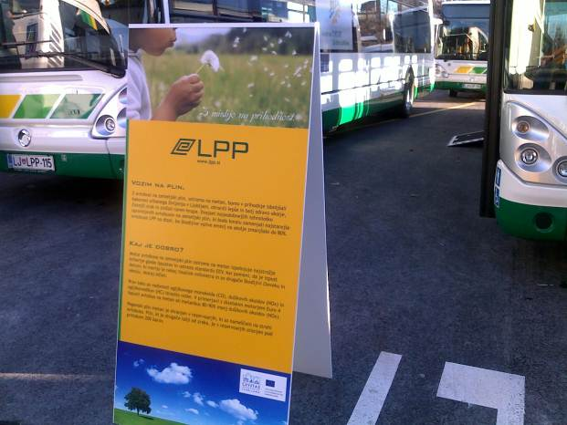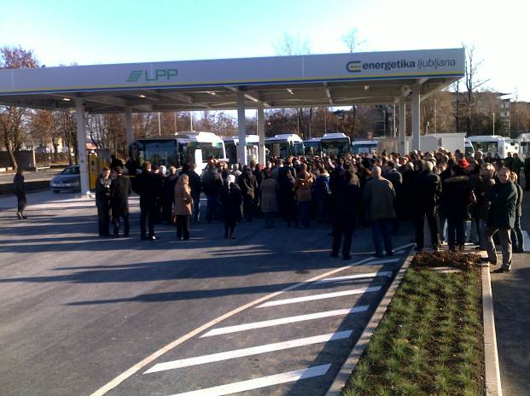

Picture 4:Features and technical data of CNG buses Picture 5: Opening event on 8 December 2011

Measurements, results of comparison and trainings

Hybrid bus versus diesel bus

As soon as the new hybrid buses arrived at LPP in May 2010 they were put into operation. They were entered in LPP’s present information system. The 18-month measurements started at that point in time. The following data was gathered for each vehicle:
- kilometres driven per month
- litres of diesel fuel consumed per month
- maintenance costs
- days of availability
- autonomy (how far vehicle can drive with one full fuel tank in relation to its average fuel consumption per 100 kilometres)
- number of passengers transported per month
- calculated fuel consumption per 100 kilometres per month

All five hybrid buses were compared to five classic (diesel) buses with engine following standard EURO III. The data is included in appendix 2. The conclusions from these measurements and comparisons are:
During the measurement period of 18 months, LPP was collecting data within its information system, the basic tool to conduct a comparison between hybrid and classic buses. During the testing period tests were not only conducted by LPP but also by the Faculty of Mechanics of the University of Ljubljana.
As expected the hybrid buses consume less fuel than classic buses because they are lighter. On lines, where there are less passengers, hybrid buses are very useful because the same customer service level can be kept while reducing the pollution of the environment.
It is very important to buy buses according to the capacity needed. It doesn’t make sense to use too big buses because they pollute more as necessary. This is valid for air pollution as well as noise pollution. Beside this, it is good to keep it in a manner “Price - performance”, because also the prices for smaller buses are lower.
Lessons learnt:
- There are many different parameters influencing the measurements.
- Much more effort is needed to understand a new technology such as hydraulic hybrid buses.

The most interesting result concerns fuel consumption. It dropped by 32.63% on average during 20 months (MIDI buses compared to SOLO). At the same level also fuel costs dropped. But of course, this data has to be regarded with care – MIDI buses are lighter, consume less fuel but they had more passengers on board. On the other hand, MIDI buses were used on those lines with fewer passengers. On the bottom line, LPP has been able to keep the customer support service on the same level, but with lower costs, less fuel consumed and less air pollution caused.

Hybrid, CNG and diesel buses

The new CNG buses were also entered into LPP’s information system and measurements have started. Unfortunately, no valid results are available yet. Now as the operation of the CNG buses started, data is being gathered, which will then be compared. LPP will conduct the same measurements that have been done for the comparison between the classic and the hybrid buses also for the comparison between the classic and the CNG buses. Again, the measurements will be conducted by the Faculty of Machining of the University of Ljubljana. The results will reveal information about air pollution by classic (EURO III), hybrid (EURO V) and CNG bus. The measurements are done always in the same way to allow for a correct comparison: data is collected on the same buses, the same line and with the same measurement equipment. This makes it possible to also learn about the influence of the weather and the number of passengers on the measurements.

These measurements will be conducted in April 2012. During the testing period also PM₁₀ will be measured while the buses are operating on the line. For this purpose, the Faculty of Machining will hire some equipment from device producer Horiba.

From all those measurements and comparisons, LPP will be able to calculate the decrease in air pollution within the City of Ljubljana. The measurements will reveal the exact PM₁₀ values from classic buses and from CNG buses. It will then be possible to calculate the amount of “not polluted” air.

Trainings and workshops

During the implementation of the hydraulic hybrid buses training sessions were held for the maintenance personnel and for the drivers on how to use and maintain the “new technology”. The trainings for the maintenance personnel were held from 29 August 2011 to 2 September 2011 and the trainings for the drivers were held from 22 January 2011 to 12 March 2011.

The same trainings were held for the new CNG buses. Trainings started as soon as the first CNG bus was delivered to LPP on 28 August 2011. In addition, dedicated on safety were held as CNG develops into a highly explosive gas when mixed with air in a certain percentage. Also, LPP’s service and maintenance workshops were prepared to prevent the accidents with CNG.

Each year – usually between January and March – all LPP drivers have to participate in courses to learn about the new technologies (hybrid and CNG), about safety and security, about economic driving and about tasks related to support older people and people with dissabilities. Thanks to the CIVITAS-ELAN project it was possible to include all those topics into the regular trainings.

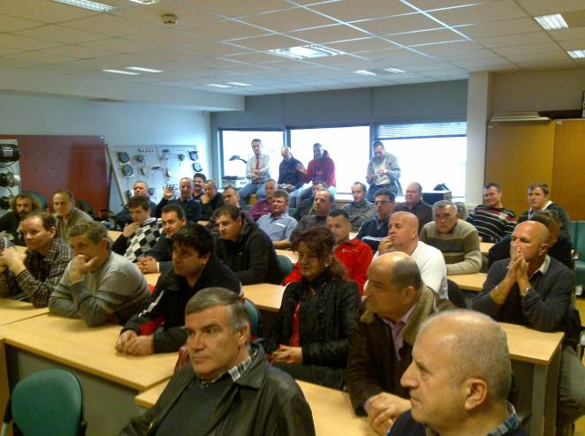

Picture 6: One of several driver trainings

Dissemination

While the hybrid buses are in operation now no dissemination campaign was launched on the hybrid buses because of the negative experiences that have been made. Still, a few newspaper articles had been published about the topic (see appendix 4).

In June 2011, LPP conducted a questionnaire-based survey on “green” technology. The questionnaire included a short explanation about the new technologies used by LPP (hybrid and also CNG) and a range of questions on citizen’s opinions and experiences with hybrid and CNG buses (see appendix 5). The questionnaire was distributed to more than 700 citizens and up to now LPP received 107 filled-in questionnaires. A preliminary analysis of the questionnaires has revealed that there is an increase in the understanding of the importance of the implementation of “green” technologies by LPP.

On 8 December 2011 a large event was held on the CNG buses. The event was attended by many stakeholder representatives: the Major, LPP’s owner, several managing directors (also of companies involved in the implementation of the measure), press representatives and the general public. A panel was held summarising the benefits of new CNG buses and the CIVITAS-ELAN project. Press material prepared for the event is included in appendix 1.

Also, all five hybrid buses and all 20 CNG buses have been labelled with the CIVITAS-ELAN logos which indicate that the vehicles were co-financed by the EU.

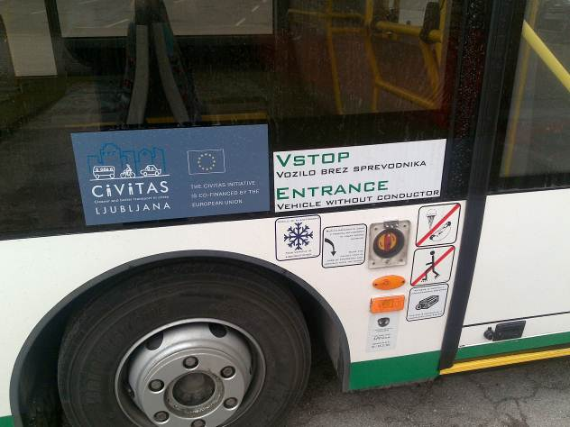

Picture 7: One of five hybrid buses

Conclusion

During the first three years of the measure implementation LPP has succeeded to:
- put five hydraulic hybrid buses into operation
- put 20 CNG buses into operation
- conduct measurements and tests with both new technologies
- compare classic, hybrid and CNG buses
- train maintenance personnel and drivers to use and to maintain the new buses
- disseminate the new technologies to the public
- inform the public about the new technologies
- promote clean and energy efficient technologies
- cut fuel consumption costs by 20%
- demonstrate energy saving and emission reduction on hybrid and CNG buses

Sources, References and Attachments

Sources and references
- Tadej Brate (2008). Ljubljanski mestni promet v slikah. Kmečki glas. ISBN 978-961-203-343-9.
- Tadej Brate (2005). Zgodovina mestnega prometa v Ljubljani. LPP d.o.o.. ISBN 961-91685-0-X.
- Tadej Brate (1997). Ljubljanski tramvaj včeraj, danes, jutri = Ljubljana tramway yesterday, today, tomorrow. Tehniški muzej Slovenije. ISBN 961-90361-3-1.

Appendix 1

Press material from CNG event held on 8 December 2011



Appendix 2

18-months period of data collection on hybrid buses


Appendix 3
Study on transport strategy conducted by the Faculty of Machining of the University of Ljubljana
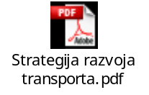

Appendix 4

Few articles from newspapers

And another one:

TV Slovenija 1, Novice 20. 01. 2010
Doseg / Reach: 617941
Država / Country: Slovenija
Čas / Time: 17:00
Trajanje / Duration: 2 min 1
LPP bogatejši za pet avtobusov
TV SLOVENIJA 1, 20.01.2010, NOVICE, 17.00
JAN NOVAK: Ljubljanski mestni potniški promet je od danes bogatejši za pet novih avtobusov, do sredine
marca pa bodo dobili še 34 avtobusov in pet minibusov. Nakup novih, sodobnih avtobusov je le del
posodobitve in razvoja potniškega prometa v glavnem mestu. V LPP zagotavljajo, da se letos kljub novim
pridobitvam cena prevoza ne bo zvišala.
ZARJA KAMBIČ: Investicija 34 avtobusov, od tega 29 zgibnih in 5 enojnih, znaša nekaj več kot devet
milijonov evrov. Vsi naročeni avtobusi imajo predpisan motor po evropski direktivi Euro 5 Diesel, ki je po
izpustih primerljiv z izpusti hibridnih avtobusov. V okviru projekta Civitas Elan so konec minulega leta
testirali hibridni avtobus, a se za nakup zaenkrat še niso odločili, saj imajo možnost testirati še avtobuse
na plin, ki so za okolje še primernejši.
ZDENKA GROZDE (v.d. direktorja Ljubljanskega potniškega prometa): Tako da se zdaj poskušamo
pogovarjati z vodjo projekta, da predlagamo Bruslju prehod iz hibridov na plinske motorje v okviru Civitas
Elana.
KAMBIČ: Kako ste zadovoljni na splošno z ljubljanskim potniškim prometom?
ANKETIRANKA 1: Slabo.
ANKETIRANKA 2: Fajn je to, ker lahko prestopamo večkrat z eno karto, tako da evo moj avtobus, kar v redu.
ANKETIRANKA 3: Jaz živim v Bizoviku v Ljubljani in ta povezava s centrom mesta je zelo slaba. Se pravi,
uporabljam avtobus številka 24, ki vozi na pol ure.
KAMBIČ: Na LPP načrtujejo podaljšanje nekaterih prog ter uvedbo park&drive sistemov tudi v primestnih
občinah. Uvedba rumenih pasov le za avtobuse pa bo povečala njihovo hitrost.
GROZDE: Sicer je pa program razvoja vezan predvsem na to, da čim bolje implementirati kartico Urbana
in predlagamo tudi državnim organom oziroma možnost uvedbe Urbane tudi v medkrajevnem potniškem
prometu in predvsem na področju cele Slovenije.
KAMBIČ: Dolgoročno načrtujejo nakup še 70 novih avtobusov, od tega 20 že v letu 2011.

And another one:

Siol.net (Splet), Slovenija 06. 04. 2010
Doseg / Reach: 584991
Država / Country: Slovenija
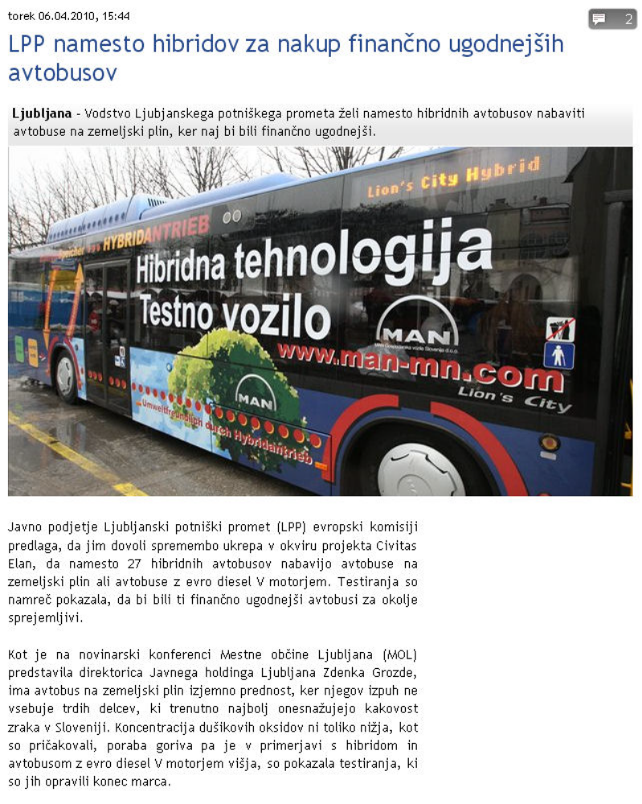

Appendix 5
Questionnaires about the implementation and importance of “green” technology

Status: Draft, Final, Approved, Submitted
Circulation: PC = Project Coordinator; PM = Project Manager; SC = Site Coordinators; EM = Evaluation Manager; DM = Dissemination Manager; SEM = Site Evaluation Managers; SDM = Site Dissemination Managers; SCo = Scientific Coordinator, P = partners, ML = Measure Leaders

