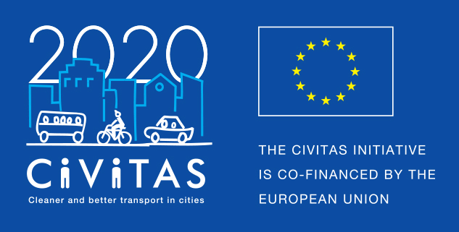
w
CIVITAS peer-exchange
Programme – e-Publication
Best practice - Video Guidelines

Project Acronym: | CIVITAS SATELLITE
Full Title: Support Action Towards Evaluation, Learning, Local Innovation, Transfer and Excellence
Grant Agreement No.: | 713813
Deadline for producing the video: 16 October 2020
Contact person: Arianna Americo, EUROCITIES
arianna.americo@eurocities.eu

CIVITAS SATELLITE Guidelines for the video production

As alternative to the cancelled CIVITAS study visits due to the COVID-crisis, CIVITAS will produce an e-publication as "an interactive best-practice sharing experience". If selected, your city will be included in the e-publication and a maximum of 2.500 EUR will be allocated to your city to produce a short (2-3 min) video. The video should focus on one of the three best practices (see the best practice template) described in the text and/or on how you think the future of mobility will look like in your city after the crisis.
In order to ensure consistency between the different videos that will be produced by the cities, we kindly ask you to stick to the following guidelines.
The video should have a length of 2 to maximum 3 minutes.
The video should focus on one of the three best practices described in the 3 Best practices text template you will have submitted previously (deadline 11 September 2020).

Deadline
The production of the video shall be finalised by 16 October 2020.

Video script

Part 1 – Introducing your city
Visual  Screen the title of the video alongside the CIVITAS logo. The title should start with “Dare to” followed by the specific practice or a behaviour you would like to invite others to take up. You can even keep it rather vague.  Ex 1: Dare to… open-up streets for people  Ex 2: Dare to… innovate.  Wide shot of the city. | Audio  We encourage you to start the speech with the same sentence of the title of the video, followed by the context.  Where are we? Explain your city’s larger engagement with the chosen theme.

Part 2 – Explain your best practice
Visual  The actual location of the best practice, focused on the interviewee. | Audio  Interview of a city expert / political representative speaking.  Describe the best practice, the innovative aspect, the benefit for citizens (might add a testimonial from user), the potential for replication in other cities: 1-2 tips.

Part 3 – Final key message
Visual  Shot of location of the best practice, without interviewee, potentially showing users in action.  Followed by visual summarising the key message and the CIVITAS logo. | Audio  Close with key message. Not more than 3 sentences followed by:  “We dared, will you?”
Inspirations

You can find a list of inspirational videos below:

Turin: https://youtu.be/IZlmRGzQOKo
In the Turin video you can see the how we would like the video to start. Please use the CIVITAS logo in attachment (you can add the logo of another project you are carrying out in your city if necessary). In this case the title is ‘Accelerating the take-up of Sustainable Urban Mobility Plans across Europe’; for our videos the title should start with “Dare to” followed by the specific practice or a behaviour you would like to invite others to take up, as explained in Part 1 above.

The overall Turin video is quite long, so we should aim at making a condensed version of it. However, please use it as inspiration according to the guidelines above.

Also good for reference Bremen: https://www.youtube.com/watch?v=scik9xGaxzY

