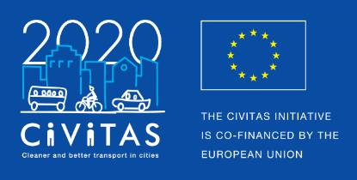
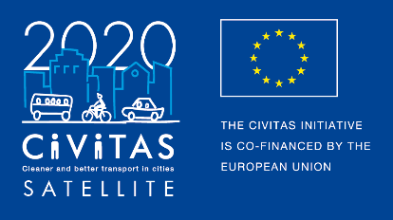
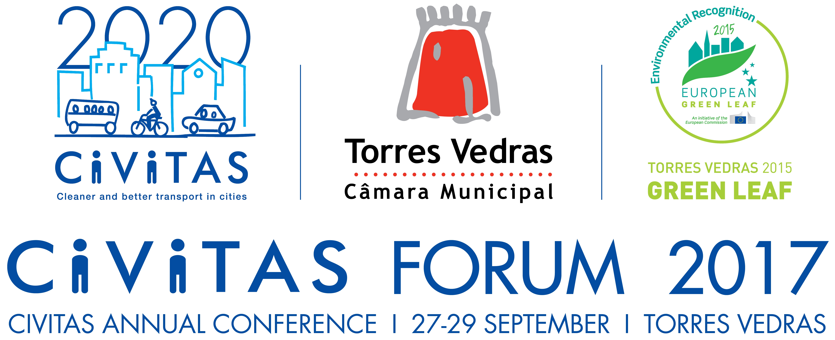
SPONSORSHIP
OPPORTUNITIES

CIVITAS Forum conference
27- 29 September 2017
Torres Vedras

About the Forum Conference
The CIVITAS Initiative, established 15 years ago by the European Commission, supports cities with developing and implementing sustainable urban mobility measures. Its flagship event is the annual CIVITAS Forum conference, with over 400 participants discussing technical solutions, innovations, and challenges to sustainable urban mobility and how these can be applied in their local contexts.
Organisers
This conference is being organised on behalf of the European Commission by CIVITAS SATELLITE together with the city of Torres Vedras.
When and Where
The 15th edition of the annual CIVITAS Forum conference will take place in Torres Vedras (Portugal) on 27-29 September 2017. The event offers you the possibility to showcase your product, solution or organisation in the form of sponsorship.

Sponsor benefits
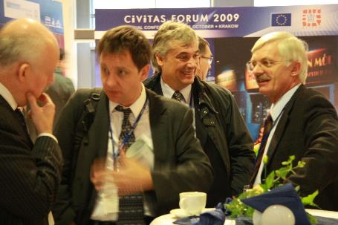
The CIVITAS Forum Conference will provide an ideal opportunity for businesses to interact with local, regional and national government representatives, as well as delegates from European and international institutions.
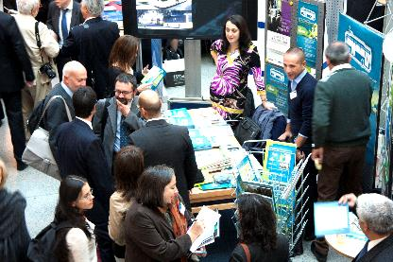
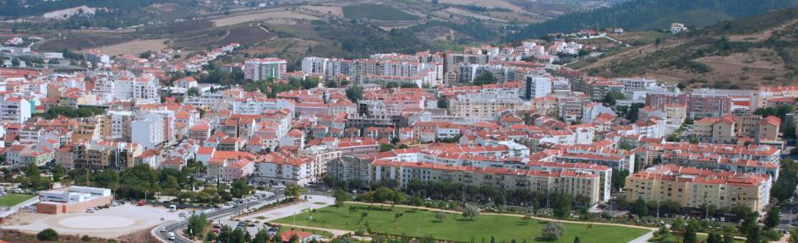

Sponsoring the CIVITAS Forum Conference can deliver a number of practical benefits:
- Work with local governments to discuss smart and innovative urban mobility solutions;
- Identify how public authorities and businesses can best cooperate to achieve sustainable solutions and at the same time benefit the local economy;
- Work with local governments to improve Europe’s competitiveness and its ability to create jobs and to tackle environmental and societal challenges;
- Gain a better understanding of local governments’ needs in dealing with societal challenges under difficult economic conditions;
- Gain a better understanding of expectations local authorities have of the private sector;
- Make use of the conference’s interactive setting to showcase your organisation’s ideas, policies, products and services to support sustainable societies.
Exhibition area
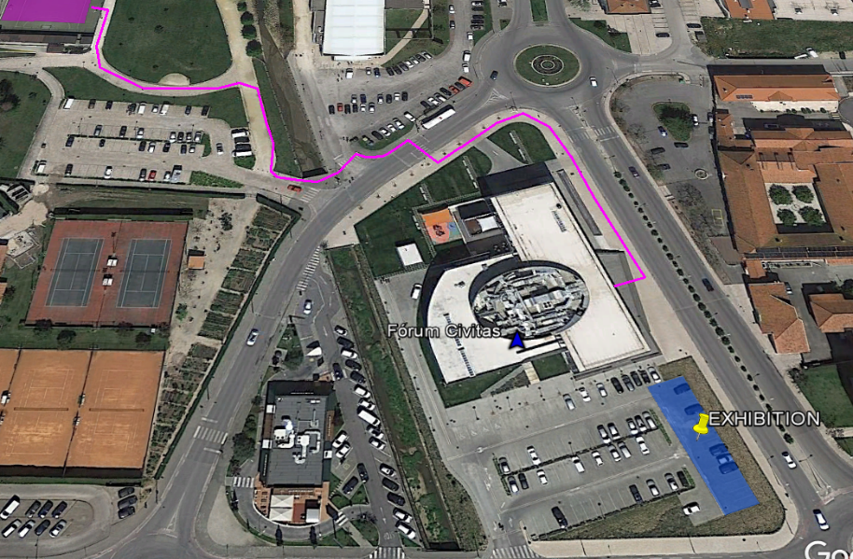
APPLICATION FORM C – Sponsorship

Contact person
Name
Organisation
E-mail address
Phone
Project

Company and product information
Company profile
(max. 300 words):
Product description
(max. 400 words):

Level of envisaged sponsorship
Visibility in conference programme brochure (full colour) | Company logo on the back of the brochure (€500)  ¼ page size advertisement (€450)  ½ page size advertisement (€1,000)  Full-page size advertisement (€1,500)
Food/ drinks | Lunch 27, 28 or 29 September 2017 (€ 250)  Cocktail reception on 27 September 2017 (€750)  Gala dinner on 28 September 2017 (€250)  You company logo, roll-ups, brochures, etc. can be placed in the eating area. The CIVITAS Secretariat will contact you about further details on logistics.
Exhibition stand | Exhibition stand (during Deployment Day only) (€250)  Exhibition stand (during entire CIVITAS Forum conference) (€750)
Equipment requirements | We will need a table at our stand  We will need chair(s) at our stand. Please indicate number: ____  We will need electricity at our stand
Additional space needed | If you require further space than just your exhibition stand, e.g. to present vehicles, please include information how much space you would need. Thereafter, the CIVITAS Secretariat will contact you about further details on logistics and costs.

Notes:

Signature: Date:

Please send your application by email to the CIVITAS Secretariat: forum.contributions@civitas.eu.
Deadline for submission: 18th May 2017
If you have any questions, please contact the CIVITAS Secretariat.

Contact:
CIVITAS Secretariat
c/o Regional Environmental Center (REC)
Ady Endre ut 9-11
2000 Szentendre, Hungary
Phone: +36 26 504046
Email: secretariat@civitas.eu

* Please note that SATELLITE will not cover any travel costs to the CIVITAS Forum conference.
** We would like to remind you that everyone who will attend the Forum conference 2017 (also those who have an exhibition stand, etc.) should also register for the conference on the CIVITAS website.

All prices mentioned are excluding VAT.

