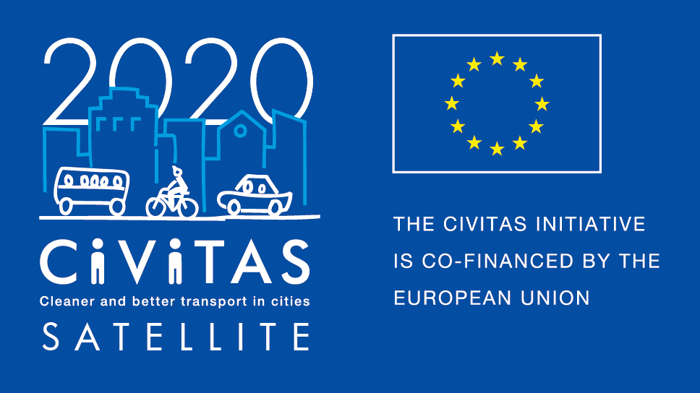
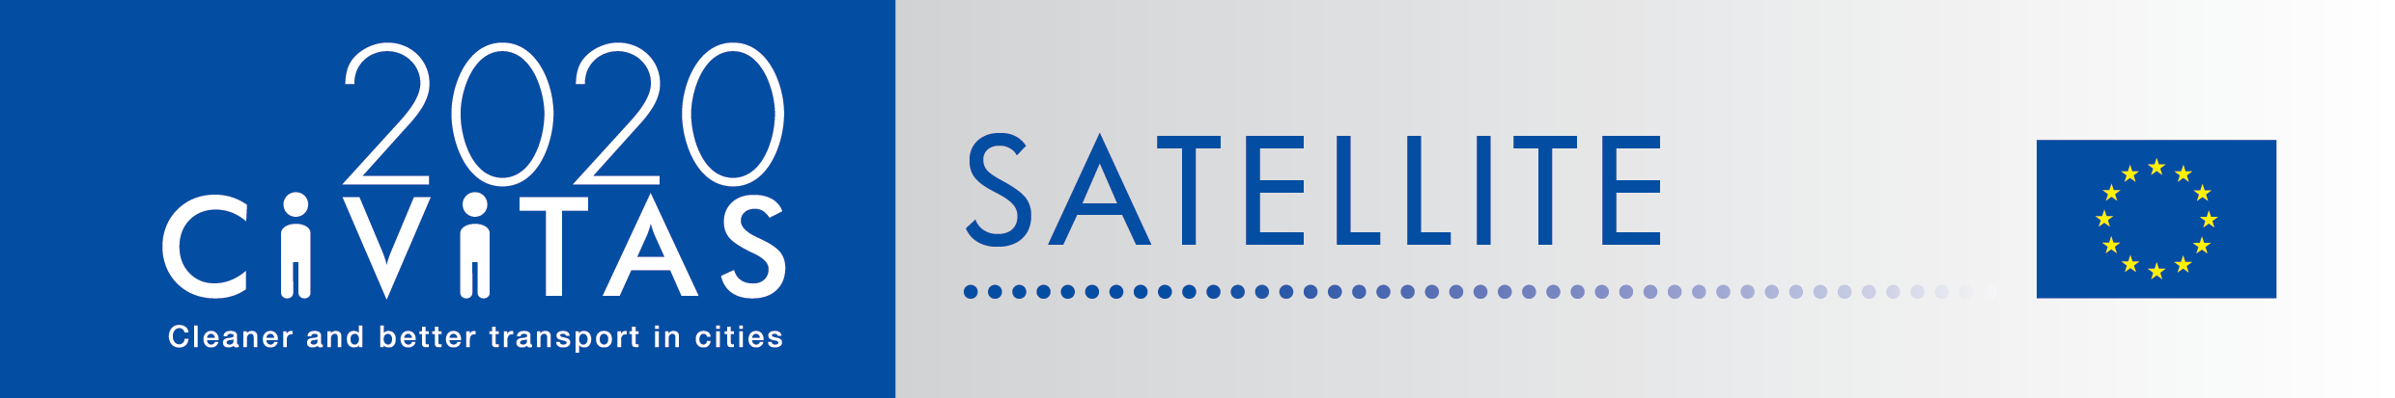
w
CIVITAS SATELLITE peer-to-peer activities in a nutshell

SATELLITE application form for visiting cities
Study Visit in Szeged

Project Acronym: | CIVITAS SATELLITE
Full Title: Support Action Towards Evaluation, Learning, Local Innovation, Transfer and Excellence
Grant Agreement No.: | 713813
Deadline for application: 20 March 2020
Contact person: arianna.americo@eurocities.eu

CIVITAS SATELLITE is an initiative designed to support cities in gaining better access to innovative solutions and to address transport challenges by applying exchange mechanisms for transfer and take-up.
Between 2017 and 2020, SATELLITE will organise at least 20 visits, in the form of work placements and study visits, for city representatives willing to learn from each other and to exchange extensively with each other.
Participants for these peer-to-peer visits will be selected each year through calls for expression of interest.

This form is for cities willing to take part as a visiting city in a study visit in Szeged on 18-20 May.

If you are selected as visiting city, you:
- Will receive support for the preparation and the follow-up of the visit you will attend.
- Might be selected to receive financial support up to €600 to cover for travel and accommodation for a study visit, after providing us with invoices.

Apply!
Do you want take part to CIVITAS SATELLITE peer-to-peer exchanges? Please fill in the application form by 20 March 2020 and send it back to arianna.americo@eurocities.eu
- Contact person:
If you have any questions, please contact Arianna Americo: arianna.americo@eurocities.eu
(+32 2 552 08 72)

ADDITIONAL INFORMATION TO READ BEFORE APPLYING

- Study Visit in Szeged
Szedeg is a pioneer city in Hungary in mobility management. The city is the National Network Manager for the Hungarian CIVINET Network. It received the CIVITAS Legacy award in 2018. Over the past 15 years, Szeged has implemented several mobility solutions, including establishing traffic calming zones; improving cycling infrastructure; creating new bus lines; expanding and reconstructing its tram and trolleybus network and providing comfort services for PT users such as Wifi network on board, contactless payment for the public transport tickets, etc.
In 2019 Szeged received funding form the Urban Innovation Actions programme within Mobility Theme for its Smart Alliance for Sustainable Mobility proposal. 2020 will be the final year of the project implementation.
During the CIVITAS study visit following themes will be explored: clean fuels and vehicles, collective passenger transport, car-independent lifestyle, integrated planning, mobility management and public involvement. There are several key questions the city of Szeged would like to raise and issues the city wants to share with European partners: What are the benefits for local authorities to work with private and public companies towards sustainable mobility? What are the difficulties and benefits of collaboration? How can benefits for employers be calculated within strict market constraints? How can we generate data on mobility patterns and how can we use them for smarter mobility planning? What are the best actions for behaviour change? How to balance between bicycle promotion and public transport development within the municipal budget?

The city of Szeged is planning to organise dynamic and interactive activities aiming to facilitate immersion into the local mobility solutions, knowledge transfer on experiences and exchange of ideas, viewpoints and impressions. A mix of different types of activities, which would allow a free flow of knowledge exchange between host city partners and the visiting city representatives. Szeged plans to organise more formal demonstrations events and more relaxed action learning events, which would create an open atmosphere for learning and exchanging ideas;

- Walkshop through the city with the Vice-Mayor – interactive and direct exchange of experience. Site visit at employers’ offices; presentation of successfully implemented projects, their actions, history challenges and barriers.
- “in the command centre” – knowledge sharing on innovative passenger detection system patented by Szeged University and its applicability for mobility planning (introducing innovative urban mobility data generation system connecting WIFI signals with camera images).
- “Riding lecture” on regenerated tramline on PT infrastructure development and comfort service with Public Transport Company in Szeged (visiting the remise), - Trolley 2.0, Eliptic project.
- Roundtable discussion with employers on employers-based mobility planning and actions – use of IT platform, experiences of car-sharing application usage, evaluating the success of new measures on mobility patterns. Calculating/measuring costs and benefits of investing in employee mobility service.
- Lecture on evidence-based mobility planning at municipal level – management, the use of data in mobility planning, connecting mobility with other aspects of local administration (SUMI project, prosperity project).
- Pecha-kucha event on the successful behavioural change campaigns.
- Summary workshop on the power of peer actions, benefits of synergies – lessons learnt from SASMob and Low-Carb projects.

- What is a study visit?
CIVITAS SATELLITE study visits offer the opportunity for up to 10 city representatives from 10 different cities to travel to another European city facing similar challenges in sustainable urban mobility to learn about possible solutions and best practices. These 2,5-3 day study visit will be tailored to the needs of the participating cities and take an interactive approach, to facilitate in-depth exchange, and strengthen cooperation. City representatives will benefit from financial support covering travel and accommodation costs.
- Why join CIVITAS SATELLITE peer-to-peer programme?
If you are a visiting city, you will:
- Have hands-on experience in another city,
- Have the opportunity to exchange on a one-to-one basis with leading peers,
- Be promoted on the CIVITAS website and European-wide media outlets as a city committed to sustainable urban mobility,
- Be offered speaker slots at European level events,
- Be able to apply for the CIVITAS award in the Take-up category

- What will be the tasks of cities involved?
If you are a visiting city, you will:
- Define a detailed request for learning
- Identify a local challenge faced by your city
- Liaise with the SATELLITE team to agree on the objectives of the visit
- Write a short impact report describing new skills acquired
- Send all documents required for the reimbursement of costs (if selected for financial support)

CIVITAS SATELLITE Call for visiting cities (Study Visit in Szeged)

- Fundamental information
Name of the city & Country
Structure & size | ☐ City  ☐ Metropolitan area  Population:
Are you member of the CIVITAS Community? | ☐ CIVITAS demonstration city  ☐ CIVITAS Forum network city  ☐ CIVINET member city  ☐ IA or RIA project partner city  ☐ None
Has your city been awarded an award for its work on sustainable mobility?  If yes, which one? | ☐ CIVITAS award  ☐ EUROPEANMOBILITYWEEK award  ☐ SUMPs award  ☐ Other (please specify)  ☐ My city has applied or has been short listed but not selected  ☐ None
Do you have recent experience of peer-to-peer exchange?  If yes please specify | ☐ Yes (Please specify below)  ☐ No

- Preparing the visit
What are the main reason(s) why you want to take part to a CIVITAS peer-to-peer visit?
Which challenge from your city do you plan to present to your host city?
How do you plan to do this?
Which key local/regional decision makers, project managers and/or stakeholders would you like to meet during your visit? Why?
Will you communicate about this visit? If yes how?

- Practicalities and joining instructions
Contact person(s) for the organisation of the visit | Name:  Position:  Telephone:  Email:  Address: | Name:  Position:  Telephone:  Email:  Address:
Can you confirm and make sure that your colleagues have a sufficient level of English to present their experience? | ☐ Yes  ☐ No
How did you find out about the CIVITAS SATELLITE study visit?
Other questions

Final declaration
I have the pleasure to inform you that the city of name of the city/region supports the participation of its staff in the CIVITAS SATELLITE initiative in [2020].
Place
Click here to enter a date.
Name
Position
City/region
NB: this form should be signed by the Mayor, the Vice-Mayor or the Director of the Transport department in your municipality

