


Implementation status report on improved public transport service levels

ELAN Deliverable No. 2.2 – D1
Project acronym: ELAN
Project full title: Mobilising citizens for vital cities

Grant Agreement No.: ELAN TREN/FP7TR/218954/”ELAN”

Workpackage: WP2 Collective passenger transport services & intermodal integration
Measure: 2.2-GEN Improved public transport service levels
Author: Frank Desloovere

Final

19/9/2011
ELAN deliverable no. | 2.2-D1
Date / Version | 19/9/2011 / Final
Dissemination level
Work Package | WP2
Author(s) | Frank Desloovere
Co-author(s)
File Name | 2.2 - D1 - Implementation status report on improved public transport service levels.docx

Keywords

 | General |  |  |  | Work package links
x | CIVITAS |  |  |  | WP1 Alternative fuels & clean vehicles |  | WP7 Energy-efficient freight logistics
x | ELAN Project |  |  | x | WP2 Collective transport & intermodal integration |  | WP8 Transport telematics
 |  |  |  |  | WP3 Demand management |  | WP9 Project coordination
 |  |  |  |  | WP4 Influencing travel behaviour |  | WP10 Project management
 |  |  |  |  | WP5 Safety, security & health |  | WP11 Research and Technological Development
 |  |  |  |  | WP6 Innovative mobility services |  | WP12 Impact and process evaluation
 |  |  |  |  |  |  | WP13 Dissemination, citizens’ engagement, training and knowledge transfer

Document history

Date | Person | Action | Status | Circulation
15/9/2011 | Frank Desloovere | Finalisation 1 ^{st} Draft | Draft | SC
19/9/2011 | Frank Desloovere | Final version | Final | PM

CONTENT

1. Measure 2.2.-GEN – An overview 4
1.1. Objectives 4
1.2. Innovative aspects 4
2. Real Time Passenger Information 4
2.1. Concept 4
2.2. Implementation 5
2.3. Next steps and future plans 6
3. Reorganisation of tram- and bus stops – Korenmarkt 6
3.1. Objective 6
3.2. Implementation 6
3.3. Next steps and future plans 8
4. Redevelopment of the tram axis between train station Sint-Pieters and ring road R40 9
4.1. Problem description 9
4.2. Concept 9
4.3. Car access restriction system 10
4.4. Implementation 10
4.5. Next steps and future plans 11
5. Accessible stops and improvement of travel times at other places in the PT network 11
5.1. Accessible bus stops 11
5.2. Redevelopment Brusselsesteenweg 11
5.3. Trip analysis of tram and bus lines 12
5.4. Screening of the traffic lights 12
5.5. Bus lanes 12
5.5.1. Kasteellaan 12
5.5.2. The Loop 13
5.6. Bypasses for buses 13
5.7. Public transport transfer point ‘Rabot’ 14

Measure 2.2.-GEN – An overview

Objectives
The main objective of this measure is to improve the quality of the main public transport corridor between the railway station and the city centre with a range of complementary measures:
- Providing real time passenger information
- Reorganising tram- and bus stops
- Redevelopment of the tram axis between train station Sint-Pieters and ring road R40
The secondary objective is to upgrade the quality of service on a number of ‘hot spots’ in the network throughout the city in order to decrease public transport travel times and to improve access to stops.
The final objectives are:
- To improve the image of public transport
- To increase the number of public transport users
- To improve the accommodation and access to public transport stops
- To cut travel times on public transport
This measure is fully complementary with measure 8.6-GEN – “Sustainable multi-modal traffic management” – in which measures are foreseen to limit car access to a level where any congestion for the public transport vehicles in this corridor is avoided.

Innovative aspects
The innovative aspects of this measure concern the holistic way in which the improvements of the public transport service transform the corridor into a strong mobility axis for the city. People will receive planning and real-time info at all stops and in the interchange points. Generally public transport will have a high level of accessibility and particularly the public transport axis will be a structuring mobility axis for the city (not anymore seen as a car axis, but clearly as a public transport axis). To avoid public transport congestion, several crossings on this axe are redesigned.
Moreover a number of stops are adapted to the special needs of mobility impaired people. This was done by involving mobility impaired people associations.

Real Time Passenger Information

Concept
The Real Time Passenger Information System makes use of the existing system that De Lijn already utilizes to monitor its vehicles.
Each tram and bus is equipped with GPS and a radio. The latter sends the vehicle’s position to the central monitoring server. This position can be consulted via GIS by the dispatchers. As the departure time of all trips at each stop and the position of each bus and tram is known, the system can determine whether the vehicles are on schedule. In case they are not, the delay can be calculated. The Real Time Application Server (RTAS) does this calculation for each stop in the network of De Lijn and makes permanent updates. This information can be used for several purposes of which the RTPI system is one of the most important. A ‘Stop Server’ queries the RTAS database for all stops with RTPI and sends the information in XML-format to the displays at these stops by GPRS.
The full colour displays have a ‘flag’ construction. They display the actual time, the departure time of the first trips at the stop, and several messages which can have a different level of urgency. Some of the displays are also equipped with a sound system (text to speech) which can be operated by pushing a button. Finally the displays have a self diagnostic system which permanently monitors the important variables of the system and provides feedback to the Stop Server.

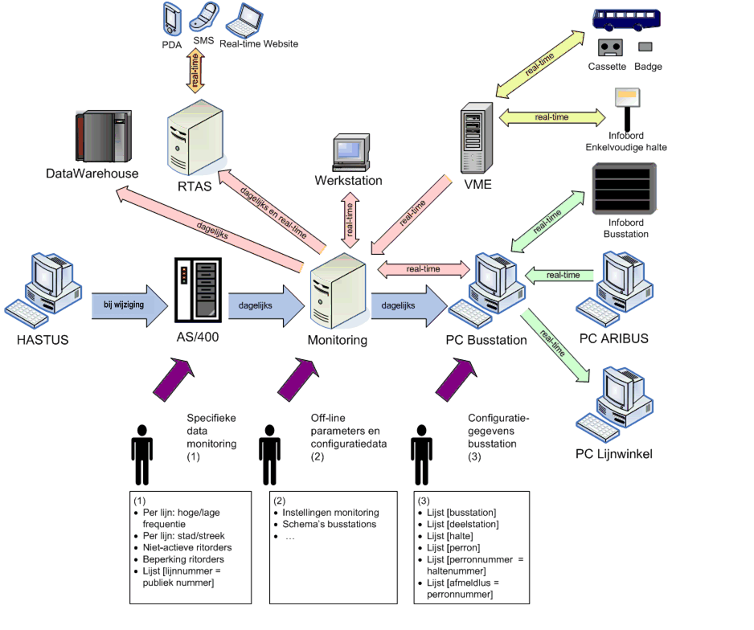
Halteserver

Design of the monitoring and real time information system

Implementation
The concept was technically elaborated as described above and a contractor assigned. A final design was approved by De Lijn. A prototype of the displays was presented by the Minister of Mobility on April 10th 2009.
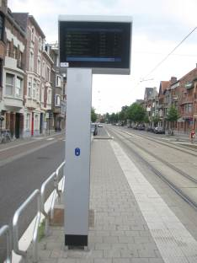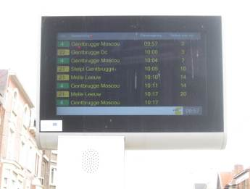
The organisation and timing for the placement of the displays were discussed with and approved by the City of Gent. On December 16th 2010, the first 23 displays were put into service. On August 31st 2011, 57 stops in Gent – of which 21 in the CIVITAS-corridor – were equipped with the RTPI-system.

Next steps and future plans
From September 5th onwards, another 50 displays will be placed in Gent of which 10 are situated in the CIVITAS-corridor. By the end of 2012, 201 displays should be placed in the province of Oost-Vlaanderen of which 166 in the City of Gent and 38 in the CIVITAS-corridor.
There are still some communication problems between the stop server and some of the RTPI-displays. This is studied in cooperation with the contractor in order to solve this problem in the short term.
The appreciation of the RTPI-displays by the public will be evaluated.

Reorganisation of tram- and bus stops – Korenmarkt

Objective
The city of Gent redesigned the Korenmarkt and surroundings in order to create a pleasant zone in the heart of the city. As a result, the public transport transfer point is concentrated in the Cataloniëstraat. This transfer point is equipped with accessible and comfortable stops.

Implementation
The tram rails on the Korenmarkt and in the Cataloniëstraat and Sint-Niklaasstraat were entirely replaced in order to make it possible to create a modern public transport transfer point and to make all tram movements possible.
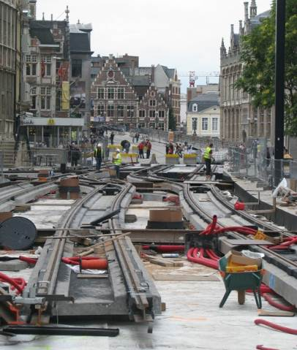
In the situation before renovation, the stops were not accessible for wheelchairs and disabled people. There was no real time information and the accommodation was poor.
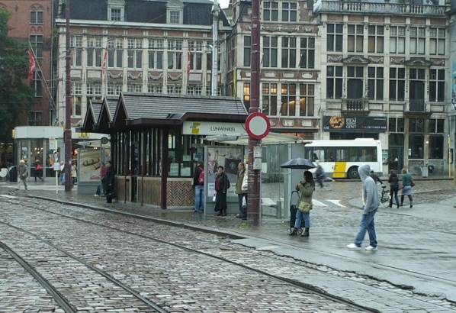

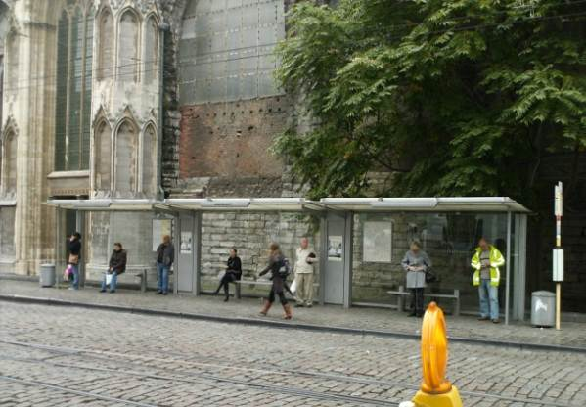
Situation before renovation
The new tram and bus stops are equipped with all passengers facilities: abris, ticket machines, real time passenger information, accessible platforms, …
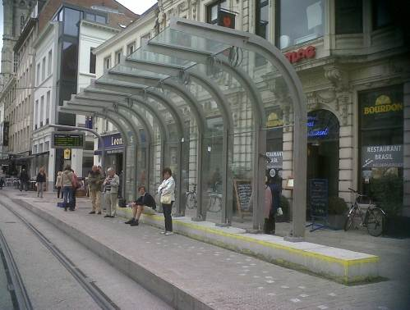
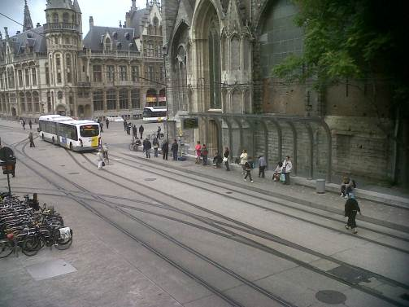
Situation after renovation

Next steps and future plans
The public transport transfer point is nearly finished: only the shelters should be finalised and the ticket machines installed.

Redevelopment of the tram axis between train station Sint-Pieters and ring road R40

Problem description
The axis Elisabethlaan-Kortrijksesteenweg-Kortrijksepoortstraat-Nederkouter is one of the most important corridors for the public transport in Gent (tram line 1). This intensely used public transport axis connects Flanders Expo and the Gent Sint-Pieters station with the Gent inner city (node Korenmarkt) with a frequency of minimum 6 minutes in peak time. From there the tram runs to the municipalities Wondelgem and Evergem.
On the section Maria Hendrikaplein – N414, which is also an important access road for cars and other motorized transport, the tram shared the road with the other traffic in both directions.
On the section Elisabethlaan – Kortrijksesteenweg the tram was mixed with the other traffic in both directions. As a consequence the tram was severely obstructed by the congestion during the peak and shopping hours, resulting in long delays.
The urban concept of this section was outdated and the road infrastructure needed to be updated.

Concept
In order to improve the travel times on the axis, the following measures were included in the concept and the final plans:
- In the direction of the centre of the city the tram uses a dedicated lane, so it cannot be obstructed by congested car traffic.
- A car access restriction system is installed and the traffic light regulation is optimised. To this end the road infrastructure of the R40 is also adapted.
- Crossing of the road by other traffic is limited to specific zones.
The client comfort is improved by the following measures:
- Broad, accessible platforms were installed
- At all stops comfortable shelters were installed.
- At all stops Real Time Passenger Information is provided.
- Safe crossings for pedestrians are provided.
The urban concept is innovative:
- The concept for both the Elisabethlaan and the Kortrijksesteenweg is similar to the design of rebuilt roads in the neighbourhood, such as the Clementinalaan and the Albertlaan.
- The individual character of both the Elisabethlaan and the Kortrijksesteenweg is taken into account.
- Sufficient attention is paid to the integration of green elements.
- The design is clear to all users of the public domain: pedestrians, bicycles, cars.
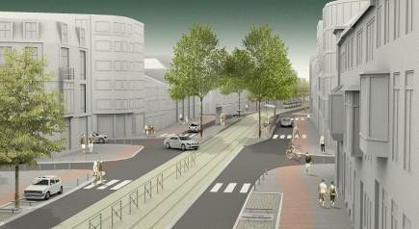
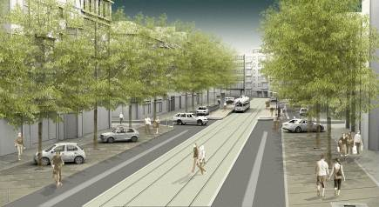

Car access restriction system
A car access restriction system was selected as the solution for the flow problem: when congestion is detected in the Nederkouter, an intelligent traffic light control guarantees an optimal flow for the tram. This system moves the congestion to the R40 by holding back the traffic flow to the Kortrijksepoortstraat. A traffic light at the Plateaustraat prevents further congestion and cut through driving.
Two cameras detect when congestion occurs. In this case the system alerts a dispatcher and requests confirmation to activate the car access restriction system. If confirmed, the signalisation regulating the car access restriction starts to operate at the crossings Kortrijksepoort and Verloren Kost. On the R40 a ‘dynamic prohibition’ to turn right to the Kortrijksepoortstraat will stay operational as long as the car access restriction system is active. Drivers will be alerted in advance about the activation of the system via dynamic traffic management signs. These signs will propose alternatives to reach the centre.
The expected result is a better flow for the tram: the estimated time gain is 7 minutes.

Implementation
The concept of Kortrijksesteenweg-Elisabethlaan was presented to the public at an information evening. The plans were adapted, based on the comments and suggestions made during this session. The road construction started on November 20th 2009. On June 30th 2011 the redevelopment of Elisabethlaan en Kortrijksesteenweg was finished. The contractor encountered some delay due to unfavourable weather conditions and unforeseen complications.
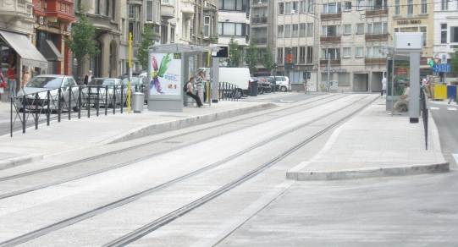
The tram lane and renovated stops in the Elisabethlaan
At this moment the ring road R40 is being adapted in function of the car access restriction system. Here too some delays occurred due to the weather conditions and the adaptation of the plans following the decision to maintain the central ‘Alpentuin’.

Next steps and future plans
In November the adaptation of the R40 and the installation of the car access restriction system will be finished. Subsequently the car access restriction system will be tested and evaluated. An adjustment of the system is planned after a few months of further evaluation.

Accessible stops and improvement of travel times at other places in the PT network

Accessible bus stops
All 1144 stops were screened on flow improvement, accessibility, shelter accommodation, etc. Based on this screening 122 stops were selected for implementation of the new bus stop concept. On September 15th 2011, 84 stops have been adapted.
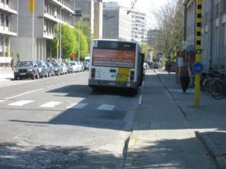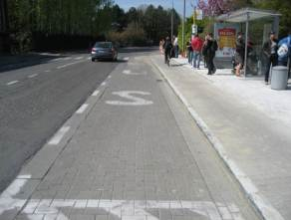
Bus stops in the Henri Dunant before renovation
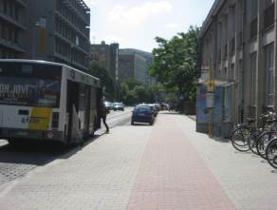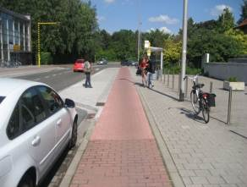
Bus stops in the Henri Dunant after renovation

Redevelopment Brusselsesteenweg
The Brusselsesteenweg is an important access road from the south to the city. In the smallest part of this road the tram is mixed with the other traffic in both directions. As a consequence the tram is severely obstructed by congestion during peak hours resulting in long delays, mostly in the direction towards the city. The objective of the redevelopment study of the Brusselsesteenweg is to improve the facilities for pedestrians, bicycles and tram. The public transport flow improvement is a significant part of this study. A new concept for the relocation of all tram stops is worked out, together with the principles of circulation and parking in all neighbouring streets. There will be a dedicated tram lane in the direction of the city in the small part of the Brusselsesteenweg.
There is a consensus about the concept between all parties involved. The start of the road construction is planned in 2013.
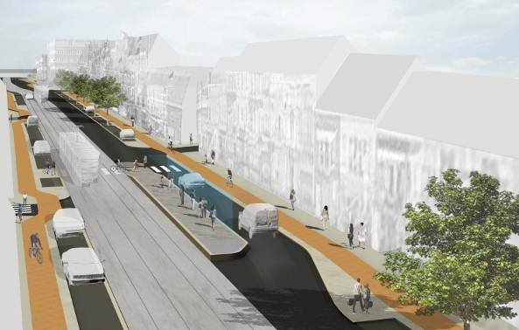

Trip analysis of tram and bus lines
The trip analysis of the tram lines and two bus lines in Gent was finalised in June 2010. For this study several tram and bus trips were analysed in order to detect the causes for delay in the travel time and to define the extent of the time lost. As a result of this analysis a list of bottlenecks in the flow of the vehicles was established. For each line a major bottle neck was determined. A proposal to improve the travel times on the lines will be elaborated for each of these items. A number of bottle necks can easily be eliminated.

Screening of the traffic lights
All traffic lights in the City of Gent were screened on their operation. This resulted in a proposal for improvement of the functioning for each traffic light. An important item in this study concerned the reduction of the delay of the buses at traffic lights. Improvement can be realised through the capability of the buses to influence the traffic light cycle.
Following this study, some of the traffic lights were adapted. A complex combination of crossings, which are used both by tram and buses and where traffic jams often occur, was studied and discussed. A new traffic light scheme that should improve the traffic flow was proposed.

Bus lanes

Kasteellaan
The trip analysis indicated a recurring delay in the travel time for buses in the Kasteellaan, a major access road to the West and to the Dampoort railway station. The delay is caused by a missing link between two bus lanes. The reason for this missing link is that the road is to narrow for a separate bus lane.
The City of Gent agreed to the use of a part of its grounds to widen the road in order to build the bus lane and to improve the infrastructure for bicycles. AWV used this opportunity to design a new concept for the crossing of the Kasteellaan with the ring road R40 and to improve bikers safety. There is a consensus about the concept between all parties involved. There is no concrete timing for the implementation yet.

The Loop
A bus lane on the site of The Loop will be built by De Lijn and AWV. The buses on this bus lane will serve a large new office building and offer the employees a direct connection with the Sint-Pieters railway station. The start of the construction of the bus lane is planned for the autumn of 2011.

Bypasses for buses
AWV built several bypasses at crossings for buses. As a result buses are not delayed at the traffic lights on these crossings. This concept was realised at the crossing of the N70 with the Alfons Braeckmanlaan and at the crossing of the Hundelgemsesteenweg with Bellevue and the Heyndrickxlaan.
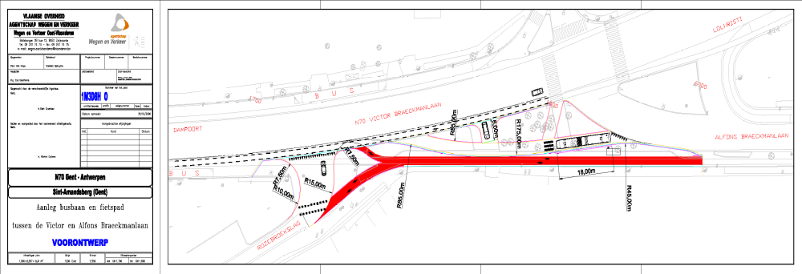
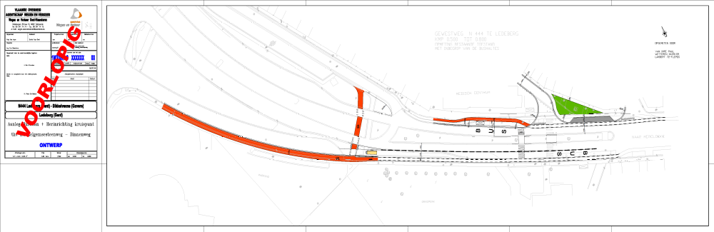

Public transport transfer point ‘Rabot’
A large social housing site is situated in the Rabot neighbourhood. The buildings are located next to a public transport transfer point. The study of a new design for the site was an opportunity to reconsider the PT transfer point. The result is a concept where accessibility and flow are important items.
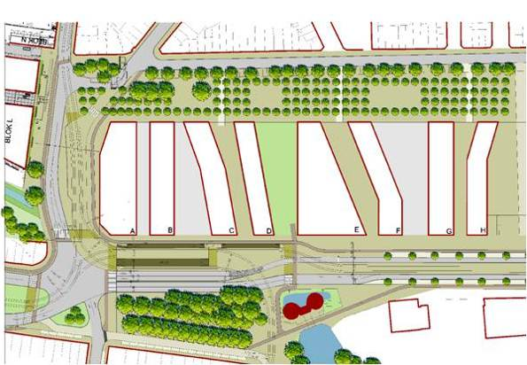

Status: Draft, Final, Approved, Submitted
Circulation: PC = Project Coordinator; PM = Project Manager; SC = Site Coordinators; EM = Evaluation Manager; DM = Dissemination Manager; SEM = Site Evaluation Managers; SDM = Site Dissemination Managers; SCo = Scientific Coordinator, P = partners, ML = Measure Leaders

