


Implementation status report on the semi public clean car fleet

ELAN Deliverable No. 1.9-D1
Project acronym: ELAN
Project full title: Mobilising citizens for vital cities

Grant Agreement No.: ELAN TREN/FP7TR/218954/”ELAN”

Work Package: WP1 Alternative fuels & clean vehicles
Measure: 1.9 GEN Semi public clean car fleet
Author(s): Geert Gisquière
Co-author(s): -

Final

15 July 2011
ELAN deliverable no. | 1.9-D1
Date / Version | 18 April 2011 / final
Dissemination level
Work Package | WP1 Alternative fuels & clean vehicles
Author(s) | Geert Gisquière
Co-author(s) | -
File Name | 1.9 - D1 - Implementation status report on the semi public clean car fleet_revised.doc

Keywords

 | General |  |  |  | Work package links
x | CIVITAS |  |  | x | WP1 Alternative fuels & clean vehicles |  | WP7 Energy-efficient freight logistics
x | ELAN Project |  |  |  | WP2 Collective transport & intermodal integration |  | WP8 Transport telematics
 |  |  |  |  | WP3 Demand management |  | WP9 Project coordination
 |  |  |  |  | WP4 Influencing travel behaviour |  | WP10 Project management
 |  |  |  |  | WP5 Safety, security & health |  | WP11 Research and Technological Development
 |  |  |  |  | WP6 Innovative mobility services |  | WP12 Impact and process evaluation
 |  |  |  |  |  |  | WP13 Dissemination, citizens’ engagement, training and knowledge transfer

Document history

Date | Person | Action | Status | Circulation
15.03.11 | G. Gisquière | Finalisation 1st Draft | Draft | SC
18.04.11 | G. Gisquière | Preparation of final version | Final | PC
15.07.11 | G. Gisquière | Revision according to EC reviewers’ comments of 10 June 2011 | Final | PC

CONTENT

1. Introduction 4
2. Basic info 4
3. Setting up the test – preconditions 5
3.1 The selected test model 6
3.2 The charging point 7
3.3 The cambio software 8
4. Test design – the actual launch through a phased approach 9
5. CIVITAS-ELAN ...more than just electric vehicles 10

Introduction

The aim of this Deliverable is to give a description of the implementation status of measure 1.9-GEN Semi public clean car fleet within CIVITAS-ELAN which should result into the integration of electric vehicles into cambio’s carsharing fleet.

On the long term, this introduction of clean(er) vehicles within the carsharing fleet should result in a decrease of usage of fossil fuels in the carsharing fleet.

The cambio fleet nowadays only consists of vehicles working on classic fossil fuels. Although carsharing is already an environmentally-friendly way of car driving, the introduction of clean vehicles should reinforce this.

Within CIVITAS-ELAN a first test project will be set with this kind of electric vehicles in order to get the necessary experiences in this field and in order also to start sensitisation in the domain, both towards existing carsharing users as towards general public. Ideally, on the long term, this test project should also result into the introduction on a larger scale of cleaner vehicles within the cambio fleet (and other carsharing fleets).

Basic info

Cambio is a carsharing provider, owning a fleet of cars which are used by a large group of users. Those users use the cars for different trip purposes. Cambio is responsible for maintaining the cars.

As a consequence there are some basic requirements for each vehicle which is being integrated within the carsharing car park:

- The usage of this car has to be more or less intuitive in order to be usable by each cambio-user without needing to get a special training
- The vehicle should offer more or less the same level of functionality as a ‘normal’ car (action radius, user friendliness, etc.) or it has to be possible to set clear limits in order to avoid problems when this functionality is not the same.

These basic requirements were decisive when making the choice of a vehicle for setting up a test project.

During the feasibility study it became clear that there was quite a revolution going on within the car sector, which makes it difficult to predict which technology will be the main technology on the longer term. As on the private market, this fact forms a barrier for a fast short term integration of cleaner technology in carsharing fleets.

Cost aspects, infrastructure problems (charging infrastructure, etc.) and others make it less evident to switch from conventional fuel-driven vehicles towards cleaner vehicles.

Nevertheless, it was decided to set up a test. Although the impact on a global level will be limited at this moment, this test will help to get the necessary expertise in this field and can start sensitisation, both towards existing carsharing users as towards general public.

As a survey (during the analysis of the user needs) made clear that cambio users were very open towards environmentally-friendly vehicles and even were prepared to do some extra efforts, cambio is convinced that setting up this test was a good decision.

Further analysis has shown that hybrid cars are most similar to ‘normal’, so on a theoretical level this would be the best or most easy option to set up a test.

However, it became clear that this test would not really offer a big opportunity to learn (rather simple impact just replacing a normal car by a hybrid car) and that actual hybrid cars are rather oversized (bigger cars than a standard cambio city car, offering no real added value compared to those standard cars). As a consequence, it was decided to set up a test with the second best, but much more challenging option: setting up a test with a 100% electrical vehicle.

This test will be much more innovating, the challenge is quite larger, the possible impact on the environment bigger and the sensitisation effect will be greater.

Setting up the test – preconditions

The existing electric models still have some drawbacks, namely the limited range, the time needed to charge the vehicle and a lack of a public charging infrastructure.

As a consequence, it is not possible to introduce an electric vehicle within the fleet as a full replacement for a 'conventional' cambio car. In order to set up this test, some things need to be done:

- Finding a charging station where the car can be charged (public or semi-public domain)
- Adapting the software tools in order to force the car to ‘come home’ at night in order to be charged and to communicate between the charging station, the electric car and the software in order to be kept informed about the status of the battery level of the car (in order to be able to guarantee a high service level and to avoid people having made a reservation and leaving with an electric car without having sufficient battery level do finish their trip without problems)

If these conditions can be fulfilled, it should be possible to have a successful test and to offer this car to carsharing users as an alternative for a ‘normal’ car for short (inner city) trips, e.g. shopping.

Of course, it must also be possible to get the people trained in using this car via a demonstration course, a manual in the car or other possible solutions.

At last, in order to be integrated within the cambio reservation system, the car must also be compatible with the cambio hardware which needs to be built within the car (in order to receive reservation request sent by the central reservation server and to open the doors for people having made such a reservation, identifying themselves with their cambio chip card).

To set up the proposed demonstration cambio needed a vehicle and a location to charge it. Finally, the reservation tools needed to be adjusted.

3.1 The selected test model

The market for electric vehicles is still in full evolution. Several brands have already announced that they are working on one or more electric models and the first ones are available in the market (though still modest).

After several contacts cambio decided in the first stage (late 2009) to conduct a test with a Zero, a small city car (for two people) by the Italian company Tazzari. If the installation of the on-board computer succeeded, this small city car would be enabled as first electric car in the cambio fleet in Gent.

The Zero is a two-seat city car, with 160 litres luggage space. The car is ideal for urban and peri-urban movements, short to medium ranges (fully charged, the Zero can ride up to 140 km).

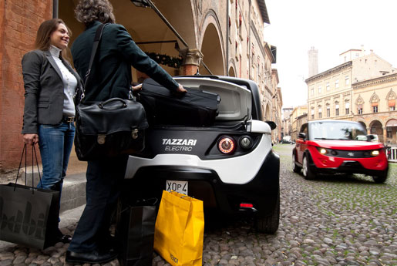

Tazzari Zero

In June 2010 the car was delivered. Previously in Italy, the necessary hardware was built in in order to be able to integrate the vehicle within the cambio fleet. However, during the first live tests, the first problems arose. The users didn’t get access to the car. After searching, cambio detected a compatibility problem between the Tazzari and the cambio hardware. The BCSA which was built in was not kept alive by the vehicle and went into sleep-modus after the car was set off: one first had to make contact in order to start the electric feed from the battery of the car towards the BCSA and only then the BCSA could awake and start functioning. As a consequence costumers would have had to get into the car first whereas in a carsharing system the BCSA is specifically meant – as one of its main functions – to control access to the car. In practice this meant that costumers needed to have the car key before entering the car in order to be able to start the car which does not work within a carsharing scheme with unguarded car-stations.

The problem didn’t get solved (probably partly also because the car was meanwhile in Belgium while the suppliers where located in Italy, so research in order to find a solution was done mainly from a distance), so a further test was impossible and it was decided to discontinue the trial. As the problem was situated at the supplier side (during negotiations it was stipulated that the integration of the BCSA had to be tested and should work successfully), the car could be returned without any cost. The BCSA which was meant to be used in the Tazzari could be used again when an alternative was found.

This decision was made in late 2010. A Plan B was put into effect in order not to jeopardize the realisation of this measure. A public tender was launched to start the search for another vehicle. Because cambio was a year further by then, there were some more vehicles available on the market to make a choice. In early 2011, the decision was made and cambio chose a Mitsubishi I-MiEV because this car was cambio hardware-proofed and because this model could be delivered earlier than other models.

The Mitsubishi I-Miev is a 100% electric car with four seats and a range of about 150 km. This vehicle has all the necessary safety devices and was the first electric car to be evaluated positively in the standard crash tests.

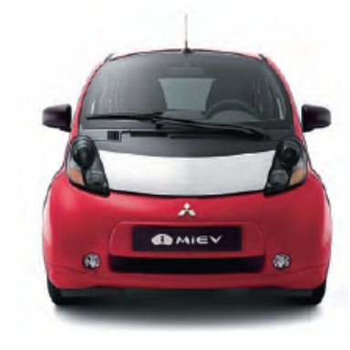

Mitsubishi i-MiEV

The vehicle was delivered and tested by cambio in March 2011. Since everything is functioning properly, the first information sessions are being planned for the end of March (28.03.11). At the beginning of April, a first limited test group will be able to start using the car. As it is a test and the potential of the car needs to be scanned (actual range), cambio will – especially in the first phase – install the necessary restrictions (maximum distance of a trip: 50 km, etc.).

3.2 The charging point

Electric cars need a long time to recharge and require a charging point. Therefore a suitable location is needed.

Charging through a cable makes it less obvious to open a stand in public space or open air (high risk of vandalism, etc.). Therefore cambio has chosen – especially in the first testing phase – to look for a more closed space.

In first instance, it was decided to start the tests in the Ramen parking of the Gent Parking company due to the following reasons: the city of Gent and the Parking company are partners within the CIVTAS-ELAN project and some of the people who work for the city of Gent will join the first testing group (these people work in the offices above the Ramen parking). At this location it will be possible to charge the car at night.

Depending on the first results of this demonstration project, it could be considered to place the vehicle on another, more public location in a second phase. At this location a charging pole will have to be installed. Doing so, cambio will probably choose a particular model in which the charging cable is attached to the charging pole and can be plugged in to the car very easily. This fact should increase the ease of use and by consequence reduce the threshold for the use of an electric vehicle: the user should not take a cable out of the trunk and connect it at two places, (s)he just takes the cable and plugs it in the car (time saving). Also, it is designed in that way the cable never drags on the floor and stays neat.

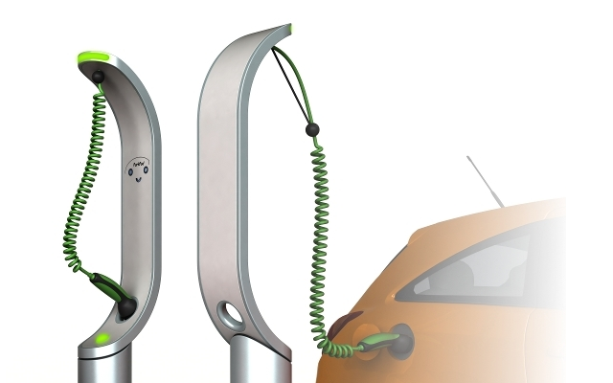

The future charging station?

A more crucial role of this charging pole is to set up a communication between the pole and the car on one side and the cambio reservation software on the other side. By setting up this communication, it is possible to have a signal sent when the cable is not well connected and the car is not being charged.

Also, it is possible to constantly monitor the status of the battery and to send a signal in time when a reservation is under threat by the limited range of the vehicle (anticipating on possible problems due to insufficient battery capacity - see below: software adjustments).

3.3 The cambio software

Electric vehicles have a number of limitations, the most important are the long charging time and the limited driving range (problems other fleet owners also will be confronted with when introducing electric vehicles into their fleet).

To fully integrate these vehicles into the cambio system it is necessary that the appropriate adjustments are made to the reservation software to overcome these two main hurdles:
- The vehicle will have to return to its base each night for recharging. Multi-day reservations or reservations at night should therefore be made impossible.
- Based on an estimate of the distance travelled during a reservation, the software will need to evaluate whether additional reservations are possible on a given day (as opposed to normal vehicles where this issue does not play because everyone can easily refuel en route). On top, based on the ‘live’ feedback via the charging pole, each closed reservation will be evaluated: if the real-time data show that the battery of a vehicle is less charged than estimated at the moment the reservation was made and thereby the following reservation is under threat, then the user must be warned in time and alternative solutions must be searched (replace car, etc.). By setting up this module, the service level must be guaranteed at all time, so the users will not turn their backs towards this new vehicle technology.

Test design – the actual launch through a phased approach

The purpose of this test design within the CIVITAS-ELAN project is to gain a number of first experiences while also working sensitising, in relation both to cambio’s own users as to the general public. The planned adjustments in the software however, should make a broader integration possible.

Preparation: March 2011

The carsharing station was provided with a charging socket, the on-board computer has been installed and cambio did the first tests. Meanwhile the necessary preparations were made to compose the initial testing group and to give this group an information session

Testing phase 1: April 2011 – September 2011

The vehicle has been integrated into the cambio fleet software and the demonstration project was published (call for test users via newsletter on 22.03.2011).

At this stage, the vehicle is only available to the cambio staff, some prospective users among the employees of the city of Gent and a limited group of cambio users (total group: 20-30 persons).

These persons received a training at the end of March (28.03.) so they clearly know how the car works and can be operated.

Reservations can only be made by phone, only one reservation per day is allowed – this in order to avoid that multiple reservations would follow each other and the battery would run low during the reservation of a user. The vehicle must be brought back in the evening so it could be daily charged during the night hours.

Also in this test phase, the adjusted software will be enabled so people are able to book through the regular reservation channels. The restrictions (limited range, charging overnight) will remain valid.

Data collection/ Evaluation

Given the limited group of users, the data collection and evaluation will be done by panel or group discussion or via individual questioning by mail or online.

Testing phase 2: starting October 2011

If in the first group all goes as planned without significant problems, the vehicle can be opened for use by a wider group.

The intention is, based on the experiences from phase 1, to develop a methodology for new users to give them access to this car class. Either through the necessary instructions on paper (or other) so that users can use to car without an on-site demonstration, either by offering a compulsory training that each new applicant-user must attend before he or she gets access to this vehicle-type.

Data collection/ evaluation

Depending on the findings in phase 1 and the size of the group in phase 2, cambio will determine in a later stage how the evaluation should take place: through panel discussion, telephone survey or online survey.

Wider deployment

Outside the strict framework of the ELAN project and depending on new developments on the field, it is quite well possible that a wider introduction of these vehicles is possible.

CIVITAS-ELAN ...more than just electric vehicles

Measure 1.9-GEN within the CIVITAS-ELAN project is not limited to testing an electric vehicle. As for the standard fleet, cambio is trying to make it more green and ecological. For this purpose, the procedure for selecting a car model (through tenders) was modified in order to include (besides e.g. the price) also the environmental impact of a car. More specific, this has been translated in taking into account the CO₂ emissions and the eco score of potential new models. In addition, certain maximum (CO₂ emissions) and minimum (eco score) limits were introduced.

The impact of these additional criteria are measured annually and the first data collection already showed a clear impact as shown in the table below.

Evolution cambio carsharing fleet Gent

2008 2009 2010
Number of cars 27 34 42
Average CO₂ exhaust class 1 122gr 108gr 101gr
Average eco-score * 67,41 70,35 71,95

* Higher score = more environmentally-friendly car

Status: Draft, Final, Approved, Submitted
Circulation: PC = Project Coordinator; PM = Project Manager; SC = Site Coordinators; EM = Evaluation Manager; DM = Dissemination Manager; SEM = Site Evaluation Managers; SDM = Site Dissemination Managers; SCo = Scientific Coordinator, P = partners, ML = Measure Leaders

